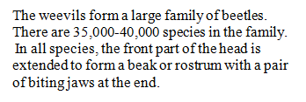
Weevil Features

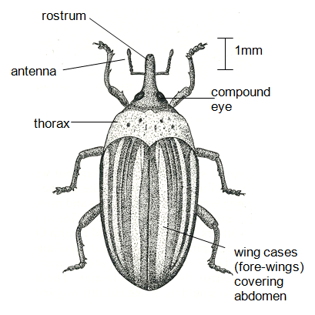
hindleg
middle leg
foreleg
tarsa
tibia
femur
collar
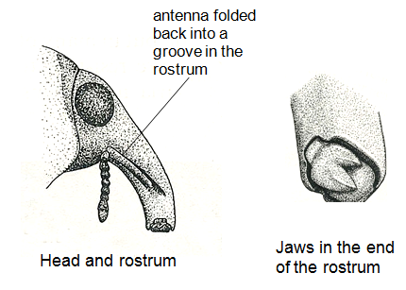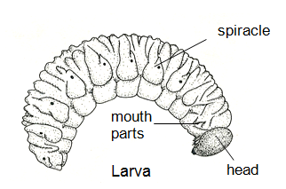

The main function of the rostrum is to bore holes in plants. In these holes, the female lays her eggs. The eggs hatch into larvae, which eat the plant material surrounding them. If this material is a crop plant or seeds used for human food, the weevils may cause serious damage.
The bean stem weevil (Alcidodes leucogrammus), bores into the base of the stem of french bean
(Phaseolus) or cowpea (Vigna) plants and lays a small number of eggs. These hatch in about 6 days to larvae similar to the one in the figure. The larvae feed on the stem tissue and damage the plant, sometimes causing the stem to break off or fall over. They pupate in the stem and emerge as adults in about 50 days, though this period is very variable. This weevil may attack and damage several rows of garden beans but it is not usually a serious agricultural pest. Burning infected plants at once, and all plants at the end of the growing season, will help to control the weevil.
Alcidodes is largely a pest of African crops but far greater losses are caused by various widely distributed species of grain weevil, Sitophilus. These are smaller and less conspicuous than Alcidodes but they do more damage because they lay their eggs in the fruits or seeds of beans, maize or rice as the crops are growing in the field. While the seeds or grains are in store, the larvae eat the inside of the seed. In the seed they pupate and emerge as adults in as little as 10 days. The adults then bore into the stored grain all around them and lay their eggs. Thus, in a month or two a large proportion of the grain can be damaged or destroyed. This is one reason why old seed and new seed should not be mixed; any weevils hatching from the old grains will attack the new seed.
It is usually the larvae which do most damage to the plant, but in some species the adults feed on and damage the plant, as well as being the means by which the eggs are introduced to new
plants or seeds. In some weevils the rostrum is so narrow that it is thought that the adults do not feed at all or that they take only liquids.
The adult palm weevil, Rhyncophorus, is about 4-5 cm long and normally breeds in the stumps of palm trees, but will also lay its eggs in young leaves of palm trees at points where these have been damaged by human activity or by pests such as the rhinoceros beetle. The larvae tunnel into the crown of the palm and sometimes kill the whole tree by destroying the growing point.

Adapted from © D.G. Mackean http://www.biology-resources.com/insects-01.html

