Notes: Vision Problems

Normal Vision
- Individuals with perfect vision are able to see both objects that are _ and _ without any problem
  - In other words, these images appear
  - This is because the image is being formed
- To do this, the will and in order to change the shape of the lens to focus the light properly.

Myopia
- Individuals with myopia are said to be
  - This means they can focus on objects
  - But objects appear blurry
- This is most often caused by an eyeball or if the lens or cornea are too curved
  - This causes the image of the object to be formed the retina
- Corrected by using a to _____________ the light rays

Hypermetropia
- Individuals with hypermetropia are said to be
  - This means they can focus on objects
  - But objects that are appear blurry
- This is most often caused by an eyeball that is or if the lens or cornea do not refract the light enough
  - This causes the image of the object to be formed the retina
- Corrected by using a to _____________ the light rays

Presbyopia
- A vision condition that occurs with
  - Usually starts around the age of 40
- Believed to be caused by a gradual and of the lens
- Ligaments also and ciliary muscles lose
- Corrected by using ______________

Astigmatism
- Inability to focus light properly due to _ shaped
- Causes the light to be _______ in a way that creates __________

Normal Vision
Object | Ciliary Muscle | Ciliary Ligaments | Lens | Image
Far away | __________________ | __________________ | __________________ | __________________
 |  |  | __________________ | __________________
 |  |  |  | __________________
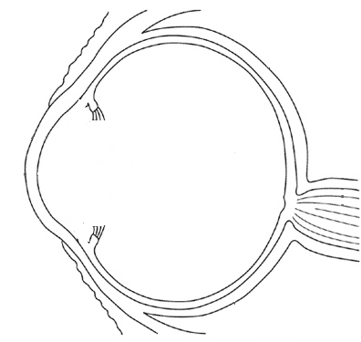

Object | Ciliary Muscle | Ciliary Ligaments | Lens | Image
Up close | __________________ | __________________ | __________________ | __________________
 |  |  | __________________ | __________________
 |  |  |  | __________________

Myopia
Normal Vision (object far away)

Myopia (object far away)

Hypermetropia
Normal Vision (object up close)

Hypermetropia (object up close)

Corrective Lenses
Myopia

f’
f

Type of Lens | Refraction | Focal Point | Image
Hypermetropia

f’
f

Type of Lens | Refraction | Focal Point | Image

Presbyopia

Type of Lens | Look up corrects for | Look down corrects for

