The Lesser of Two Weevils
/20

Introduction to problem and situation
You just landed yourself a great Summer job working as a research assistant for world famous entomologist power couple David and Edna Carapace. They are the leading experts on the weevil species of the world and have contributed to discovering all 10 of the currently known species. They just recently came back from a weevil-collecting expedition and are hoping they might have stumbled upon a new species! However, being the world-famous entomologists that they are they have to run off to a conference in Nairobi and have tasked you with the job of determining whether or not they have found a new species.
Just before leaving, Mr and Mrs Carapace happen to remember that you’re new and haven’t quite had a chance to get to know where everything is. To help you out, they provide you with a drawing for each the 10 known species for you to use as comparison (see the pictures provided by your teacher on Teams).
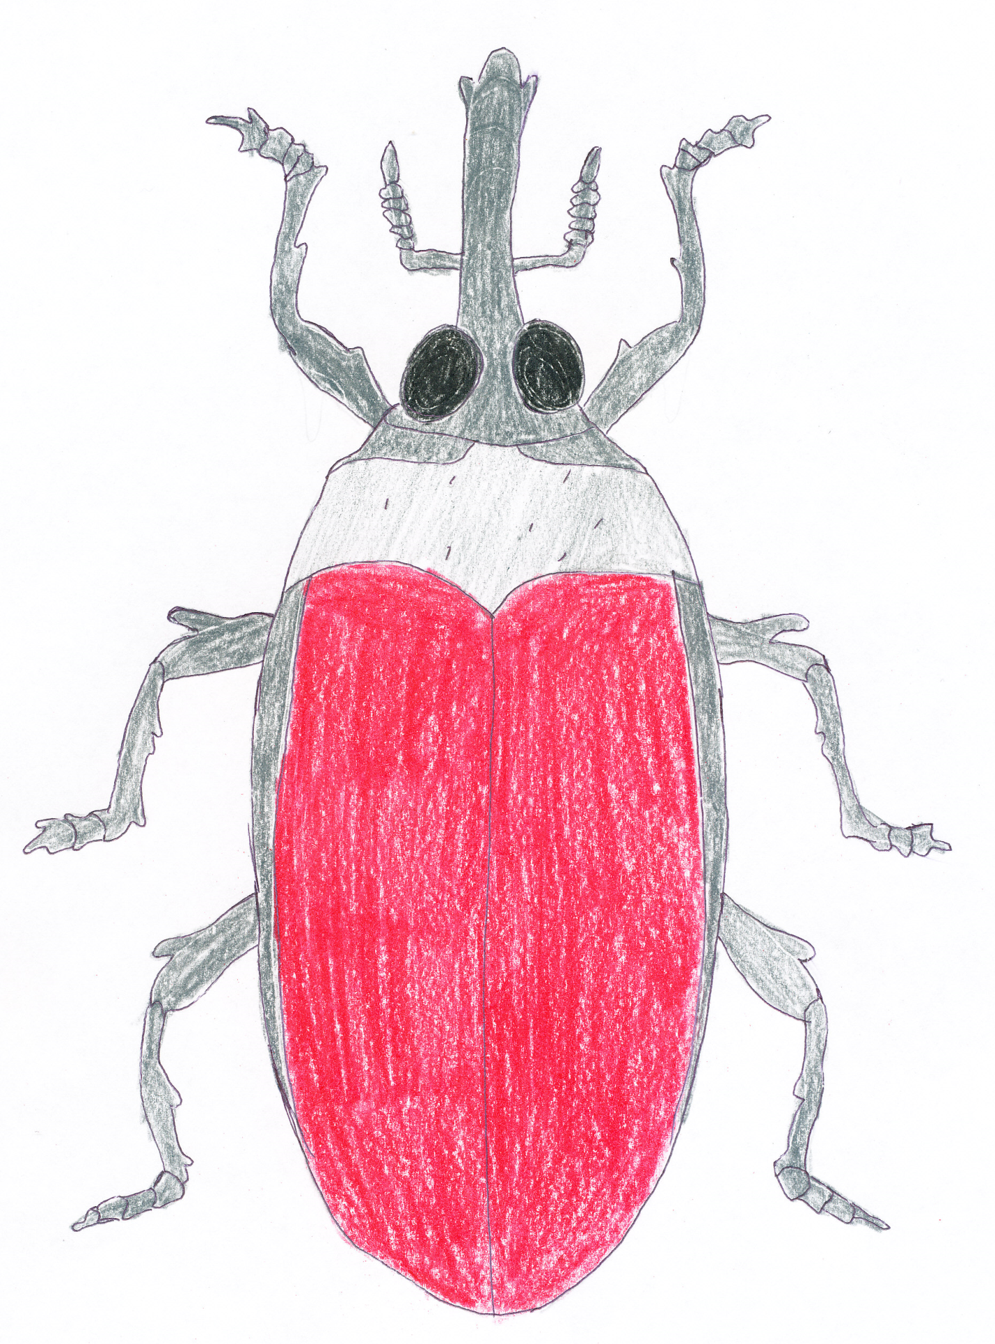

New Specimen

Part A: Taxonomic Key
Use the space below to create a taxonomic key for the currently known species of weevils that could be used to help identify the different species in the wild! Consult the Weevil Features sheet for the proper names of different structures (10 marks)

Results Sheet
Use your key to determine whether the unknown specimen is a new species. If it is a new species, provide it with a name (remember: it should be in the same genus as the others); if it is not, indicate to which species it belongs. Justify your answer.
Species name of unknown specimen (1 mark):

Justification (3 marks):

New Discovery
It has been several weeks since you were asked to determine to what species the unknown specimen belonged and, during that time, additional measures were taken to identify the specimen. After extensive consideration of the habitat where the specimen was found (see the Additional Weevil Habitat Information document on Teams) and an analysis of its DNA, it has been determined that the specimen is considered to be a member of the weevil species Weevilus kentii.
- What possible reason would account for the differences in its appearance (think natural selection)? You may be creative but you must justify your answer using scientific reasoning.
(3 marks)

- What possible impact could this adaptation have on the species? What about the effect on the other species in the area? Justify your answers using scientific reasoning. Consult the food web in the Additional Weevil Habitat Information document (3 marks)

