Term 1 Exam Review

  - Fill in the blanks below about the states of matter:
All substances are made of ___________________________ which cannot be __________________ by the naked eye because they are ________________________.

  - Name the three states of matter:_________ __________ _________

  - Fill in the following table summarizing the 6 changes of state

Start Phase | End Phase | Change of State
Gas | Liquid | Condensation
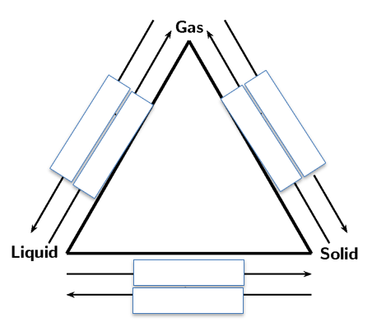
  - Fill in the diagram below

  - Complete the following table
 | Solid | Liquid | Gas
Shape
(definite or not?)

Volume
(definite or not?)

Forces/bonds
(strong or weak?)

Movement

Drawing
(Particle model)

- Give the definition for the following terms:
    - Mass

    - Volume

    - Density

    - Temperature

    - Solubility

- Fill in the table below for Mass, Volume and Density

 | Regular Solid | Irregular  Solid | Liquid | Equipment | Unit
Method to determine  Mass | weigh |  |  | Scale (balance) | g
Method to determine  Volume |  | Water displacement
Method to determine  Density |  |  |  | None (need to calculate)

- Define characteristic (CP) and non-characteristic properties (NCP).
CP definition: ________________________________________________________________________________________________________________________________
NCP definition: ________________________________________________________________________________________________________________________________

- List examples of characteristic properties (CP) and non-characteristic properties (NCP).
CP: __________________________________________________________________________________________________________________________

NCP:
__________________________________________________________________________________________________________________________

- Jade wants to measure the volume of a piece of quartz from her mineral collection. She pours 20 mL of water in a graduated cylinder. She gently slides in her piece of quartz. The figure below shows the results obtained. What is the volume of quartz? Show your work. (Don’t forget units!)

- Solve the density of the marble with a weight of 14 g and 28mL. Show your calculations below. (Don’t forget units!)

- How does the volume of an object affect the density if the mass stays the same?

The Earth’s Internal Structure

We can divide the Earth’s internal structure into three distinct layers:
- ______________
- ______________
- ______________

The Earth’s Internal Layers

Crust | The Earth’s crust is ____________. Its thickness varies:  -Between _______________ beneath the oceans  -Between _______________ beneath the continents
Mantle | Upper Mantle | - Can be up to 670 km thick.  - Is a ____________. Composed of partially melted rock.  - Causes _______________ (plate tectonics) due to _______________  - Convection:___________________________
 | Lower Mantle | - This layer is _____________ despite its high temperature because the ____________ is very high.  - It is composed mainly of ________, _________, _________, __________, _________
Core | Outer Core | - The outer core is _________  - This layer gives rise to the _______________________  - ________________
 | Inner Core | Despite its VERY ________________, the inner part of the core is _________ because of the enormous ____________ holding the core’s particles together.

Relief & Soil
    - What factors affect relief?

    - The Earth’s relief is constantly changing because of underground forces.
True or False (circle the correct answer)

3. How can humans contribute to the transformation of relief? (give 3 examples)
-
-
-

4. What are the 3 components that make up soil?
-
-
-

