Solutions and Concentration Notes

What is a solution?
______________________ mixture of ________________ and ________________
- Solute: substance ________________
  - Often a ________________
- Solvent: substance in which the ________________________________
  - Usually a ________________
Homogeneous mixture
- A mixture where you ________________________________________________between the different substances involved in the mixture
Aqueous solution
- Aqua = ________________
- A solution where ________________ is the ________________
Example
I take a spoonful of Nesquik powder and mix it into my milk to make chocolate milk.
- What is the solute? ________________________________
- What is the solvent? ________________________________
- What is the solution? ________________________________

Concentration
What is concentration?
The amount of substance within a given volume
C:_________________
m:___________ of solute
V: _____________ of _________________

More or less concentrated?

m=2g
V=1L

m=8g
V=4L

Example
The water from which of the following containers would taste the sweetest?
The water from which container would taste the least sweet?

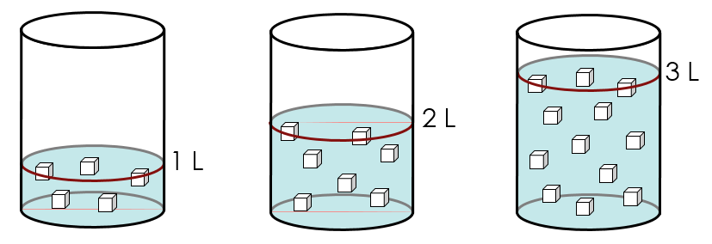

Practice Problem
Ian is feeling a little under the weather and decides to make himself some tea. To make it a little more appealing he decides to add 15g of sugar to his teapot which contains 1.5L of tea. What is the concentration of his sweetened tea in g/L?

Converting Units
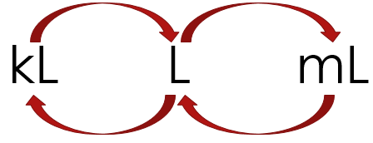
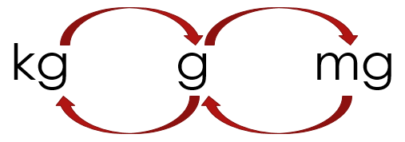

Practice Problems
Jenna made herself 50ml of Kool-Aid by dissolving 2.5g of the powder into water. What is the concentration of the Kool-Aid in g/L?

Rearranging the Equations
Example
Emma wants to make 125ml of a 8g/L saline solution. How much salt will she need to use?

What is the maximum volume that Cory can make of an 80g/L solution of chocolate milk if he only has 23g of Nesquik powder?

Concentration in Percent (%)
What is percentage?
___________________________________

What percent of the squares are grey?
We can also measure concentrations in % (m/V)

What is the % concentration?

Practice Problems
- What is the % concentration of sugar in a 355ml can of Coca-Cola?

- What is the % concentration of sugar in a 591ml bottle of Gatorade?

- What is the maximum volume that Will can make of an 8% solution of chocolate milk if he uses 24g of Nesquik powder?

Concentration in ppm
What is ppm?
Stands for “__________________________________________”
- How _________________________________________________________
Practice
If a 2L sample of lake water contains 0.5g of phosphates, what is the concentration of phosphate in ppm?

The salinity of the Baltic sea is about 7000ppm. If I took a 250ml sample of sea water, how much salt would it contain?

Converting Units
Unit | g/L | % | ppm | mg/L
Example | 25g/L | 25% | 25ppm | 25mg/L
Using g and ml

Practice
Convert the following into percent concentration
150g/L | 25ppm | 37g/400ml | 14mg/L

Convert the following into g/L
12% | 28ppm | 30g/500ml | 24mg/L

Convert the following into ppm
33% | 129g/L | 30g/750ml | 0.6mg/L

Place the following concentrations in order from least to most concentrated:
- 0.4% | - 10g/L | - 35ppm | - 150mg/L

Dilutions
What is dilution?
____________________________________________________________________________________________________________________________________________________________
- When you are diluting a substance the amount of _____________ remains the ___________
- The volume of _________________________________
- Therefore the _________________________________

