Notes: Skin, Smell and Taste

The skin is the _______________________________ of the body, covering its _______________ surface

Purpose of the skin
The skin has many functions:
- _______________the inner organs and cells
- Shields us from harmful _______________
- Excretes _______________ (e.g. sweating)
- Protects from ______________________________like bacteria
- _______________regulation
  - Insulation and evaporative cooling
- Makes _______________
- Helps to _______________ the environment
  - _______________, _______________,_______________ _
- ________________
  - Health and emotions

Structure of the Skin
The skin is composed of three different layers:
- _______________
- _______________
- _____________________________________________________

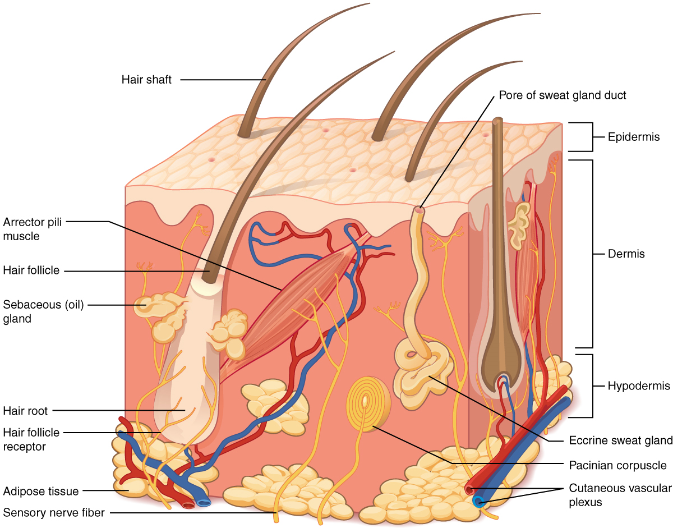
Epidermis
The epidermis has a _______________ layer and a _______________ layer
The dead layer is the _______________ layer
- ______________________________causes the cells to burst and _______________
The living layer is _______________
- A layer of cells that are ______________________________
- New cells push old cells towards the _______________
  - This helps in the _______________ process

The lower layer also contains the _______________
- The pigment that gives skin its _______________ and helps ____________________ against the sun’s _______________
- Tanning is a result of ______________________________being produced due to ______________________________
- Keep in mind that too much sun exposure can lead to _______________ in the cells that contain the melanin which may cause _______________!
The epidermis is our _____________________________________________against bacteria invasions and other environmental dangers
Dermis
The dermis is where you will find:
- Sensory_______________
- ______________________________
- _______________ glands
- Secrete sebum (__________) to _______________ the skin
  - Keeps in moisture and waterproofs
- _______________ glands
  - Produce sweat that is then carried to the surface via the _______________
- _______________follicles
Hypodermis
Also sometime called the _______________________________________
The hypodermis is mostly made up of _______________ tissue (_________________________)
The fat cells act not only as an ______________________________but also as a ______________________________

Sensory Receptors
There are three different types of sensory receptors in the epidermis:
- _______________ sensory receptors for _______________ and _______________
- _______________ sensory receptors for _______________and _______________
- _______________ sensory receptors to indicate pain
The different sensory receptors are _____________________________________________over the body
Ex:
- The cheeks and underside of the wrists are more sensitive to heat
- The soles of the feet are more sensitive to pressure

The Nose
What is its function?
- __________________________
- __________________________
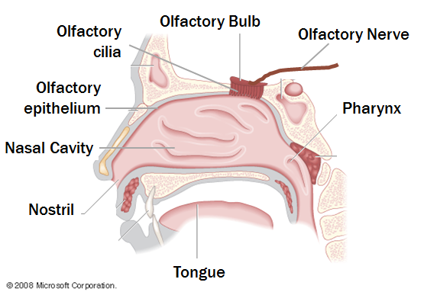

Smelling
The nose is the organ associated with ____________________ and ____________________
The nerve cells associated with smell are called _______________________________________
- Most of these nerve cells are concentrated in the __________________________at the tip of the ____________________________________________________
Although we’re very ___________________ at __________________________ smells we are generally ____________________ at __________________________ them
- We are used to identifying what we _______________ and __________________but not what we __________________________

What is the sense of smell good for?
We use our sense of smell to gather information from the world around us, such as:
- __________________________
- __________________________ (ex: fire, toxic chemicals, etc)
- __________________________
- __________________________ (?)

Smell and memory
Smell is also strongly associated with __________________________
- Scientists believe that since a mixture of particular smells is more novel than shapes for example, ________________________________________________________________________________________________________________________________________________

The Tongue
What is the function of the tongue?
- Has the sensory receptors for __________________________
- Helps _______________________________________around for chewing (mastication)
- Used to _____________________ food
- Important in ________________
All over your tongue there are little bumps called _______________
- Within some of these papillae are located the ______________________________
Taste buds are the ______________________________for _______________ on the tongue

Taste and Flavour
The words taste and flavour are often used interchangeably
But humans can only detect ____________________________________:
- ______________________________
- ______________________________
- ______________________________
- ______________________________
- ______________________________
Flavour is actually the ___________________ between _____________ and _______________
- It is said that only _______________of flavour comes from the sense of taste, the other _______________is from the smell

Scientists ______________________________that taste buds are spread out in a ______________________________on the tongue
They now believe that all taste buds can experience ______________________________

Other receptors
There are also other receptors on the tongue to detect:
- ______________________________
  - Hot and cold
- ______________________________
  - Prickling feeling
  - Spiciness
- ______________________________
  - Texture of food

