Notes: Respiratory System
Why do we need to breathe?
__________________________________________________________

Cellular Respiration
- The process of ________________________________________molecules with the help of ____________________ to produce ________________________________________and ____________________
- This process also releases ____________________ (ATP) that can be used by the cell
_____________ + ______________→ ________________+ _____________ + _____________
- We need to breathe in order to ________________________________________to help us ________________________________________and ___________________________________
- And breathing out helps us ________________________________________
Metabolism
  - Your metabolism is the whole set of ________________________________________that take place in cells that ________________________________________
  - This includes:
    - Converting ____________________________________ (cellular respiration)
    - Converting ___________________________________________________________ (digestion)
    - Removal of _______________________________________ (excretory system)

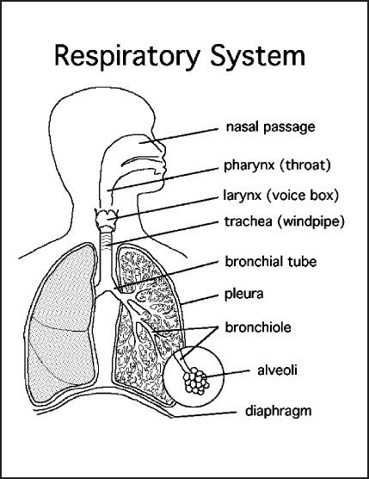

Pathway for Air
What is the pathway for air entering the lungs?
  - ______________________________
  - ______________________________
  - ______________________________
  - ______________________________
  - ______________________________
  - ______________________________
  - ______________________________
Structure | Function
Nostril | ______________________________to respiratory system
Mouth | ______________________________ opening to respiratory system
Nasal cavity | ___________________ and ___________________ the air as it enters. Hairs (cilia) and mucus trap ____________________________________ ___________________.
Turbinate bones | Increase the ______________________________________in nasal cavity and bring the blood close to the air  This ____________________________________________________ (humidify) the air before it enters the lungs
Pharynx | The area that is open to both the _________________________________.  It’s the place where _____________________________________________ ____________________________.  Shared by the digestive and respiratory systems!
Uvula | _____________________________________________________________when you swallow so food doesn’t go up your nose!
Epiglottis | ______________________________________________when you swallow so food doesn’t go down the lungs
Larynx | Is the ______________________________________________which contains the ______________________________________________.  These _______________________ when air passes through them and ______________________________________________!  Men have _________________vocal chords (Adam’s apple)→ deeper voice
Trachea | Is an open tube surrounded by ___________________________________.  These rings keep it _______________________.  It ___________________________down to the lungs.  It’s lined with ________________and ______________________________ to catch and brush out the _______________________.
Bronchi | Two ________________________________, built and protected like the trachea, that _________________________________________________ ____________________
Bronchiole | The bronchi _______________________into tiny branches like an upside down tree.  They ____________________________________all through the lungs
Alveoli | Are ______________________________________________, like tiny bunches of grapes, at the end of the bronchioles.  They are _____________________________________________________  - This is where _____________________________________occurs through the process of _______________________. Oxygen moves into the blood and carbon dioxide moves out of the blood.  These are the ______________________________________________of the lungs
Lungs | The _______________________ that are made up of the ______________  Note: the 2 lungs are __________ identical  - The _______________________is somewhat ________________to make space for the _______________________
Diaphragm | ________________________________________________extending across the bottom of the rib cage  - When _____________________________________________ into the abdomen  - this ________________________________the lungs to suck in air  - When it ________________, it _______________________________ under the ribs  - This ________________________________and forces the air out

