Notes: Waves and the Physics of Light

Waves
A is a which travels through a vacuum or medium (air, water, etc) that contains matter
A wave transports
Some waves do _______to travel in; they can travel even in the
- Example:
Other waves to travel; they depend on the ____________
- Example:

What is light?
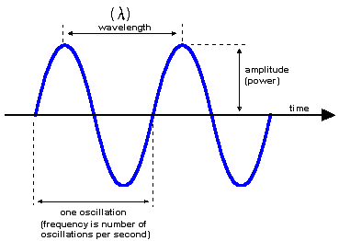
Light: An that is visible to the naked eye
Waves have 3 components:
1)
2)
3)

Amplitude
Amplitude: is the from its resting position
- In other words, amplitude is a wave’s
- For light, this means its

Wavelength
Wavelength: The wavelength of a wave is the between a point on one wave and the same point on the next wave, eg.
- For visible light, the wavelength will indicate its
- _ has the longest wavelength
- _ has the shortest wavelength
The colours we see are only a small part of the electromagnetic spectrum
- We call this the
We also have other types of waves that we cannot see
  - Example:
__________________________ | __________________________ | __________________________
__________________________ | __________________________ | __________________________

Frequency
Frequency:
- Measured in Hertz (Hz) = wavelengths/sec
Note: wavelength and frequency are related
- The the wavelength, the the frequency
- The the wavelength, the the frequency

Classification on the Electromagnetic Spectrum
Types | Radio Waves | Infrared | Visible Light | UV Rays | X-Rays | Gamma Rays
Frequency
Energy
Tech
Applications
Interesting Facts

Types of Waves
Transverse waves: are that consists of oscillations occurring (or right angled) to the direction of energy transfer
- Because they are not made of vibrating particles they can travel through a vacuum. They do not need a . So they travel through space.
- They are very fast 300 000 000 m/s in the air
- Speed of light

Compression waves: waves that ________ through which it is transmitted
- Also called waves
- Example:
Compression waves must travel through a (solid, liquid or gas)
- One molecule hits another molecule, which hits another one and so on
- Passing on
- Since they depend on they cannot move very fast
- Less than 350 m/s in air

Light and Lenses

Properties of Light
- The sun is the of
- Light can be and
- Light travels in a from its source
- The is dependent on the it is travelling through; light can be !
- White light is made up of of light
- Light energy can be __________ into other types of energy

Light behaviour
- Light usually travels in a
- Light can be bent
  - This is called

- We can use lenses to bend the light and at one point
  - This point is called the

- We can also uses lenses to the light waves outward
  - We call this the light

- We have looked at 2 types of lenses:
  - _ lenses
  - _ lenses
Type of lens:

Type of lens:

