Nutrition and Digestion Test Review

Matching
Place the letter corresponding to the following processes in the correct box for the appropriate structure of the digestive tract.
A) Ingestion | B) Break down of protein by gastric juices | C) Break down of starch by saliva | D) Break of carbohydrates by intestinal juices
E) Absorption of most nutrients | F) Absorption of water, vitamins and minerals | G) Release of bile to help breakdown fats | H) Movement of waste into rectum
I) Movement of food by peristalsis into stomach | J) Breakdown of proteins by intestinal juices | K) Churning and mixing of food
L) Breakdown of fats by intestinal juices | M) Mastication and deglutination | N) Movement of food into small intestine by peristalsis

Organ  Mouth | Mechanical Processes | Chemical Processes
Mouth and pharynx
Esophagus  Stomach |  | NONE
Stomach
 | Small Intestine
Small intestine
Large intestine | Large Intestine | NONE

Short Answer
- Which two nutrients are the body’s main sources of energy?
_______________________ _______________________
- Which nutrient is used to repair the body’s cells and tissues?
_______________________
- Which two nutrients are only required in small amounts daily?
_______________________ _______________________
- What are the building blocks that proteins are broken down into during digestion?
_______________________
- What are the building blocks that fats are broken down into during digestion?
_______________________ _______________________
- What are the building blocks that carbohydrates are broken down into during digestion?
_______________________
- What is the function of the uvula?
_____________________________________________________________________
- What is the function of the epiglottis?
_______________________ ______________________________________________
- For each of the following foods indicate the main macromolecule (fat, carbohydrate, protein):
Bread _______________________

Tuna _______________________
Steak _______________________
Butter _______________________
Potato _______________________
Tofu _______________________
Bean _______________________
Apple _______________________
Rice _______________________
Donut _______________________

- What are some signs that would indicate your friend might have an eating disorder?

- What are the two main types of eating disorders?
_________________________ ___________________________

- What are some benefits and concerns associated with GMOs?
Benefits | Concerns

- What is pasteurization? What are some of its applications today?

- Name the parts of the digestive tract in order (start with ingestion):

___________________________
___________________________
___________________________
___________________________
___________________________
___________________________

Labeling
Label the structures indicated below.
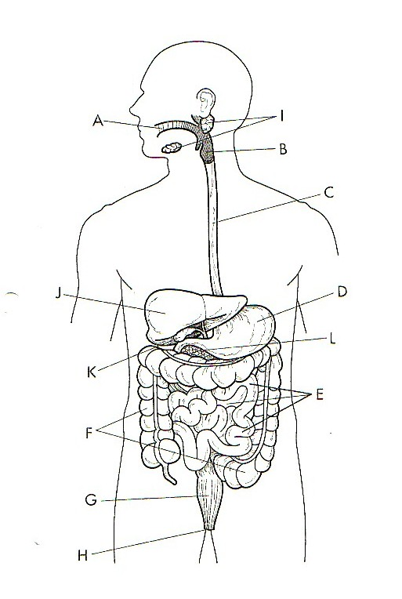

The Human Digestive System
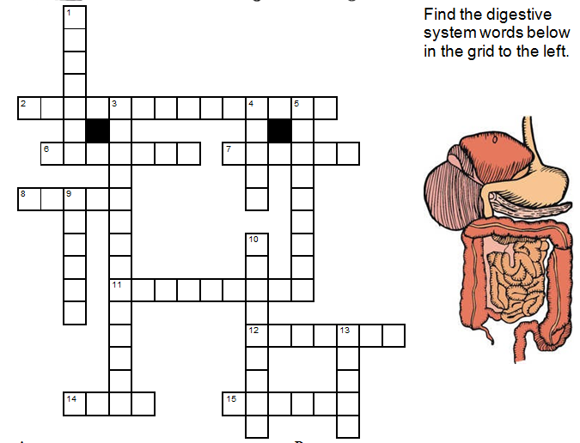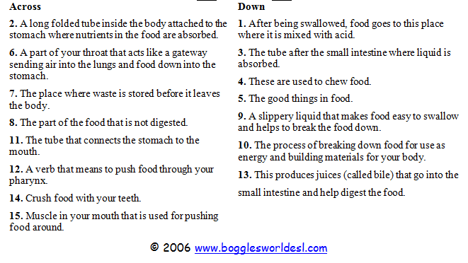

Analysis Questions
- Here is a meal plan for one day on the “Get Lean” Diet. Based on the information provided:
- Calculate the total number of calories consumed
- Calculate the total amount of grams of each macromolecule consumed
Food Item | Fat (g) | Carbs (g) | Protein (g) | Calories
3 eggs | 33 | 3.3 | 39
1 slice cheddar | 9 | 0.4 | 7
1 cup baby spinach | 0.1 | 1.1 | 0.9
1 peach | 0.4 | 14 | 1.4
2 tbsp Chocolate protein powder | 0 | 5 | 20
2 cups chocolate milk | 16 | 52 | 16
2 tbsp peanut butter | 16 | 6 | 8
1 tbsp chia seeds | 4.5 | 6 | 2.5
3 ice cubes | 0 | 0 | 0
4 oz rib eye steak | 25 | 0 | 30
½ avocado | 14.5 | 8.5 | 2
1 tomato | .2 | 4.8 | 1.1
¼ red onion | 0 | 1.8 | 0.2
1 Recovery shake | 16 | 50 | 25
3 oz chicken breast | 3.6 | 0 | 31
1 oz whole-wheat flax penne pasta | 1 | 37 | 7
1 cup sliced mushrooms | 0.2 | 2.3 | 2.2
2 cups broccoli | 0.6 | 12 | 5.2
½ cup marinara sauce | 1.9 | 10.5 | 1.8
1 tbsp extra virgin olive oil | 14 | 0 | 0
Total
Is this meal plan healthy for a 15-year old? Justify your answer.

- Here are the nutrition labels for 3 energy drinks.
- For each one, indicate how many grams of fat, proteins and carbohydrates there are
- For each one, indicate how many calories they contain
- Determine which one is the healthiest option. Justify your answer.
B
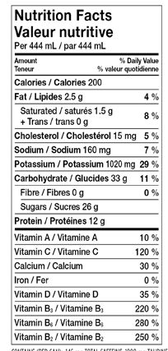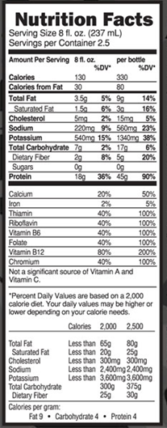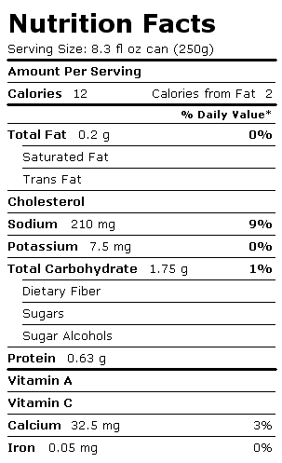
C
A
Fats: __________
Carbs: __________
Proteins: __________
Total Calories: __________
Fats: __________
Carbs: __________
Proteins: __________
Total Calories: __________
Fats: __________
Carbs: __________
Proteins: __________
Total Calories: __________

Which is the healthiest option? Is there any other information that would be useful to have?

