Notes: Transmission and Transformation Systems

**Transmission systems:**

* Multiple _________________________ that have the ____________________________________ of movement (rotational, linear, etc)

**Transformation systems:**

* ____________________________________ in the system have __________________types of movement
  + Ex: rotational movement leads to linear movement

Components can be connected __________________or through an ______________________________

**Reversibility:**

* A system is considered reversible if ________________________________________________________________________
  + **Driver:** __________________the motion
  + **Driven:** __________________the motion
    - Remember: there can be _______________________components too

# Transmission Systems

**1) Gear Trains**

* At least __________________whose teeth __________________
* Notice that the gears move in __________________ directions
* 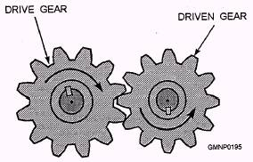Are they reversible?
* Speed of the gears depends on:
  + The ____________________________________

OR

* + The __________________ of the gears (friction wheels)

$$speed ratio=\frac{asdasdaasdasdada}{asdasdaasdasdada}$$

$$speed ratio=\frac{asdasdaasdasdada}{asdasdaasdasdada}$$

### Example:

If a driver gear has a diameter of 20cm and the driven gear has a diameter of 40 cm, what is the speed ratio?

Which one is moving faster?

**2) Chain and Sprocket**

* At least __________________connected by a __________________
* **Notice:** all the gears turn in the__________________ direction
* 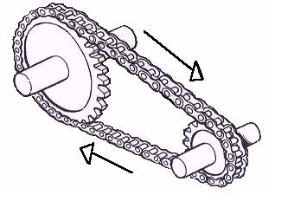If it had gears on the __________________; they would turn in the __________________ direction
* Are they reversible?

_________________________________-

**3) Worm and worm gear**

* Consists of a __________________ and at least one __________________

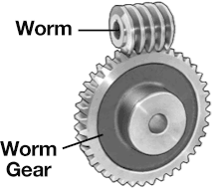

* Are they reversible?

________________

**4) Friction wheels (or friction gears)**

* Like gears but ____________________________________
* Touch __________________; __________________ causes the movement

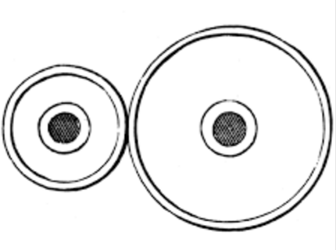

* Are they reversible?

________________

**5) Belt and pulley system**

* Like chain and sprocket but ____________________________________
* 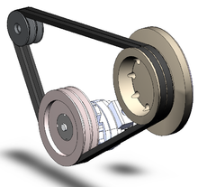Are they reversible?

________________

# Transformation Systems

Also have __________________components and __________________ components

* ____________________________________

**Remember:**

* **Transmission:** ____________________________________of movement throughout
* **Transformation:** __________________ the type of movement
  + Ex: rotational to translational

1) **Rack and Pinion**

* 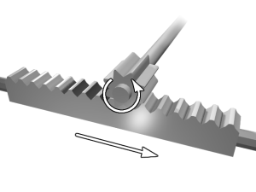Composed of a gear (__________________) and a grooved/toothed bar (__________________)
* Are they reversible?

________________

2) **Screw gear system**

* Composed of a __________________ and a __________________
* 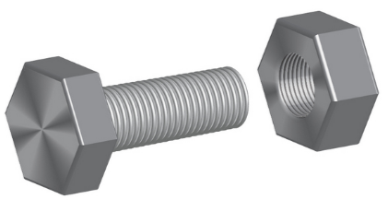Are they reversible?

________________

3) **Cam and follower**

* 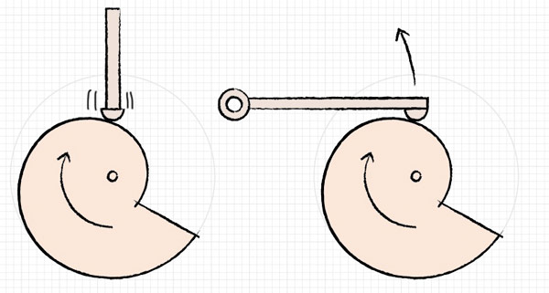Composed of a wheel that is often oddly shaped (__________________) and stick that raises and lowers (__________________)
* Are they reversible?

________________

4) **Slider and crank (piston)**

* Similar to cam and follower but the crank is usually __________________ and the slider is usually a _______________________________________________________________________
* Are they reversible?

________________

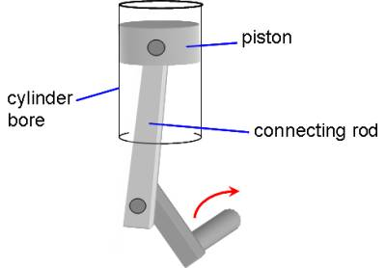

# Speed Ratios

**Components with teeth**

1. a) Calculate the speed ratio for the following chain and sprocket system.



Driven component

7 teeth

Driver component

28 teeth

b) If the driver sprocket rotates 8 times clockwise, then the driven sprocket will rotate ______________

**Components without teeth**

1. a) Calculate the speed ratio for the following belt and pulley system.

Pulley B = 4”

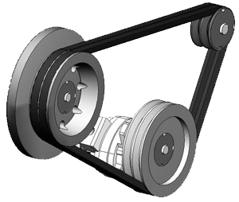

Pulley C = 10”

Driver component

Pulley A = 8”

Speed ratio (A→B)

Speed ratio (A→C)

b) If pulley A rotates 40 revolutions per minute (40 rpm)…

… pulley B will rotate at a speed of ____________

… pulley C will rotate at a speed of ____________

# Recap - Motion Transmission Systems

|  |  |  |
| --- | --- | --- |
| **Type** | **Picture** | **Reversible** |
| **Gear train** | http://s.hswstatic.com/gif/gear-bevel2.jpg | Yes |
| **Chain and**  **sprocket** | Bikes | Yes |
| **Worm and worm gear** | Wine bottle opener | No |
| **Friction gear**  **systems** | Printers | Yes |
| **Belt and**  **pulley**  **system** | Motors | Yes |

# Recap - Motion Transformation Systems

|  |  |  |
| --- | --- | --- |
| **Type** | **Picture** | **Reversible?** |
| **Rack and pinion** | http://www.vexrobotics.com/wiki/images/thumb/5/52/RackAndPinionSketch.JPG/250px-RackAndPinionSketch.JPG | Yes |
| **Screw gear System**  **Type 1** | http://wiki.ece.cmu.edu/ddl/images/thumb/Jack_model_FBD.JPG/500px-Jack_model_FBD.JPG | No |
| **Screw gear system**  **Type 2** | http://static.ddmcdn.com/gif/pipe-wrench-1.jpg | No |
| **Cam and follower** | rockisoanim.gif (76596 bytes) | No |
| **Slider and crank**  **mechanism** | **Crank and slider animation** | Yes |