Notes: Reflection and Refraction

Reflection
Occurs when ______________ ______________ ______________ and ______________ ______________ towards the direction it came from
Reflection is what allows us to ____________________________:
- ______________ ______________ off an object and ______________ ______________ ______________ → sight

Reflection Diagrams
Definitions:
- Incident Ray: the ray that ______________________________________ ______________ __________________
- Reflected Ray: _____________________________________________________
- Normal: a line ______________ ______________ ______________ at the point of reflection
- Angle of Incidence: the______________ formed between _______________ _____________________________________________________ __
- Angle of Reflection: the ______________ formed by the _________________ ____ ___________________________________
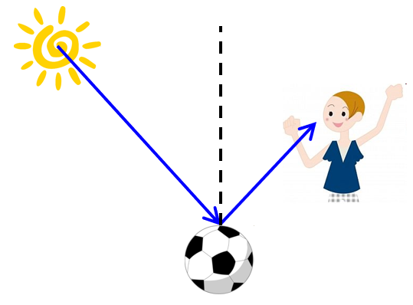

Laws of Reflection
The ______________ _________________________ is always ______________ to the __________________________________________
The ______________ ______________ and the ______________ ______________ are always in the ____________________________
- ex: on the ______________ ______________ of the ______________

Mirrors
When ______________ ______________ rays contact a surface such as a ______________, their ______________ ______________ ______________ resulting in a __________________ ______________________
A mirror with ______________________, or that is flat is called a ________________ ____________
Reflections from plane mirrors have several characteristics:
- The image ______________ ______________ _________the mirror
- The ______________ between the object and the mirror and the reflected image and the mirror are __________________________________________
- The ______________ ______________ ______________ is called a ______________ ______________
- A virtual image is not real and therefore ______________ ______________ _________ on a mirror; it is made by lengthening the reflected rays
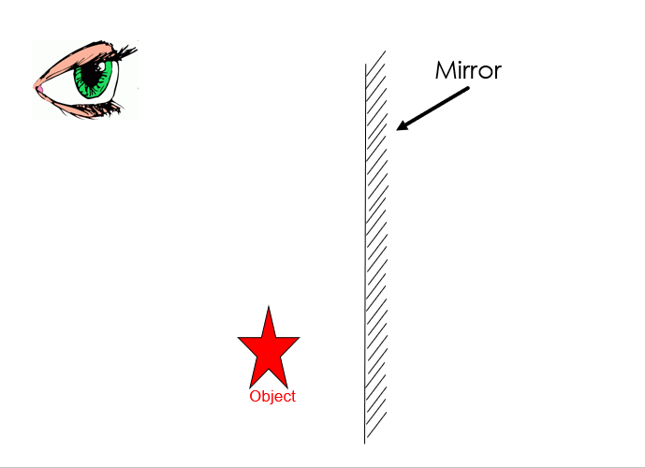

Uses of Plane Mirrors
The two principles that make plane mirrors useful are:
- They ______________ ______________ ______________ (pathway) of light rays by ______________
- This ______________ the observer’s ____________________________
Uses: ______________________________________________________________________

Refraction
Refraction: the ______________ of a ______________ ______________ as it passes from ________________________________________________________
- Occurs when the ________________________________________________________
Most often occurs as light goes from ____________________________
Happens because the ______________ ______________ ______________ ______________ as the medium changes

Lenses
Lenses are made of ______________ ______________ __________and have at least one ____________________________
The curve of a lenses allows it to ______________ ______________ as it passes through
There are two types of lenses
- ____________________________
- ____________________________
______________ ______________ bring light rays ______________
______________ ______________ ______________ light rays

Focal Point
The ______________ ______________ of a ______________ ______________ is the ______________ ______________ where the refracted rays ______________ ______________ when the incident rays run parallel
- The focal point is __________________________________________
The ______________ ______________ of a ______________ ______________ is the ______________ ______________ from which the refracted light rays ______________ ______________ ______________ when the incident rays run parallel
- The focal point is ____________________________
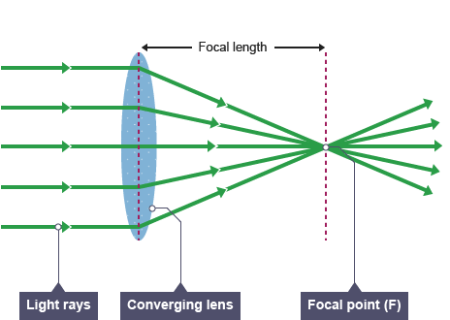
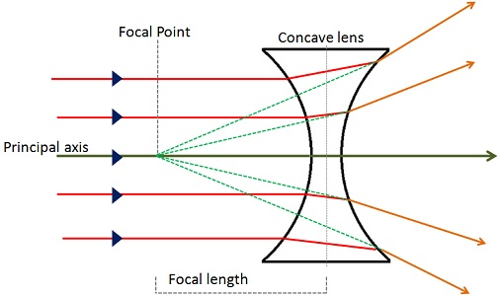

Colours and Light
- When you see ______________: it is ______________ ______________ _________ being reflected equally back to your eye
- When you see ______________: all of the light is being _________________ (that’s why your black T-shirt gets so hot in summer)
  - it is the ____________________________
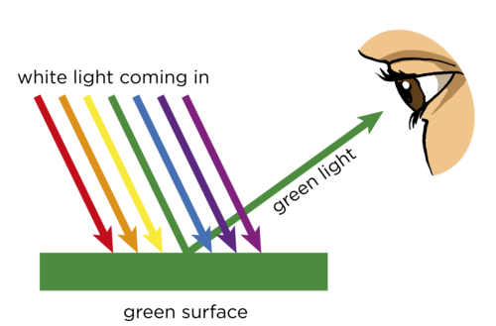
- The grass ______________ all of the light ray colours ___________________________. It ______________ ______________ back to your eye.

