Notes: Periodic Table

Periodic Table
A ______________________________________________used in Science to organize the elements according to their ___________________________________________________ ____________________
Group or Family
- All the elements in a ____________________________________________on the periodic table are said to be in the __________________________________________.
- All elements in the same group/family have ____________________________________ _____________________________________
  - This is because they have the same number of ____________________________
Valence electrons: the number of electrons in the _________________________________ ________________________________

- You will see that on the Periodic Table they are ______________________ (IA, IIA, IIB, etc)
- Each group/family also has a __________________

Period (orbits, energy levels, energy shells)
- All the elements in a ______________________on the periodic table are said to be in the ____________________________________________
- All elements in the same period have the same number of ______________________ ______________________

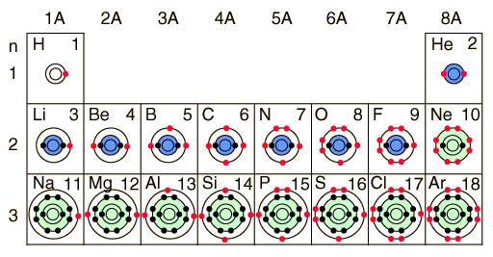
Staircase
- You’ll also notice that there is a staircase along part of the Periodic Table
  - This staircase divides the _______________________________________________
    - Most elements _________________________________________________
Hydrogen
- You’ll notice that hydrogen is labelled as a non-metal even though it is placed on the side with the metals; this is because it does not exhibit most of the characteristics required to be a metal (we’ll discuss these shortly)
- But sometimes it does act like a metal…
For our purposes, it is a ______________________!

Properties of Metals, Non-Metals and Metalloids
Metals

Non-Metals

Metalloids

Group Names & Characteristics
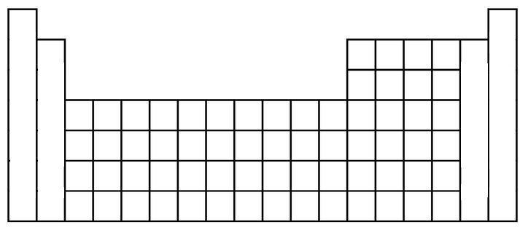
Alkali metals
- ______________________on the left
(does not include ______________________ ← remember, not a metal)
- The ____________________________________________
  - Because each element only has ___________________________________________
- Obviously, have all the properties of metals

Alkaline earth metals
- _________________________from the left (starts with Beryllium)
- ________________________________but not as much as alkali metals
- Again, have all the properties of metals

Transition metals
- All the metals in the ______________________ chunk of the Periodic Table
  - You’re not responsible for them!

Groups 3A, 4A, 5A and 6A
- Just named after the first element in the group
  - Ex: Boron family, Carbon family, etc

Halogens
- ______________________ (begins with Fluorine)
- Have all the characteristics of ______________________
- If you __________________________________________________, you’ll get a ______________________
  - Halogen + metal = salt
- Used as ____________________________________________
  - Kills bacteria, fungi, etc
Noble or Inert Gases
- Produce a ____________________________when ______________________ is passed through them
  - Think neon signs
- ________________________________________________________________________________________
  - This means that these elements are ______________________→ they __________________________________________with any other substance
    - Will __________form compounds

Practice Questions
- Fill in the table below:
Element | Number of Valence Electrons | Chemical Family Name
Br
Ca
Na
He

- Four elements from the periodic table are described below:
Element 1: This element from Period 2 has two more electrons than helium
Element 2: This soft metal from Period 3 has one valence electron.
Element 3: This element from Period 4 is found in bones and teeth
Element 4: This element from Period 3 has some of the properties of metals and non—metals

Which of these elements belong to the same group or chemical family?
- 1 and 2
- 1 and 3
- 2 and 4
- 3 and 4

More Atomic Representations
- What is the Rutherford-Bohr model for Argon?
  - # protons:
  - # electrons:

As you can imagine, drawing out all the orbitals and all the electrons for some elements could be very tiring
  - Imagine doing it for Oganesson (Og)… DON’T DRAW IT!

Lewis Dot Diagrams
- When talking about ____________________________________________, the only electrons we’re really interested in are the __________________________________ (the ones on the last shell)
- Along comes Gilbert N. Lewis (1916) and develops a _____________________________ ____________________________________________________ (especially for showing how different elements bond to form compounds!)
- And it looks something like this…

- __________are used to show the number of ______________________________ ______________an element has
  - This means that all the elements in the _________________________________ have the __________________________________________________________
- These dots are arranged in the 4 compass points (______________________)
  - Again, you _________________________________________________________ _________________________________________________________!
Examples:

The following are INCORRECT examples:

Practice
Draw the Lewis Diagram for:

Calcium
Carbon
Chlorine

Octet Rule
- Remember the Noble/Inert gases? What was special about them?
  - Their ____________________________________________; we call this having a ____________________________________________
    - Or ____________________________________________
  - This means that they are ____________________________________________; they don’t form bonds with other atoms
    - They are ______________________ just as they are
- All the other elements, though, ______________________________________________ outer shells
  - So they are __________
- These elements are so unhappy that they ______________________________________ __________________________
  - Which is why (other than the noble gases) there are _______________________ _____________________________________________________; they are always found in a ______________________!
How do they become “happy”?

_________________________________________________________________________________________________________

Example
- What would need to happen for Sulfur to have a full octet?

  - What would happen to the charge on the Sulfur atom?

- What would need to happen for Sodium to have a full octet?

  - What would happen to the charge on the Sodium atom?

Octet Rule
- When an atom ____________________________________________ in order to obtain a ______________________________it becomes ______________________ (either ____________________________________________)
  - An atom with a charge is called an ______________
  - This process is also what allows for _______________to be formed between atoms! (But we’ll discuss that later)
- Keep in mind that ion formation (the ______________________received) is dependent on the __________________________________________________________________
  - So all the elements in the ___________________________________________ will _____________________________________________________________
    - They will obtain the __________________________________________

Practice
- During ionization, an atom can become a positive ion. How does an atom become positively charged?
A) it gains one or more electrons
B) it loses one or more electrons
C) it gains one or more protons
D) it loses one or more protons

- Which atom is correctly represented using Lewis notation?
