Notes: Sound

Waves
Sound is a ________________________ wave (a type of _______________________ wave)
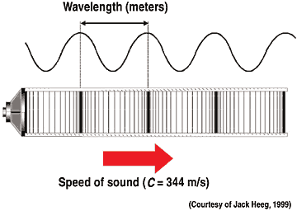

Sound
Sound is a ______________________________________________produced by the _______________________ of an object and transmitted to the object’s environment
As an object vibrates (like the membrane on a drum) it moves up and down _______________________ the air molecules next to it
- These continue to bump each other like dominoes

Guitars and Vocal Cords
By ____________________or strumming the strings on a guitar we cause them to __________________
- The soundboard on an acoustic guitar is hollow and helps ______________________ the sound
- Just like the strings on a guitar our vocal cords produce sound by vibrating

How do we hear?
We are able to hear sounds once the sound wave reaches our _______________
Just like when you tap a drum, the air molecules being pushed by the sound wave hit the eardrum and cause it to _______________
The _______________ is not only filled with _______________but also lined with ______________________________cells
As the eardrum _______________, it causes the fluid to “slosh” around which moves the receptor cells
- Like seaweed (or an anemone) in the ocean

Amplitude and Frequency
Just like light waves, sound waves have both _______________________and ______________________
For sound:
- Its __________________________ determines how ________________the sound is
- Its __________________________ determines the ________________of the sound

Amplitude
The _________________ of sound depends on its _________________, meaning how much energy it transmits
We measure the intensity (amplitude) of sound using the _________________ (dB) scale
- An increase in 10 dB means that a sound becomes _________________louder
  - E.g. 65 dB is 10 times louder than 55dB
  - 75 dB is 10 times louder than 65dB
  - 75 dB is 100 times louder than 55dB

Loud music and hearing loss
Prolonged exposure to sounds louder than _________________can cause ________________________
60-60 rule : You shouldn’t listen to music for more than 60 minutes at 60% of the maximum volume
Threshold of hearing: The ______________________________________that a healthy person can hear

Frequency
Frequency is the __________________________________per _________________
The_________________of the sound changes its tone or _________________
- low frequency = _________________ sound
- High frequency = _________________sound

Just like with light, frequency and wavelength are related
- Low frequency = _________________wavelength
- Higher frequency = _________________wavelength
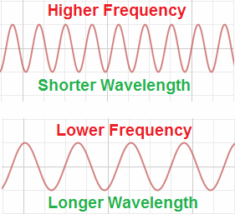
The human ear can generally hear between __________________________________
- As you age you lose the ability to hear the __________________________________of the spectrum

