Notes: Muscles

# Musculoskeletal System

The _________________________________________is an essential activity of the human body

* + And to move we need _____________________!

|  |
| --- |
| **Did you know?**   * Our body has over _____________________________________________________________ * Muscles make up about __________________________________________ |

**Muscles have 4 main functions:**

* _____________________
* __________________________________________
  + your muscles are working to keep you standing up, even if you are not moving
* __________________________________________
  + some joints are held in place by muscles
* __________________________________________
  + 75% of energy expended during muscle movement becomes heat

# Body Movement

Body movements are determined by three types of muscles

__________________________________________– can be controlled by _____________________**.**

__________________________________________– cannot be controlled by will.

_____________________ – control the contractions of the _____________________.

## Skeletal Muscle

* __________________________________________to provide voluntary movement
  + _____________________**:** strong, tough connective cords ____________________________________ ___________________________
  + _____________________**:** tough, sheet-like membrane
* Help __________________________________________
* _____________________internal organs
* Called __________________________________________because they have striations of alternating light and dark bands
* Fleshy body parts are made of skeletal muscles
* Provide movement to the limbs, but __________________________________________, __________________________________________and _____________________the ability to __________________________________________for _________________________________

Ex: Blinking eyes, talking, breathing, eating, dancing and writing all produced by these muscles

## Smooth Muscle

Called smooth muscle because they are unmarked by striations

______________________________to bones, ____________________________, ___________ _______________________________and can __________________________________________for a long time

Not under conscious control so they are also called __________________________________________

Found in walls of __________________________________________ (intestines, bladder, stomach, uterus, blood vessels)

## Cardiac Muscle

Found only in the _____________________

____________________________ muscle

Requires a continuous supply of oxygen to function

Cardiac muscle cells begin to ____________________________________________________________ __________________________________________

__________________________________________

## Special Muscles

_______________________________________________________________are openings between:

- The esophagus and stomach

- The stomach and small intestines

- Walls of the anus, urethra and mouth

Open and close to _______________________________________________________________

# Characteristics of Muscles

*All muscles have 4 common characteristics*

_____________________ – ability to respond to a stimulus (ie: nerve impulse)

_____________________ – muscle fibers that are stimulated by nerves contract (become shorter) and causes movement

_____________________– ability to be stretched

_____________________ – allows the muscle to return to its original shape after it has been stretched

* __________________________________________
  + Buildup of lactic acid caused by vigorous exercise where blood is unable to be transported
* __________________________________________
  + State of partial contraction is called muscle tone
* _____________________
  + Permanent shortening of a muscle or joint from remaining tight for too long
* _____________________
  + Loss of muscle tone occurs when muscles are not used for a long period of time.
  + This is why astronauts must spend a lot of time working out so that their muscles don’t atrophy!

Muscles can only _____________________. They can never push.

* Because of this, muscles will ______________________________________________________. One muscle will __________________________________________, while its partner will __________________________________________.
* This type of relationship is called an __________________________________________.

**What is the best example of this?**

__________________________________________

# Muscles and Heat

When muscles work, they __________________________________________that our body needs to function properly

* Major source of this heat is from the __________________________________________
* Recall that ATP is the result of __________________________________________
  + Therefore muscle cells need enough _____________________**,** _____________________and other materials circulated by the blood in order to function properly
  + When the __________________________________________, ___________is released, thus producing _____________________
* _____________________**:**
  + Moving a body part toward the midline
* _____________________**:**
  + Moving a body part away from the midline
* _____________________**:**
  + Decreasing the angle between two bones or bending body parts
* _____________________**:**
  + Increasing the angle between two bones or straightening the body part
* _____________________**:**
  + Turning a body part around its own axis

**Circumduction:**

* Moving in a circle at a joint

|  |
| --- |
| **Summary: Types of Motion**  **Abduction** – moving away from midline  **Adduction** – moving toward midline  **Flexion** – bending of body part  **Extension** – straightening of body part  **Rotation** – moving around its own axis  **Circumduction** – moving in a circle at a joint |

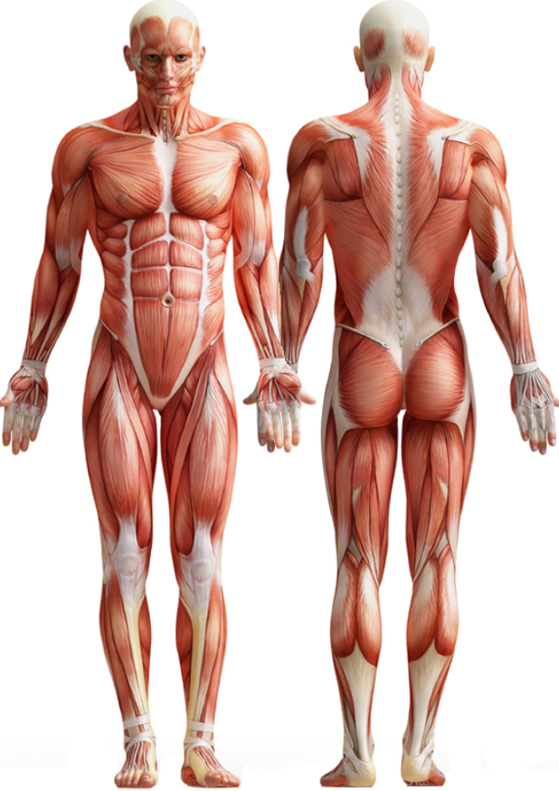

# Muscles and Their Functions

|  |  |
| --- | --- |
| **Muscle** | **Function** |
|  | flexes lower arm |
|  | abducts arm; injection site |
|  | flexes sole of feet |
|  | extends & adducts upper arm |
|  | adducts and flexes upper arm |
|  | moves ribs for breathing |
|  | extends head, moves shoulder |
|  | extends lower arm |
|  | extends thigh; injection site |
|  | compresses the abdomen |
|  | flexes thigh & extends lower leg |
|  | flexes and inverts foot |

# Muscular Disorder

_____________________

**Description:** Chronic, widespread pain in specific muscle site; numbness and tingling in arms or legs;

Often accompanied by fatigue as well as sleep, memory and mood issues

**Cause:** unknown

**Treatment:** Treat symptoms – pain relief; stress reduction and muscle relaxers

__________________________________________

**Description and cause:** Group of inherited diseases that cause chronic, progressive muscle atrophy resulting in total disability and early death

**Treatment:** No cure

Treatment used to slow progression of disease

__________________________________________

**Description:** Chronic condition where nerve impulses are not transmitted correctly leading to progressive muscular weakness and paralysis; affects respiratory muscles and can be fatal

**Cause:** could be antibodies attacking the receptors for acetylcholine; could also be antibodies blocking the function of certain proteins

**Treatment:** Medications to relieve symptoms

__________________________________________

**Description:** Sudden, painful involuntary muscle contractions

**Causes:** Caused from overexertion, low electrolytes or poor circulation

**Treatment:** Treat by applying gentle pressure and stretching of the affected muscle

_____________________

**Description:** Overstretching of a muscle or tendon frequently in legs, back or arms

**Cause:** Caused by sudden muscle exertion

**Treatment:** Treated by resting, muscle relaxants, or pain medications, elevation of extremity and applying hot/cold compresses

# Problems from Lack of Movement

* _____________________
  + Tightening and shortening of a muscle resulting in a permanent flexing of a joint
* __________________________________________
  + Muscles become weak and joints become stiff
* __________________________________________
  + Blood clots and pressure ulcers can develop
* __________________________________________
  + Especially calcium from the bones making bones brittle and easily to be fractured
* __________________________________________
  + Poor appetite; constipation; urinary infections; respiratory problems; and pneumonia

|  |
| --- |
| **Good Body Mechanics**   * Maintain broad base of support (8-10 in.) * Bend from hips and knees to get close to object * Use strongest muscles: shoulders, arms, hips, thighs * Use weight of body to help push/pull * Carry heavy objects close * Avoid twisting body; turn whole body when changing direction * Avoid bending for long periods * Get help if object is too heavy |