Notes: Heat and Temperature

Recall
One of the electrical functions in a circuit is:
- ______________________________________________________
  - E.g.: light bulbs, speakers, heating elements, etc.
Problem is ________________of the energy is usually _________________________ into the form we want
- Ex: when you turn on a light bulb _________________________of the ______________________________________________is transformed into __________________________________________________
- A lot of it is actually converted into ___________________________________________
  - In fact, with an incandescent light bulb, only about __________of the electrical energy ends up as light energy

Heat
Definition: is the amount of ____________________________________that is ___________________ from one place to another because of __________________________________________________.

What is the difference between heat and temperature?

Heat
Has 2 variables:
- __________________________________________________
  - Less _______________, means _________________________________
- Degree of _________________________ (in other words the _________________________) of particles
  - This is what _________________________ is!

Temperature
Definition: __________________________________________________of atoms/molecules
- High agitation = ____________________________________
- Low agitation = ____________________________________
Temperature is also generally used as a __________________________________________________
- Mass _________________________affect temperature
  - Big or small, 37°C is 37°C

Heat Transfer
- Cold energy _________________________exist
  - Cold is merely the __________________________________________________
- Heat is always transferred from areas of _______________________________________ ________________
  - So move from ____________________________________

Example:
Imagine you have 4 buckets; each with the same amount of water but at different temperatures
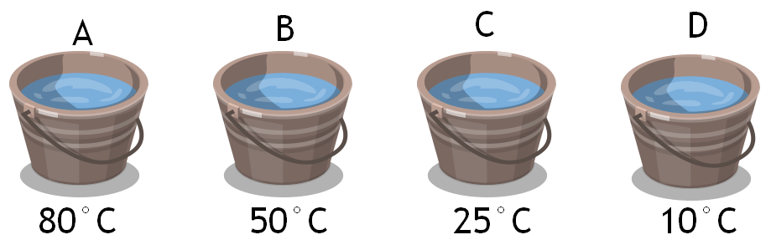
What would happen if you mixed buckets A and C together; and buckets B and D together?

Which buckets lost heat? Gained heat?

Recap
- Heat depends on:
  - _________________________
  - ________________________________________________________________________
- You ________________________________, but you measure the ________________________
- You __________________________________________________; only lose heat

