Notes: Current and Voltage

What is current?
Also sometimes referred to as ________________________________
- It’s a measure of the ____________________________________________________ (electrons)
- Basically counting the number of electrons that _______________________________ ___________________

Symbol for current (used in formulas): ____________
Unit (current is measured in …): ____________
Symbol used: ____________

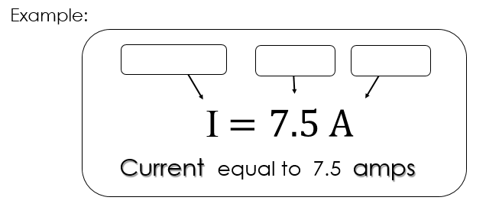
Often, electric currents are very small and therefore measured in __________________.
$$150 mA=_______ A$$

Alternating and Direct Current (AC and DC)

Direct Current
The electrons are transferred through the circuit always in the __________________ direction.
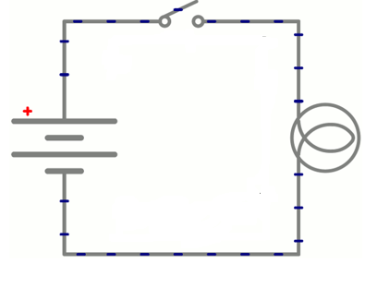

Alternating Current
The electrons __________________ (in a regular pattern) the __________________ in which they travel through the circuit.
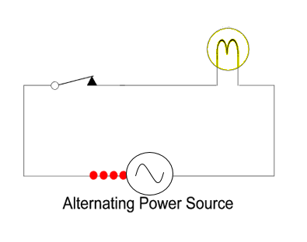
Device used to measure the amount of current travelling through any part of a circuit: __________________
Schematic (circuit diagram) symbol for an ammeter: __________________

Example
To measure the current, the ammeter must be installed into the circuit so that the electrons pass through it.

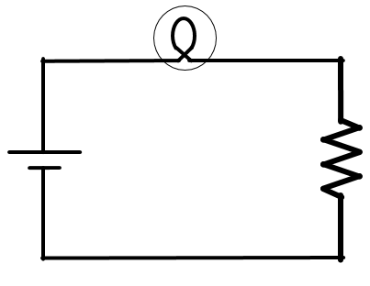

What is voltage?
Also often referred to as __________________________________
- A measure of the difference in electrical _________________________________ between two points, per unit electric charge.
  - It’s like measuring the _________________ that will push (and be carried by) the _________________ in a circuit.

Symbol for potential difference (used in formulas): _________________
Unit (voltage is measured in …): _________________
- Symbol used: _________________

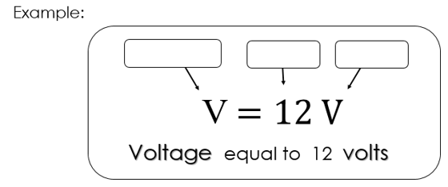
Sometimes, voltages are very high and therefore measured in kilovolts.
$$735 kV=__________ V$$

Grounding
In very basic terms, grounding is used as a means to ____________ you from electrical shock
- Imagine an appliance that has metal components
  - These would ____________ electricity if they somehow came into contact with it
  - So they are usually connected back to the ________________________ that will take those charges away and back to the electrical panel, tripping the ________________________and ____________ the flow of electricity

Device used to measure the potential difference (voltage) across any part of a circuit: ____________
Schematic (circuit diagram) symbol for a voltmeter: ____________

Example
- We wish to measure the potential difference across the resistor.
In order to measure the potential difference across a component, the voltmeter must be connected to each side of the component.

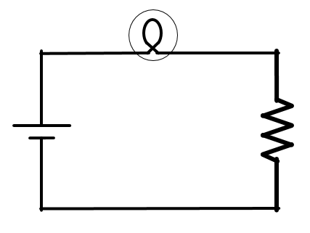
- If we wish to measure the potential difference across the light…

Summary
Variable | Definition | Symbol | Unit
Current Intensity
Potential Difference
Resistance

