Notes: Communities

Communities
- Definition:
  - A __________________________________________ of ____________________ ____________________that share the _________________________________.

Biodiversity
- Definition:
  - ____________________________________________living in a community.
- ______________________affect biodiversity:
  - ______________________of different species
  - ____________________________________________ (# of individuals of each species)
  - _______________ number of organisms
- To be diverse you must have: ____________________________________________, an ____________________________________________of each species and a __________________________________________________________________
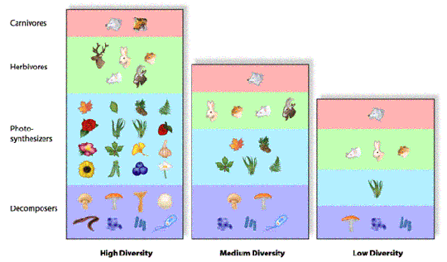

Calculating Biodiversity
- Things to calculate:
  - the ____________________________________________
  - the ____________________________________________of organisms
  - the ____________________________________________of each species
Calculating relative abundance:

Example:
Which ecosystem is more diverse?
Ecosystem A | Ecosystem B
15 chickadees | 21 chickadees
12 partridges | 17 partridges
8 bears | 0 bears
20 raccoons | 3 raccoons
11 hares | 6 hares

Interactions in a Community
- 4 types:
  - ______________________
  - ______________________
  - ______________________
  - ______________________

Competition
- Definition:
  - Organisms which seek the ____________________________________________in their habitat (ex. food, shelter, mates).

Predation
- Definition:
  - Relationship between 2 living organisms where __________________________ __________________
  - Parasitism: one organism ________________________________________________ and benefits, the other is ________________________________________________ __________________

Mutualism
- Definition:
  - ___________________________________________________ from relationship
    - ex: pollination.

Commensalism
- Definition:
  - one ____________________________________________, the other is ______________________ (neither harmed nor helped).
    - ex: taking over an old nest.

Review – Past Exam Question
- 1. Large number of yellow flowers are scattered unpredictably all over a field. What pattern is involved in this case?
A) Clumped
B) Random
C) Dense
D) Uniform

