Notes: Combustion

Combustion
A reaction that __________________ a large amount of _______________ in the form of ____________.
All combustion reactions are ______________________________
2C₈H₁₈ + 25 O₂ → 16CO₂ + 19H₂O + energy

Oxidation
A chemical change involving ______________.
  - Combustion is a form of ______________________!

How to recognize oxidation/combustion reactions
Look for the ____________________________________________________________
Other Oxidation/Combustion examples:
- _____________________________________________
- _____________________________________________

Combustion reactions
For combustion to occur, three requirements must occur:
- There exists an ______________________________
  - something to cause the fuel to burn – oxygen is the most common
- There exists _______________
  - what’s burning
- The ______________________________is surpassed
  - minimum temperature for fuel to ignite
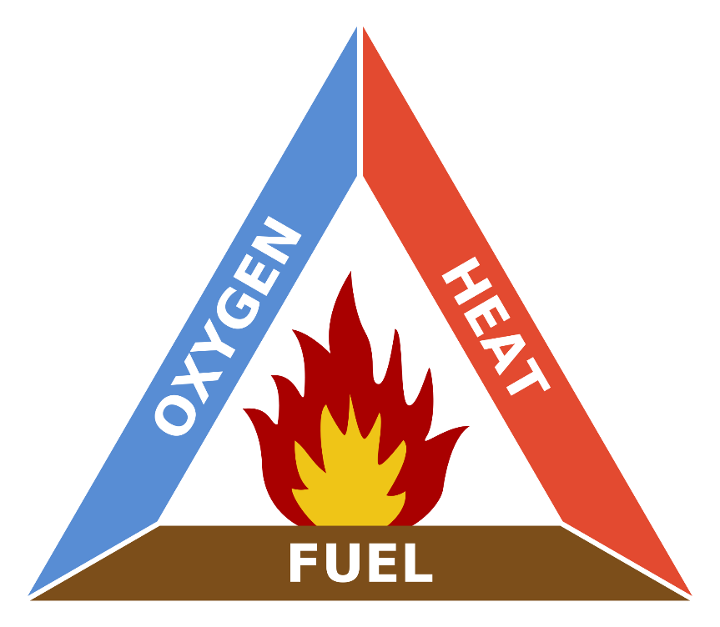

Categories of combustion reactions
Three categories
- _____________________________________: Occurs _______________ once ignition temperature is reached.
- _____________________________________: occurs _______________ since ignition temperature is reached _______________________________________________. Often unpredictable.
- _____________________________________: occurs over ________________________ _____________________; energy released is _______________.

Cellular Respiration
Form of _________________________, and therefore a type of __________________________
______________________________trapped in _______________ is released and used for bodily functions

Photosynthesis
_______________of ______________________________, therefore is an ______________________________
Solar energy is ___________________________________into chemical bonds, forming _______________ (in _______________)

Difference between cellular respiration and photosynthesis
Cellular respiration is the _______________ of photosynthesis
- Cellular respiration _______________ glucose, and ______________________________
Photosynthesis _______________ glucose, and ______________________________

Past Exam Question
A fire is extinguished by removing at least one of the three conditions required for combustion to occur. These conditions are indicated in the fire triangle below.
Table I -Functions of a CO₂ Extinguisher
 | Function
1 | The main function of the carbon dioxide (CO₂) is to smother the fire by reducing the amount of oxygen gas (O₂) that feeds it
2 | In the very early stages of a fire, the CO₂ has a cooling effect, since it comes out of the extinguisher at a temperature of -78°C.
3 | The gas comes out of the extinguisher as a powerful spray that puts out small paper fires by scattering the pieces of material involved.
State the part of the fire triangle each descriptor is referring to

