Motion Transmission and Transformation Worksheet
- Answer the questions below.
a) We are the two directions of rotational motion.
b) We are motion transmission systems with at least one gear.
c) I am a motion transmission system that cannot be reversible.
d) I am a system for which the gear teeth, the gear type and the number of teeth in each gear must be considered when I am being built.
e) I am a system in which some of my components must contain a smooth groove.

- Complete each figure below, indicating:
i) the directions in which the driver and driven components of the system rotate.
ii) the name of the motion transmission system illustrated.

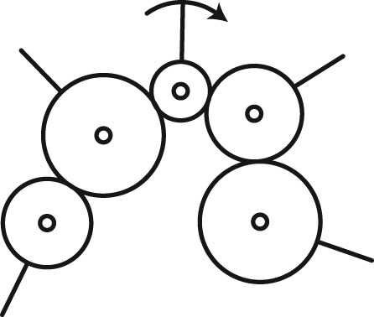
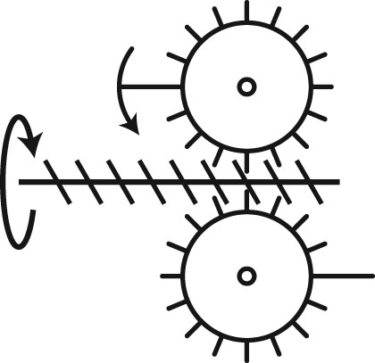
- For each of the following statements, determine whether there is an increase, decrease or no change in speed during motion transmission.
a) Motion is transmitted from a friction gear two centimetres in diameter to a friction gear three centimetres in diameter.
b) In a gear train, the motion of a gear with eight teeth is transmitted to a gear with six teeth.
c) In a gear train, the motion of a gear five centimetres in diameter is transmitted to a gear four centimetres in diameter.

- Look at the three motion transmission systems below.
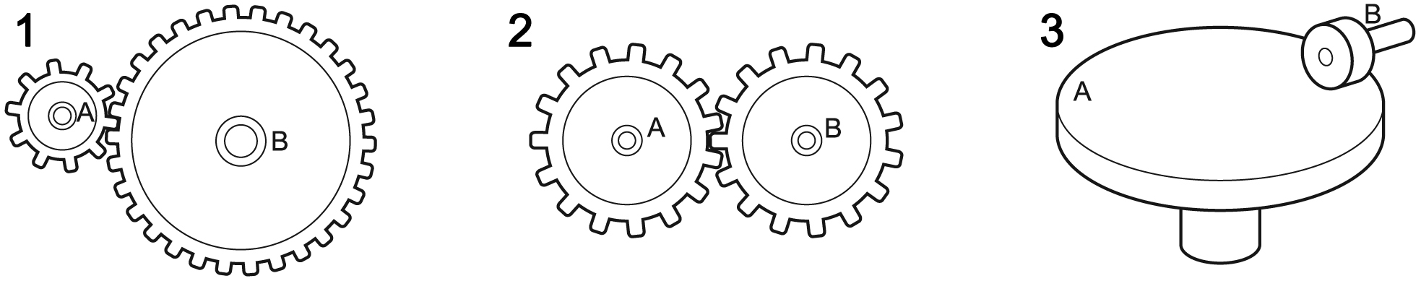
a) In which of these three systems will there be an increase in speed when motion is transmitted from component A to component B? Explain your answer.
b) In which of these three systems will there be a decrease in speed when motion is transmitted from component A to component B? Explain your answer.

- Identify the type of motion transformation system described by the following statements. In the case of screw gear systems, specify the type.
a) These systems usually require a device such as a return spring.
b) To turn the wheels of a car with the help of a crankshaft, we use this type of motion transformation system.
c) This type of system is often found in jacks for lifting cars.
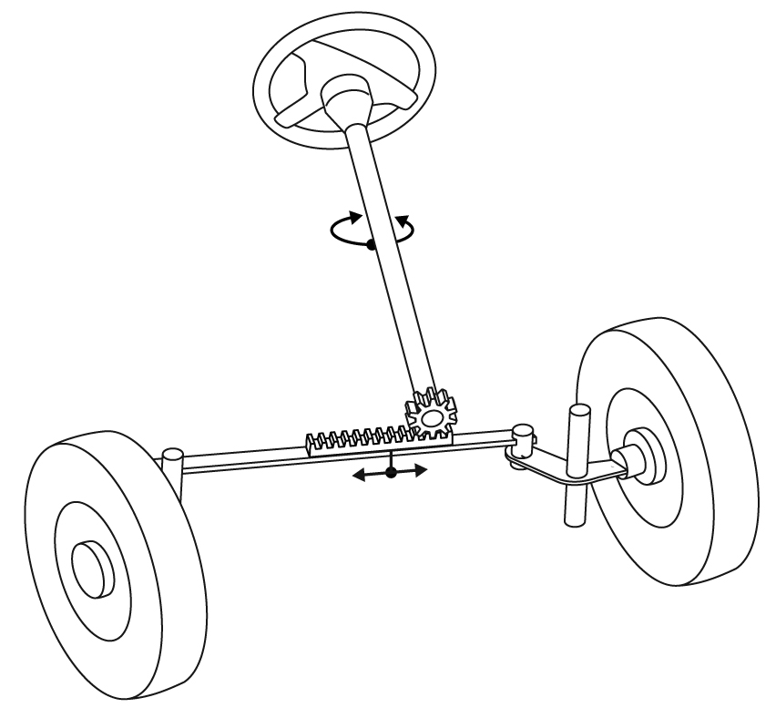
d) This type of system is often found in automobile steering systems, such as the one illustrated below.

- For a study on motion transmission, you have been asked to provide information on the main systems that perform this mechanical function. For each diagram below:
a) Name the motion transmission system.
b) Write “yes” or “no” regarding the possibility of reversibility.
c) Complete the diagram by indicating the direction of rotation of each of the driver and driven components in the system.

A
Name of the system:
Possibility of reversibility:
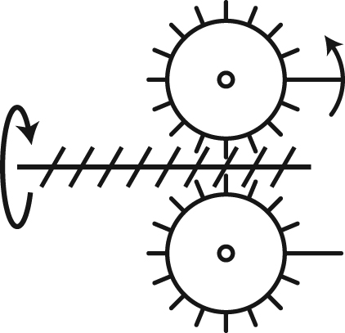
B
Name of the system:
Possibility of reversibility:
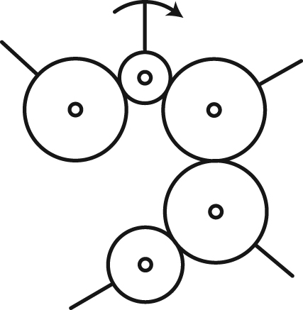
C
Name of the system:
Possibility of reversibility:
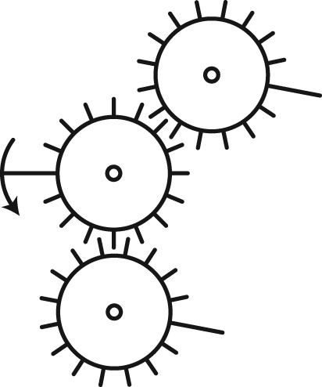
D
Name of the system:
Possibility of reversibility:
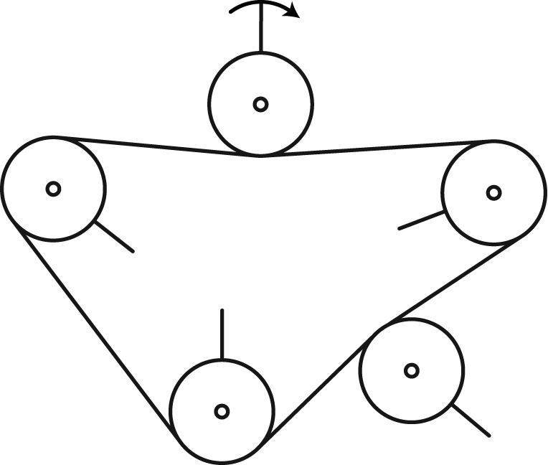

- One characteristic an engineer may look for in the design of a technical object is a significant change in rotational speed between the parts. The two systems below have been proposed to meet this purpose.
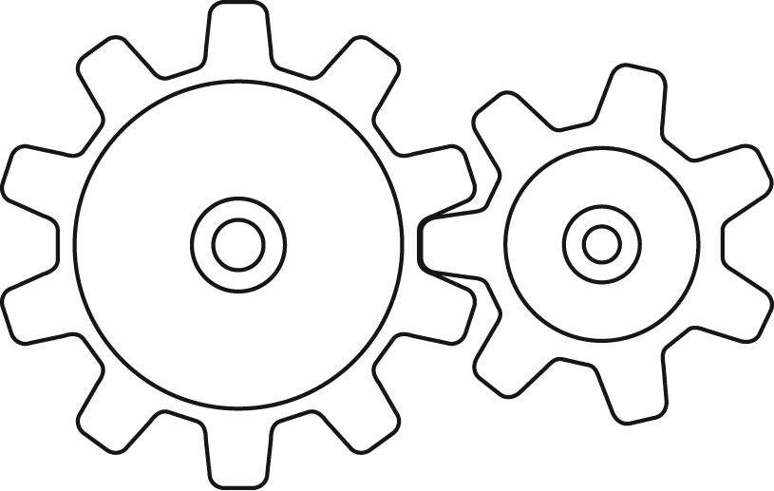
System 1 System 2

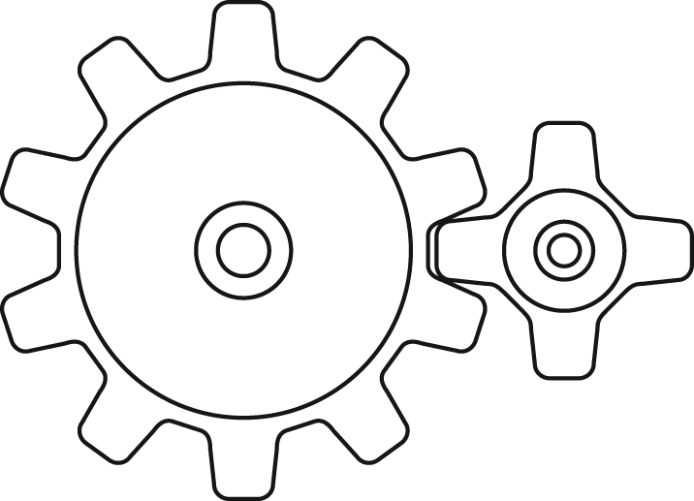
a) Which type of motion transmission systems are they?
b) In which system is the change in rotational speed between the gears greater? Explain your answer.

- Antonia is asked to build a gear train using two of the gears illustrated below.
B
A
C
a) Which gears should she choose for her system?
b) Which characteristic of the gears would motivate her choice?

- Look at the motion transformation system opposite.
a) What is this type of motion transformation system 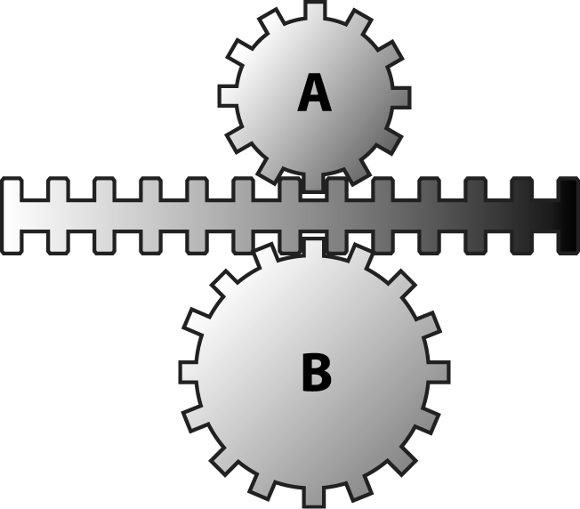
called?
b) Which of the two gears will turn faster? Explain
your answer.

- Which of the following diagrams of a motion transmission system correctly illustrates the motion of the components?

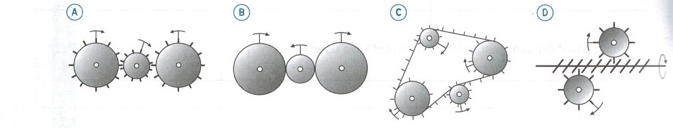
A) A and C B) B and C C) C and D D) B, C and D

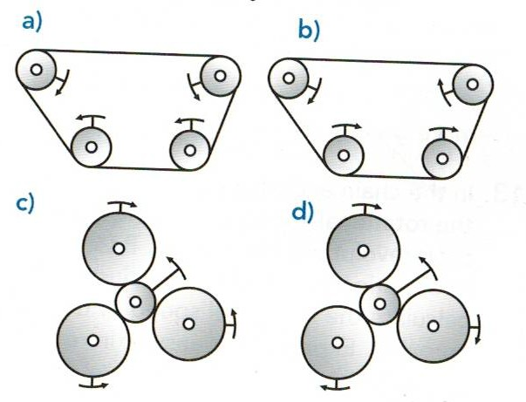
- Which of the following diagrams of a motion transmission system correctly illustrates the motion of the components?

- A and B B) B and C C) B and D D) A and C
- A tensioner is used to tighten the wire or rope
of a clothesline, as in the illustration opposite.
Which type of motion transformation system is
at work here?

- Explain why a sprocket wheel and chain system is used in a bicycle rather than a belt and pulley system.

- Look at the motion transformation systems below.

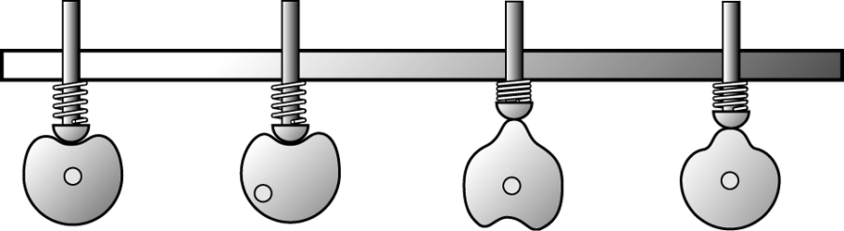
D
C
B
A
a) What are these motion transformation systems called?
b) What does the spring do in these systems?

- A cam and follower system transforms the rotational motion of a cam into the reciprocating translational motion of a follower. Which cam below would not allow for both clockwise and counter-clockwise motion?

A) B) C) D)

- A student wishes to build a pull toy of a clown sitting in a cart in which a mechanism will cause the hat of the clown to move up and down as the cart is pulled. Which one of the systems below would not be suitable for a mechanism in this toy?
A) Crank and slide C) Cam and follower
B) Rack and pinion D) Crank, connecting rod, and slide

- Examine the cam and follower system illustrated below.
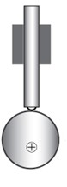

Describe two ways the rise of the follower could be increased
- A wheel and worm gear system is shown below.
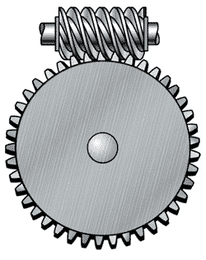
Given a constant speed of the driver (worm), what changes can be made to the components of the system to increase the speed of the driven gear?

- Look at the two worm and worm gear systems opposite. In which system will the rotational speed be more greatly reduced? Explain your answer
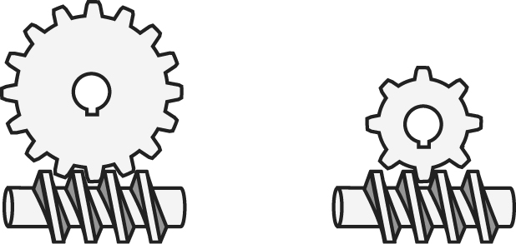

- The mechanism illustrated below moves a paper flower in and out of a container.
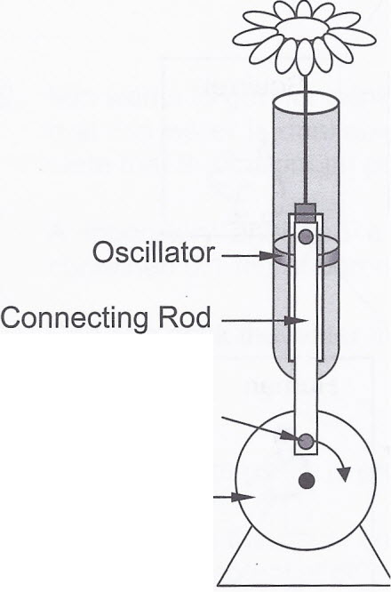
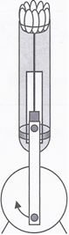
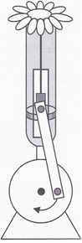

a- Is this a motion transmission or motion transformation mechanism?
b- Is the system reversible?
c- From the list of changes suggested below, choose the combination of two changes that should be made to the mechanism so that the flower can come further out of the container.
Change 1- Increase the diameter of the crank.
Change 2- Decrease the diameter of the crank.
Change 3- Move the connecting rod pivot away from the center of the crank.
Change 4- Move the connecting rod pivot closer to the center of the crank.

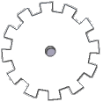
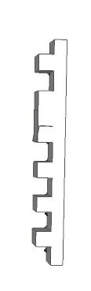
- Consider the following system. It shows a rack that controls the rotational motion of 3 gears.
A B C

If the rack translates upwards, what direction would gears A, B and C turn? (CW or CCW)

