Notes: Mechanics of Breathing

Inhalation
- Inhalation:
  - _____________________________ muscles contract
    - Ribs go _______________________
  - _______________________ contracts
    - Diaphragm goes _______________________
  - _______________________ of lungs _______________________
    - _______________________ inside lungs _______________________
  - Air rushes ______
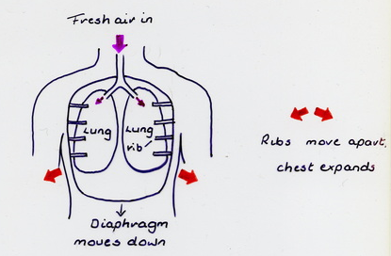

Exhalation
  - _______________________ muscles _______________________
    - Ribs go _____________________________
  - _______________________ relaxes
    - Diaphragm goes ________
  - _______________________of lungs _______________________
    - _______________________inside lungs _______________________
  - Air rushes ____________
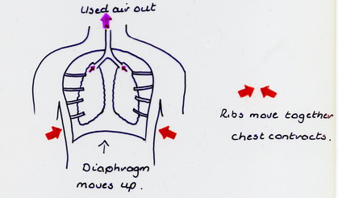

Diffusion
- During diffusion:
  - _______________________moves ____________ the blood and _____________________________ moves _____________ of the blood.
- The blood then carries the oxygen to the cells
  - _______________________ moves ____________of the blood (into the cells) and ______________________________________________ moves ______________the blood (out of the cells).
    - _________________________________is brought back to the _________________

Composition of Air
- The air we _______________________is a mixture of gases:
  - Nitrogen (N) 78%
  - Oxygen (O₂) 21%
  - Carbon Dioxide 0.04%
  - Other gases < 1%
- The air we _______________________is also a mixture of gases:
  - Nitrogen 78%
  - Oxygen 16%
  - Carbon Dioxide 5%
  - Other <1%

Why don’t the concentration of nitrogen and “other” gases change?
______________________________________________

