Notes: Organization of Matter
Atom
  - __________________________________________________________________________________________________________________________________________
Element
  - Substance made from __________________________________________________
Molecule
  - A ___________________of atoms that are _________________________________ __________________________
Compound
  - A ___________________formed by combining ___________________________ __________________________ _______________________
Pure substance
  - A substance made of ___________________________________________________ ______________________________________
    - Only ____________________________of particle
Mixture
  - Two or more substances that are ______________________________________
Heterogeneous mixture
  - A mixture where you can ______________________________________the ______________________________________
Homogeneous mixture
  - A mixture of substance that ______________________________________
  - You ___________________ see the ____________________________________ ________ _____________

Solution
  - A ______________________________________where the parts ______________ ___ _______ _________________________________ from each other even under magnification
Colloid
  - A ______________________________________where the parts cannot be distinguished from each other to the ______________________________________
  - But the particles _______________________________________________________ ____________________________________________

Characteristic vs Non-Characteristic Properties
- When identifying an unknown substance in the lab, we are dependent on the ___________ ___________________________
- We look at the ______________________________________of the substance and use all of the information collected as ___________________ in order to identify what it could be
  - These properties can be _________________________________________________ ___________________________________

Characteristic
- A property that is ____________________________________________________________
  - ______________________________________shares this property
  - Examples:
    - ___________________
    - ___________________
    - ___________________
    - ___________________

Non-characteristic
- A chemical or physical property that _____________________________________________ __________________________________________
  - Examples:

    - ___________________
    - ___________________
    - ___________________
    - ___________________
    - ___________________
    - ___________________
    - ___________________
    - ___________________
    - ___________________

- Although non-characteristic properties can be shared by many different substances, they can still be useful in helping to identify an unknown
  - Different substances will ______________________________________________ ______________________________
  - Some non-characteristic properties can be used to determine a _______________ _________________________ (volume & mass are used to calculate density)

Testing for Identification

Electrical Conductivity
- How: ____________________________________________
- Possible outcomes:
  - ________________________ = Substance ________________________! Keep in mind that some substances are better conductors than others

Presence of Water
- How: ________________________________________________
- Possible outcomes:
  - _______________________________________= There’s ____________________ present in the solution!
  - __________________________________= ________________________________

Acid. Base & Neutral
- How: ________________________________________________
- Possible outcomes:
  - ________________________________________________________________________
  - ________________________________________________________________________
  - ________________________________________________________________________

Presence of Glucose
- How: ________________________________________________
- Possible outcomes:
  - Stays ________________________= _________________________________________
  - Turns ________________________ = ________________________ is present in the solution

Presence of a Protein
- How: ________________________________________________ (protein test solution)
- Possible outcomes:
  - Turns ________________________ = ______________________________________
  - Turns ________________________ = _____________________________________ in the solution

Presence of a Fat
- How: ________________________________________________
- Possible outcomes:
  - Stays ________________________ = ________________________
  - Turns ________________________________________________ = ________________________________________________in the solution

Presence of Hydrogen Gas
- How: ________________________________________________
- Possible outcomes:
  - A ____________________________________= ________________________________ is present

Presence of Oxygen Gas
- How: ____________________________
- Possible outcomes:
  - The splint ______________ = ____________________________ is present
  - The splint ______________________ = ____________________________is present

Presence of Carbon Dioxide Gas
- How: ____________________________
- Possible outcomes:
  - Limewater stays __________________________________________
= __________________________________________is present
  - Limewater becomes ____________________________
= __________________________________________is present

Physical vs Chemical Changes

Physical Changes
- Affects the _____________________of a chemical substance, but _______________________ ____________________________________________________
- You can ______________________________________________________________________ such as melting, cooling, bending, stretching and other means
- Also includes __________________________________________
- Phase changes:
  - Gas to liquid _____________________
  - Liquid to gas _____________________
  - Gas to solid _____________________
  - Solid to gas _____________________
  - Liquid to solid _____________________
  - Solid to liquid _____________________

Chemical Changes
______________________________the entire ______________________________________________ of the substance
What are some signs of a chemical change?
1. _____________________ (formation of a solid)
2. __________________________________________ (bubbles without heating)
3. __________________________________________
4. __________________________________________
5. __________________________________________

Types of chemical changes
- Chemical changes involve __________________________________________
  - We represent these in the form of _____________________
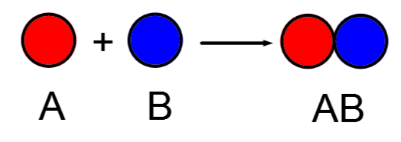
- The substances on the left are the _____________________, and on the right are the _____________________

- There are several different types of chemical reactions:
  - __________________________________________
  - __________________________________________
  - __________________________________________
  - __________________________________________

Synthesis Reactions
- When _________________________________________________________________________ ________________________________________________________________

Decomposition Reactions
- When a _______________________________________________________________ into two or more substances
  - Basically the ____________________________________________________________

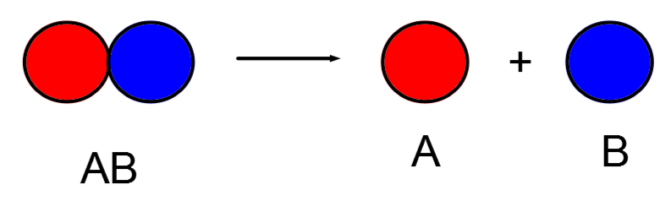
Oxidation Reactions
- Any reaction where _____________________________________________________________
Precipitation Reactions
- When __________________________________________are combined to form a new _____________________ _____________________________________________________that is _____________________ in the solution
  - Insoluble: __________________________________________

