Lymphatic System

What is it?
- We talked about how the circulatory system ______________________________________with the cells
- Well this exchange is not direct, it actually happens in the fluid around the cells called ________________________ or ________________________________________________
- It is this fluid that is the basis of the ________________________________________________
- The lymphatic system works with the ______________________________________________
  - The two systems are ______________________________________________
- The lymphatic system is composed of _______________________________________________ that carry a clear fluid called _______________ around _______________________

What is lymph?
- Lymph is just ______________________________________that is now being carried in the vessels of the lymphatic system
  - This fluid contains:
    - ___________________
    - ______________________________________
    - ______________________________________
When the fluid is just outside the cells = ________________________________________________
When the fluid is inside the vessels = ________________________________________________

Functions
1) ______________________
  - Extra plasma that has ______________________________________________and is in the ___________________________________may need to be returned to the blood and this can be done through the lymphatic system (_______________________)
    - Lymph vessels carry lymph in pretty much the same way that veins carry blood – using ___________________________________________in the legs and arms

Capillaries have ______________________________________________in them that allow the blood plasma and ______________________________________________to leak out into the ______________________________________________spaces

This is also how substances get _______________________ between the _______________________and the _______________________

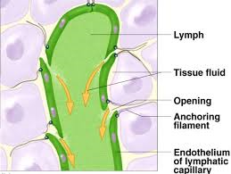
Plasma Uptake
- _______________________ are specialized capillaries:
  - They have dead ends that ______________________________________________

2) ________________________________
  - Lymph is very similar to blood plasma
  - Contains:
______________________________________________
_______________________
______________________________________________
_______________________
_______________________
Lymph Nodes
- What do they do?
  - ________________________________along the lymphatic system
  - ________________ and ________________ the lymph
  - ________________________________________________to fight viruses and other infections (immune defense)
- Located in:
  - groin, neck, armpit, tonsils, thymus, spleen, and wall of the intestine

- Normally you _______________________________________your lymph nodes but when you’re ______________ they can get _______________
- This is because they are working overtime to _____________________cells to fight the infection
Swollen lymph nodes = _______________________

How do white blood cells fight infection?

- Eat bacteria/virus in process called _______________________
- Produce _________________________

Remember: Lymphatic and circulatory systems work together!

Vaccines

What are vaccines?
- Vaccines usually contain an agent that resembles the disease – often made from _______________________ ________ forms of that microbe
- Provide __________ _____________to a __________ _____________
  - _____________ because there are _____________ _____________ for an attack
  - _____________because you _____________ _______ with it, you _____________it via the _____________

How do vaccines work?
- When the vaccine is _____________into the body it triggers the body’s _____________ _____________
- The immune system will recognize the vaccine as a threat and __________________to destroy it
  - This means the next time the body sees this type of threat it will be able to very ________________________________________________________________ because it already has the antibodies or at least knows how to make them.
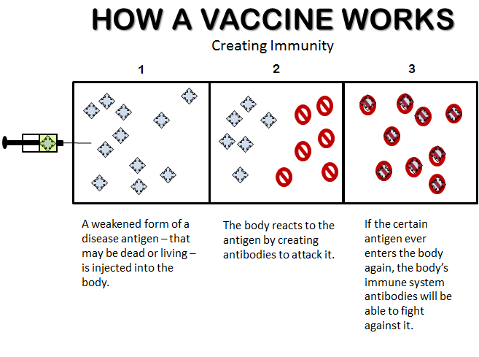

Circulatory System vs Lymphatic System
Topic | Circulatory System | Lymphatic System
What is the function of the system? | Moves ________________  Collects and distributes ___________, ________________ and ________________.  Regulates ____________________. | Collects and transports _____________ ___________________generated by the tissues into the circulatory system.
How does the fluid flow around the system? | Flows in a ______________________ _____________________________ through arteries, capillaries & veins.  Blood is pumped by the ___________.  __________________________________ assist in movement.  _________________ prevent backflow in veins | Flows in an ______________________ from tissues into ______________________________to be deposited into __________________________.  Lymph is ______________________________.  ______________________________assist movement.  _______________prevent backflow in larger lymphatic vessels.
What is the fluid made of? | Plasma  - White blood cells  - Red blood cells  - Platelets  - Nutrients  - Hormones  - Some wastes  - Oxygen | Lymph  - White blood cells  - Many wastes  - Carbon dioxide
How is the fluid filtered? | Blood is filtered by the _______________________.  Nephrons in the ________________ remove wastes and excess water as urine________________.  ________________________________is removed in the ________________. | ___________________________remove some fluid and debris.  ____________________________________________clustered in these nodes also ________________________________and some cancer cells.

