Lithosphere and Hydrosphere Worksheet

- A student is trying to determine which mineral is most hard. He scratches the three minerals, Quartz, Feldspar and Apatite and sees the following results :
- Quartz scratched Apatite
- Quartz scratched Feldspar
- Apatite did not scratch quartz
- Apatite did not scratch Feldspar
- Feldspar scratched Apatite
- Feldspar did not scratch Quartz
Which of the three minerals is the hardest?

- At first glance, pyrite looks very much like gold. What tests could you conduct to try and distinguish one mineral from the other?

- What is the difference between a rock and a mineral?

- A teacher takes an enormous rock from her garden and shatters it into small pieces. She gives each of her students a piece, and they must analyze its hardness, colour and streak. Will all the students obtain different results? Explain your answer.

- Read the statements below and classify them as igneous, sedimentary or metamorphic rocks.
- Transformed rock due to heat and pressure
- Rock with accumulated debris
- Occurs in or outside a volcano

- Name each layer of soil and give a characteristics of each.
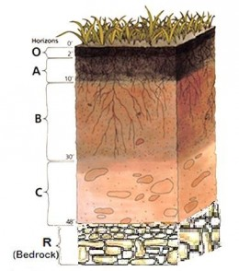

- Explain how soil is produced.

- Some regions of Québec are known for being very fertile, while others are much less fertile even though they are exposed to the same climate. What are the three conditions for soil fertility?

- Which of the following is a consequence of melting permafrost?
A) Increased primary productivity C) Decreased levels of greenhouse gases
B) Decreased erosion D) Decreased decomposition of organic
matter in soil

- Which of the following does not affect the flow of water into a catchment area?
A) Depth and latitude of the water reservoir C) Shape and slope of the terrain
B) Industrial and urban development D) Density and diversity of the vegetation

- From the statements below, choose two which will cause an increase in the salinity of ocean water.
1. increased erosion
2. ocean water redirected to a tidal energy plant
3. ice floes and glaciers melt
4. water evaporates at the equator
A) 1 and 3 B) 1 and 4 C) 2 and 3 D) 2 and 4
- Different factors can affect the circulation of surface currents and deep currents in the ocean.
1. Temperature differences in the water
2. Air pressure differences in the atmosphere
3. Differences in the waters’ salinity
4. The rotation of the Earth
5. The depth of the water
Which of the factors above only effect surface currents?
A) 1 and 3 only B) 2 and 4 only C) 1, 3 and 5 D) 2, 4 and 5

- What are the characteristics of ocean water which has a tendency to sink?
A) Low temperature and low density C) Low temperature and high density
B) High temperature and low density D) High temperature and high density

- Which of the following is true about glaciers and pack ice?
A) Both glaciers and pack ice are formed on land.
B) Both glaciers and pack ice are formed on the ocean’s surface.
C) Both glaciers and pack ice contain freshwater.
D) Both glaciers and pack ice form icebergs.

- How does the melting of permafrost lead to higher average global temperatures?

- Global temperatures have been increasing at a steady rate. Ecologists have been hired to study the impact of increasing temperature s on a region in Northern Quebec. Which graph below correctly shows the consequence of a rise of temperature in the region? Explain your answer.
Graph A Graph B

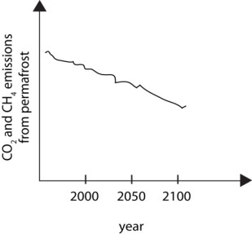
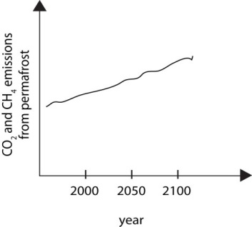

- Describe what a catchment area is.
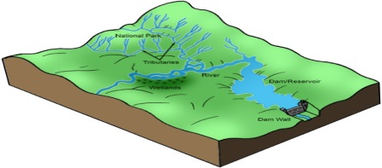

- The diagram below shows four different locations (1,2,3 and 4) and the site of a toxic spill identified by the letter X.
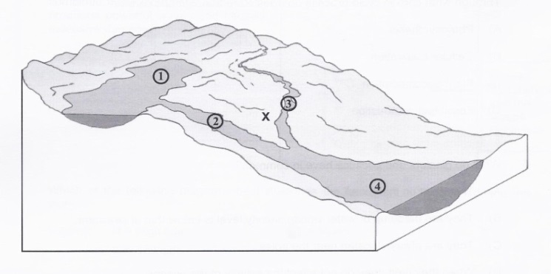
Which statement about the impact of the toxic spill is TRUE?
- Location 1 will be the most affected, since the flow of water will carry the toxic substance into the lake.
- Location 2 will be only slightly affected, since the current will prevent the toxic substance from accumulating.
- Because of the terrain, only location 3 will be affected.
- Location 4 will be affected the most, since it is downstream from the spill.
- What is the cryosphere?

- Label the pictures below as an iceberg, ice floe or glacier.
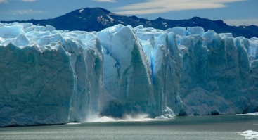 | 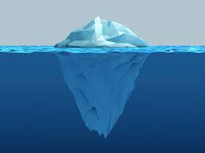 | 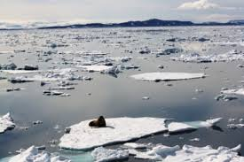

- What is a some negative impact of icebergs being produced?

- For each statement state whether it is an example of a surface current or a subsurface current.
a- these currents are altered by density and salinity
b- these currents are mostly controlled by wind
dc these currents will allow cause you to swim off course in the ocean

- What is the name of the circulation below and describe how it works?
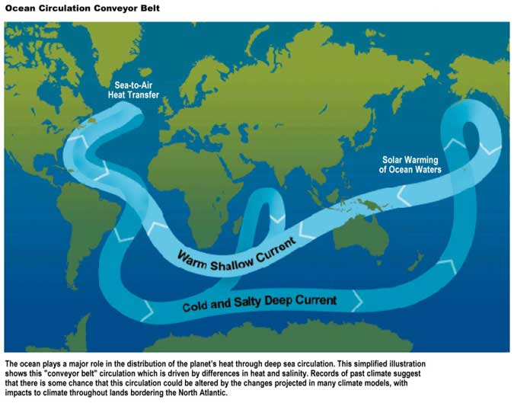

- Explain how the warming of the water in the poles will affect thermohaline circulation.

- Cruise ships regularly offer tours along the shores of Greenland. Tourists can observe the spectacular blocks of ice that break off from the coast and fall into the sea.
- What are these blocks of ice called?
- A few fragments of ice melt in the seawater. This water does not stay near the coast; it moves about. What factors will affect its movement?

- Will the meltwater eventually arrive at the equator? Explain your answer.

