**Links, Guides, Systems, Constraints and Materials Pretest**

* + - 1. The diagram below shows the motion transmission system in a technical object.

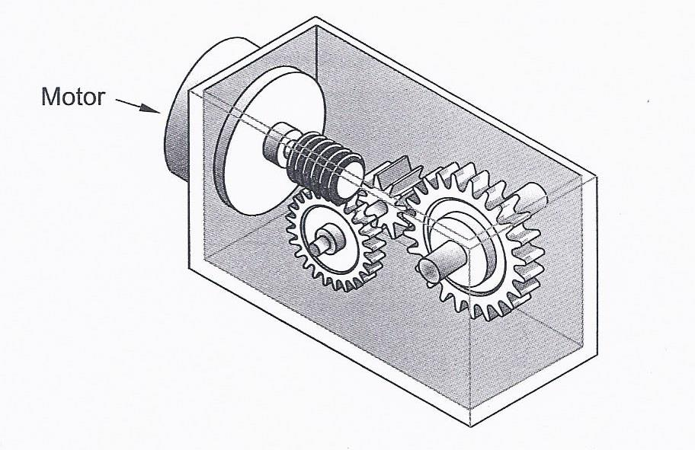

The 4 possible characteristics of this type of system are listed below.

1- It increases speed 3- It is reversible

2- It decreases speed 4- It is irreversible

Which combination of characteristics explains why this mechanical system was chosen?

A) 1 and 3 B) 1 and 4 C) 2 and 3 D) 2 and 4

* + - 1. Different methods of protecting certain materials are listed below.

Protection methods

|  |  |
| --- | --- |
| 1 | Zinc coating |
| 2 | Oil treatment |
| 3 | High temperature treatment |
| 4 | Soaking in an acidic solution |

Which are the two appropriate methods for protecting a piece of iron from oxidation (rust)?

A) 1 and 2 B) 1 and 4 C) 2 and 3 D) 3 and 4

* + - 1. Which statement correctly explains the driver, driven and intermediate?

1. The driver initiates the motion, the driven receives the motion and the intermediate is in between the driver and the driven.
2. The driver receives the motion, the driven initiates the motion and the intermediate is in between the driven and the driven.
3. The driver initiates the motion, the intermediate receives the motion and the driven is in between the driver and the intermediate.
4. The driver receives the motion, the driven initiates the motion and the intermediate comes after the driven.
   * + 1. During a violent storm, the windows of the “Three Little Pigs” boutique were broken by flying debris, nearly injuring its customers. As a result, the owners want to replace the glass in their windows with a transparent material that is more resistant. What mechanical properties must the transparent material have?

A) Elasticity and hardness C) Resilience and hardness

B) Elasticity and malleability D) Resilience and malleability

* + - 1. What is the motion transmission system and the motion transformation system shown below?

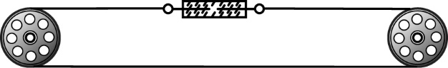

|  |  |  |
| --- | --- | --- |
|  | Transmission | Transformation |
| A | Belt and pulley | Rack and pinion |
| B | Belt and pulley | Screw gear |
| C | Screw gear | Worm and worm gear |
| D | Rack and pinion | Screw gear |

* + - 1. A washing machine contains many parts that may break down over time. From the choices below, explain which would be the best system to attach the back cover of the machine to the body of the washing machine to permit access for repairs.

A) rivet B) glue (adhesive) C) screw D) nail

* + - 1. The diagram below shows a motion transmission system consisting of three gears. Gear B is the driver.



Which of the following indicates the speed ratio between gears A and B and the number of teeth gear C should have so that speed ratio between gears B and C is 1/3?

1. The speed ratio between gears A and B is 0.25, and gear C should have 4 teeth
2. The speed ratio between gears A and B is 0.25, and gear C should have 36 teeth
3. The speed ratio between gears A and B is 4, and gear C should have 4 teeth
4. The speed ratio between gears A and B is 4, and gear C should have 36 teeth
   * + 1. Look at the three motion transmission systems below.

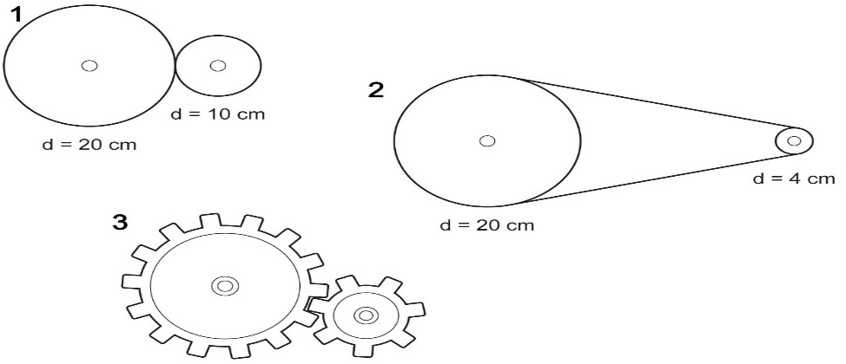

In which of these three systems does the biggest speed change occur?

1. System 1 because the diameter difference between the driver and the driven is greater than system 2 and 3.
2. System 2 because the diameter difference between the driver and the driven is greater than system 1 and 3.
3. System 3 because the diameter difference between the driver and the driven is lesser than system 1 and 2.
4. System 1 and 3 because the diameter difference between the driver and the driven is lesser than system 2.
   * + 1. What mechanical constraint is illustrated below?

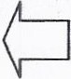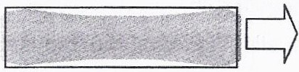

1. Compression B) Deflection C) Torsion D) Tension
   * + 1. The following diagrams show different playground activities, for each item of playground, the arrow indicates where something is subjected to a constraint.

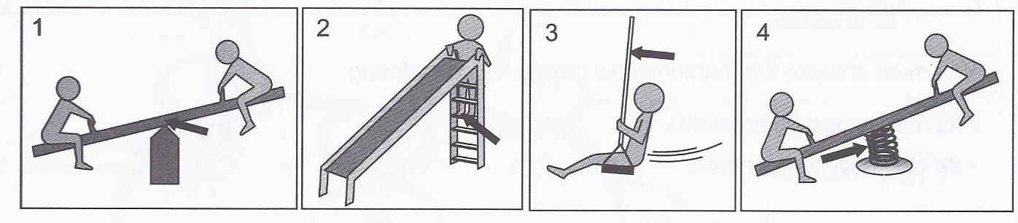

Which diagram shows tension being exerted?

A) Diagram 1 B) Diagram 2 C) Diagram 3 D) Diagram 4

* + - 1. Give the links for Part A and Part B which is attached with a rivet.

[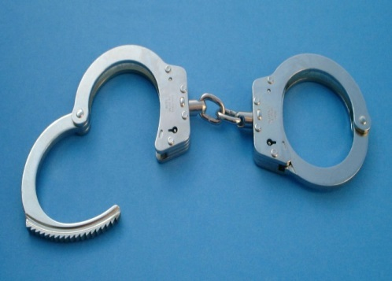](https://www.google.ca/url?sa=i&rct=j&q=&esrc=s&source=images&cd=&cad=rja&uact=8&ved=0ahUKEwjH4c6o_Z3MAhXDeD4KHekJA3QQjRwIBw&url=https://en.wikipedia.org/wiki/Handcuffs&bvm=bv.119745492,d.cWw&psig=AFQjCNFmmzPVZC1b4F7KYbzGWByGwvngmg&ust=1461267900363851)

Part B

Part A

* + - 1. Name each system below and state whether they perform a transmission system or transformation system.



* + - 1. Identify the type of guide in the pictures provided and determine what controls the movement.

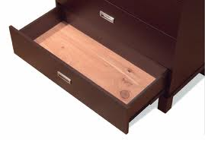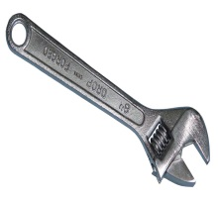

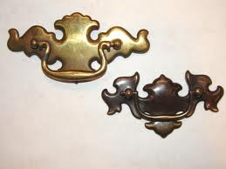

* + - 1. An electric motor spins a 16-tooth gear in a clockwise fashion at the rate of 12 rotations per second.



You are working on a project and need to reduce the overall speed to 8 rotations per second clockwise. Four different gears are available: A, B, C, and D.

|  |  |  |  |
| --- | --- | --- | --- |
| **Gear A**  **8-tooth gear** | **Gear B**  **16-tooth gear** | **Gear C**  **24-tooth gear** | **Gear D**  **32-tooth gear** |
|  |  |  |  |

Describe how you would add gears to the motor gear in order to create an overall clockwise motion of 8 rotations per second.

Indicate the order in which the gears must be added, the direction of motion of each gear (clockwise or counter-clockwise) and the number of teeth on each gear.

Justify your answer with calculations.

* + - 1. Match the constraint with its description with its example

|  |  |  |  |
| --- | --- | --- | --- |
| Constraint | **Description** | **Example** | **Draw symbol** |
| 1. Compression |  |  |  |
| 1. Tension |  |  |  |
| 1. Torsion |  |  |  |
| 1. Deflection |  |  |  |
| 1. Shearing |  |  |  |

* + - 1. What is the difference between thermoplastic and thermosetting?
      2. Gymnastics equipment is subjected to many constraints. Name each constraint for the following pictures.

A B C

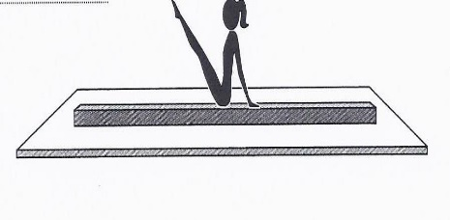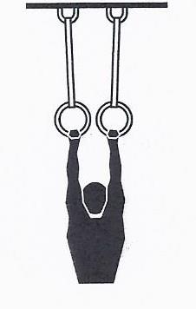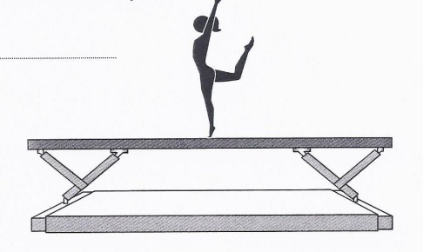

* + - 1. Below is a picture of a C clamp. If the Tommy bar rotates clockwise the Swivel shoe moves towards Part A of the frame.

Flat head

[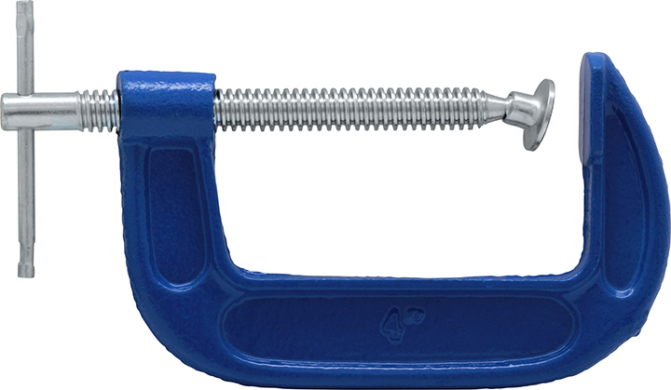](http://www.google.ca/url?sa=i&rct=j&q=&esrc=s&source=images&cd=&cad=rja&uact=8&ved=0ahUKEwjShO-M-KzMAhXMcj4KHUKhBmsQjRwIBw&url=http://www.princessauto.com/en/detail/4-in-c-clamp/A-p2910511e&psig=AFQjCNFCRfsIoRuPf_BkGkn_i_QY6xLLqg&ust=1461781850012917)

Part A

Tommy bar

Swivel shoe

Internal thread

External thread

Frame

1. Specify what **acts** as a guiding control for the Swivel shoe as it rotates to Part A.
2. Indicate the **type** of guiding involved.
   * + 1. A toy is represented in the diagram below. This toy is a box containing a cam that can move a cat in and out of the box through the rotation of a crank.

Sequence for one rotation of the crank

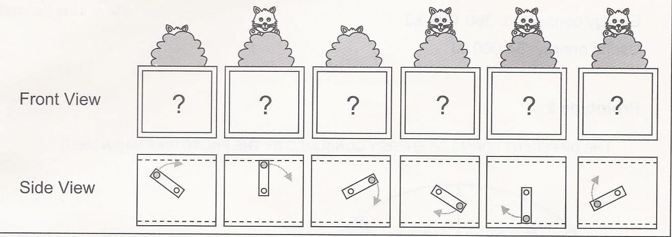

The designers want the toy to work as follows:

- The cat must move in and out of the box twice with each rotation of the crank and remain out longer the second time.

- The cat’s head must come out as far out of the box as possible.

Which one of the cams below will make the toy move according to the designer’s specifications? Justify your answer.

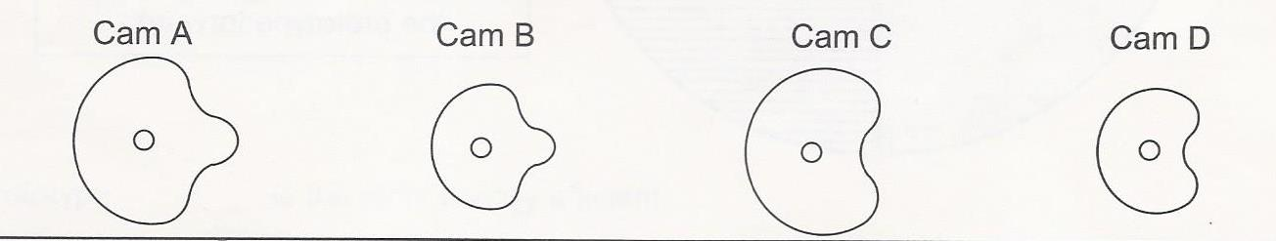

Use the appendix on last page to answer questions 20-22

* + - 1. To move appropriately, subassembly B represented below needs a guiding control. Which part acts as the guiding control for this subassembly and what type of guiding is involved?



* + - 1. a- To what constraint are the two ends of the clip subjected when the memo holder is opened?

b- The following are mechanical properties of materials.

- Hardness - Elasticity - Malleability - Stiffness - Resilience

What mechanical property must the clip have so that it can be subjected to this constraint when the memo holder is used? Explain why.



* + - 1. Circle the links for each part.



