Hydrosphere Worksheet

      - The average salinity of the ocean is 35 g/L, but may vary from one area to another depending on certain conditions. The following table lists observations regarding four different areas of an ocean.
Area | Observation
1 | Area that receives water from a melting coastal glacier
2 | Tropical area with strong surface winds
3 | Area with a large amount of water is lost through evaporation
4 | Arctic area where pack ice is formed
Which area of this ocean has the lowest salinity level?
A) Area 1 B) Area 2 C) Area 3 D Area 4

      - The following map illustrates part of the thermohaline circulation of the Atlantic Ocean. The map shows the path of the Gulf Stream, which is a surface current that flows from the east coast of North America toward northern Europe.
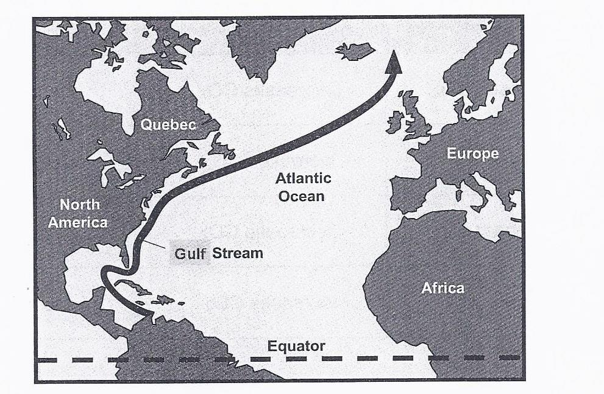
The following four statements refer to the Gulf Stream
- This current carries cold water toward northern Europe.
- This current carries warm water toward northern Europe.
- As the water is carried toward northern Europe, its density decreases.
- As the water is carried toward northern Europe, its density increases.
Which of these statements are true?
    - 1 and 3 B) 1 and 4 C) 2 and 3 D) 2 and 4

      - The following diagram illustrates the principal of ocean circulation.
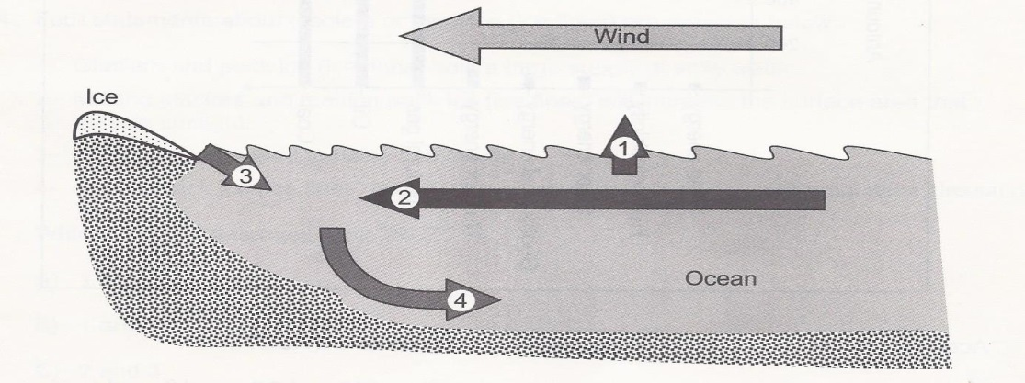
Which of these arrows represents the water with the greatest density?
A) Arrow 1 B) Arrow 2 C) Arrow 3 D) Arrow 4

      - From the statements below, choose two which will cause an increase in the salinity of ocean water.
1. increased erosion
2. ocean water redirected to a tidal energy plant
3. ice floes and glaciers melt
4. water evaporates at the equator
A) 1 and 3 B) 1 and 4 C) 2 and 3 D) 2 and 4

      - Different factors can affect the circulation of surface currents and deep currents in the ocean.
1. Temperature differences in the water
2. Air pressure differences in the atmosphere
3. Differences in the waters’ salinity
4. The rotation of the Earth
5. The depth of the water
Which of the factors above only effect surface currents?
A) 1 and 3 only B) 2 and 4 only C) 1, 3 and 5 D) 2, 4 and 5

      - What are the characteristics of ocean water which has a tendency to sink?
A) Low temperature and low density C) Low temperature and high density
B) High temperature and low density D) High temperature and high density

      - Which of the following is true about glaciers and pack ice?
A) Both glaciers and pack ice are formed on land.
B) Both glaciers and pack ice are formed on the ocean’s surface.
C) Both glaciers and pack ice contain freshwater.
D) Both glaciers and pack ice form icebergs.

      - The following statements are related to ocean circulation.
1- The salinity of ocean water will decrease when neighboring coastal glaciers melt.
2- Cold water near the poles will move toward the ocean floor.
Which of the following choices is correct?
A) Only statement 1 is true. C) Statements 1 and 2 are correct.
B) Only statement 2 is true. D) Neither statements are correct.

      - Which location is in the same catchment area?

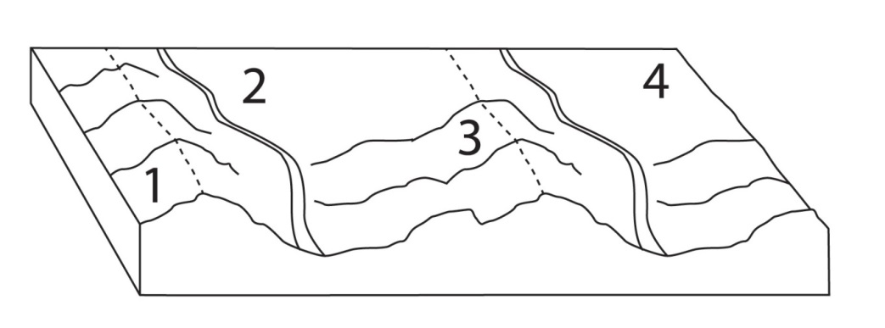
A) 1 and 2 B) 1 and 3 C) 2 and 3 D) 2 and 4

      - Which of the following does not affect the flow of water into a catchment area?
A) Depth and latitude of the water reservoir C) Shape and slope of the terrain
B) Industrial and urban development D) Density and diversity of the vegetation

      - What is the role of thermohaline circulation?
  - It keeps the pH of oceans uniform.
  - It captures atmospheric CO₂
  - It transports heat from the equator toward the poles.
  - It controls the tidal cycle.

      - Describe what a catchment area is.
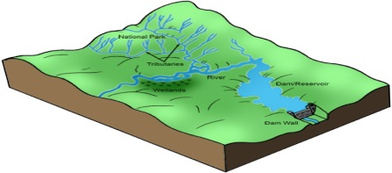

      - For each statement state whether it is an example of a surface current or a subsurface current.
a- these currents are altered by density and salinity
b- these currents are mostly controlled by wind
c- these currents will allow cause you to swim off course in the ocean
      - Explain how the warming of the water in the poles will affect thermohaline circulation.

      - Cruise ships regularly offer tours along the shores of Greenland. Tourists can observe the spectacular blocks of ice that break off from the coast and fall into the sea.
- What are these blocks of ice called?
- A few fragments of ice melt in the seawater. This water does not stay near the coast; it moves about. What factors will affect its movement?

- Will the meltwater eventually arrive at the equator? Explain your answer.

      - True or false?
a) Pack ice is found on land and glaciers float on the sea. ______
b) Watersheds will be more polluted towards the bottom of the drainage basin. ______
c) Having a flat land will produce a good watershed. ______
d) Icebergs are formed from pack ice ______
e) Both rocks and minerals are pure substances. ______
f) Glaciers float on the sea ______
g) Melting pack ice has no effect on sea level ______
h) The Gulf Stream is a surface current ______
i) Ocean salinity will decrease if glaciers continue to melt ______
j) Surface currents can be driven by wind only ______

