Human Reproduction Notes

Why Reproduce?
In order to ensure the ________________________of the __________________ and the continuation of life in general by producing __________________

Asexual vs Sexual Reproduction
Remember:
- Asexual reproduction:
  - Can produce offspring __________________ needing a __________________
  - Offspring are __________________ to parents
- Sexual reproduction:
  - Requires __________________from a _____________and a __________________
  - Offspring ____________________________________with each parent but are ________________________________to either one

Stages of Human Development
1) male and female __________________ (sperm and egg) come together (__________________) to form the __________________
2) the zygote eventually develops into an __________________ (2 weeks)
3) After 9-10 weeks the embryo develops into a __________________
4) The child is born (__________________)
5) The infant will __________________ into a toddler and child
6) the child will become an __________________ and start to undergo __________________
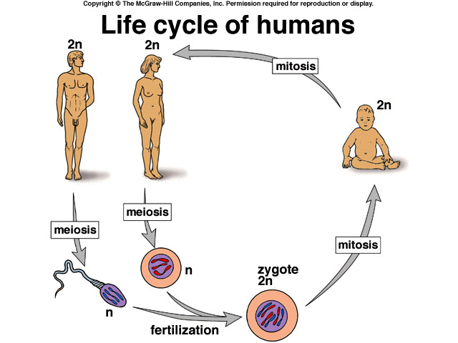
7) ____________________________________is reached
________________________
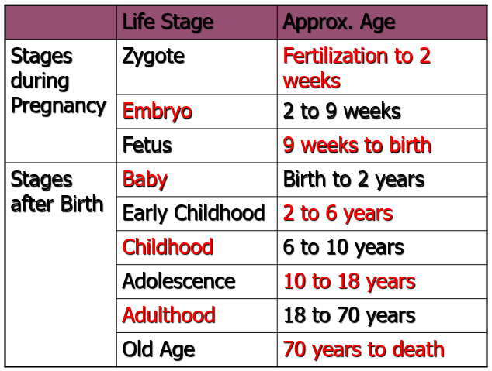

Puberty
- What is puberty?
  - It is the ______________________________________________________that involves the changes that __________________ the human body to __________________
- When does it start?
  - Usually between the ages of about __________________
  - The start is marked by the increase in production of _____________________________
Hormones
- We often talk about hormones only in relation to puberty and sexual reproduction but there are ____________________________________of hormones.
  - Hormones are ____________________________________that are released by glands into the __________________ and will ______________________________in particular organs or tissues
- They are also responsible for regulating:
  - __________________
  - ____________________________________
  - ____________________________________, etc
- Triggering puberty:
  - Puberty is triggered by the production of 2 hormones from the ____________________:
    - ______________________________________________________ (FSH)
    - ____________________________________ (LH)
  - LH and FSH stimulate:
    - ____________________________________in females
    - Production of __________________ and __________________ (sex hormones) in females
    - Production of __________________ in males
    - Production of __________________ in males
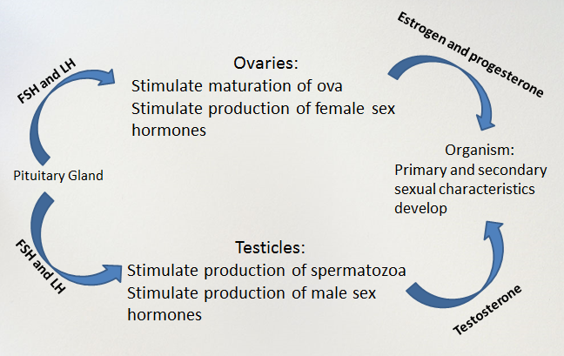
- The release of these ______________________________ (estrogen, progesterone and testosterone) initiates a number of ________________and ______________________________
Primary vs Secondary Sexual Characteristics

Sexual characteristics are _______________________________________________ which indicate an individual’s __________________________________.
- ____________________ sexual characteristics are the sexual characteristics that _______________________________________________________
  - ________________________________________________________________
- ____________________ sexual characteristics are the ones that __________________ ____________________ (usually during ____________________)
  - Ex: ____________________________________________________________

Puberty in Females
Primary Sexual Characteristics
- ____________________________________begins
- ______________________________________________________

Secondary Sexual Characteristics
- __________________ and ____________________________________appears
- __________________develop
- _____________________________ (wider hips)
- ____________________________________accumulate on _____________ and __________________primarily

Puberty in Males
Primary Sexual Characteristics
- ______________________________________________________
Secondary Sexual Characteristics
- __________________, __________________ and ________________________appears (“hairiness generally increases” p.143)
- Larynx enlarges causing the ____________________________________
- Skeletal ____________________________________– put on muscle
- ______________________________________________________
  - Helps with growth spurts!

Male Reproductive System
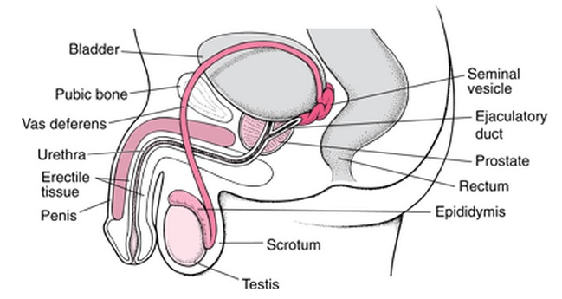

Spermatogenesis
- The release of __________ during puberty starts the ________________________________ process
- Cells inside the ____________________________________ (inside the testicles) called __________________undergo __________________ to produce __________________
  - The cells that produce the spermatozoa are constantly being __________________ and spermatogenesis is __________________
    - This means a male can produce about _______________________________per day

Erection and Ejaculation
- __________________ occurs as a result of ____________________________________
  - The tissues around the penis __________________ with __________________
- After formation, sperm are pushed into the _________________________________where they are __________________
  - When the erect penis is __________________, this causes the sperm to be pushed ____________________________________
  - They accumulate in a bulge of the urethra along with different ____________________________________
    - The mix of sperm and seminal fluids is called _______________________
- Following the stimulation of the penis, sperm are __________________ through the __________________ in a process called ____________________________
  - The __________________ is also the passageway used for __________________
  - To ensure that urine and sperm don’t mix there are _____________________________ that ____________________________________of both substances

FYI
- Need erection to ejaculate, but do NOT need to ejaculate if an erection occurs.
- There are approximately 350 million sperm/ejaculation.
- Sperm can live in a woman for ____________________________________

Female Reproductive System
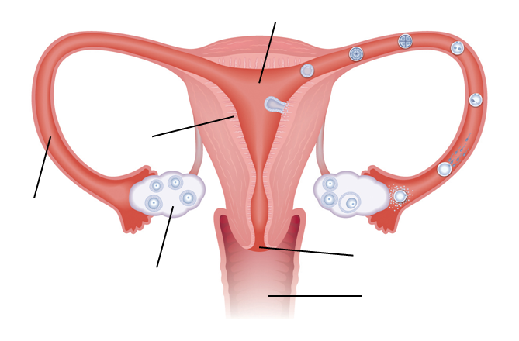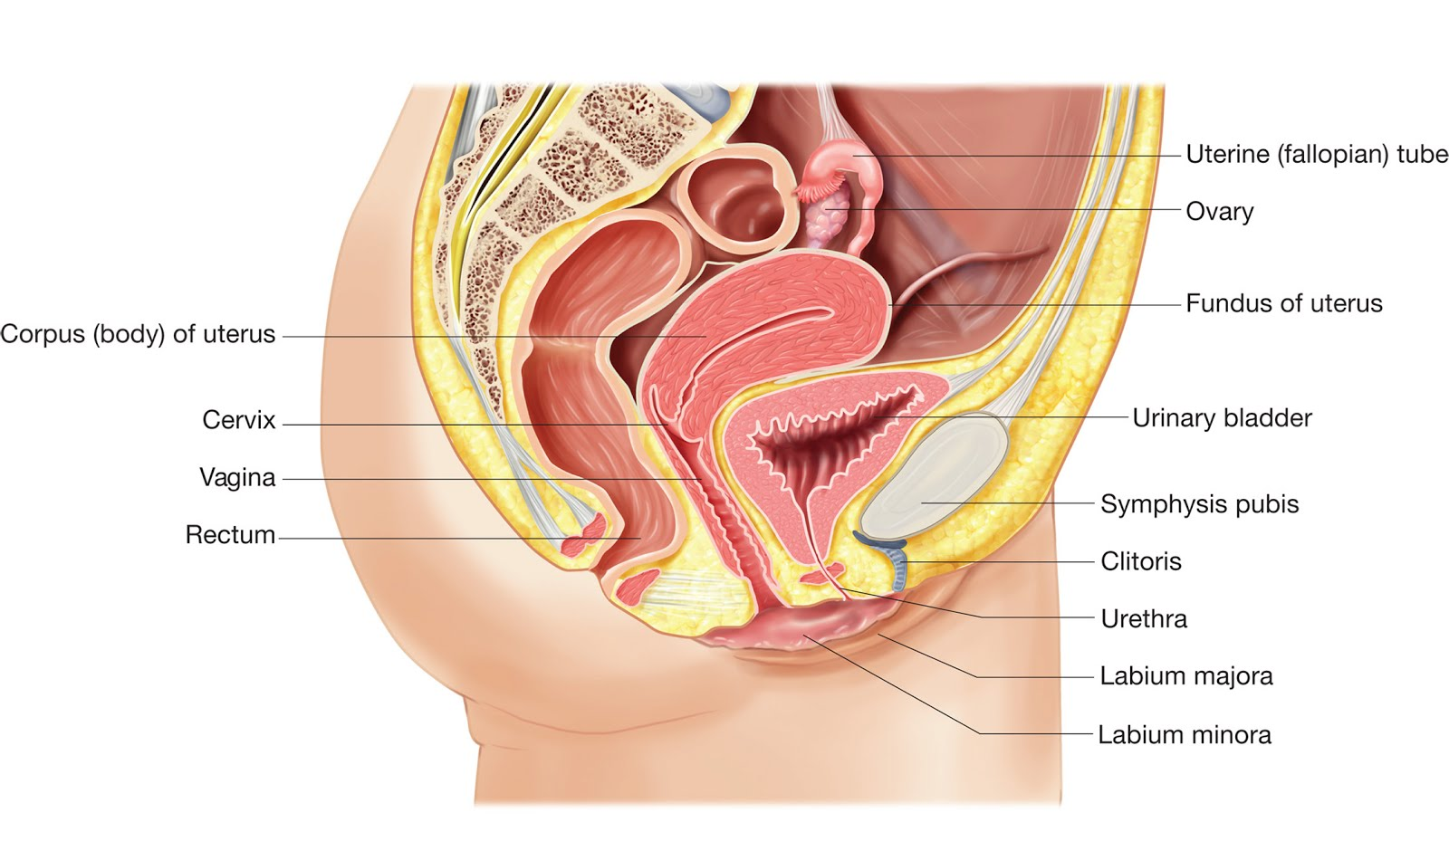

Oogenesis
- By the time a girl reaches ______________________she has around ______________________ (cells capable of becoming ova)
  - These oocytes will undergo __________________ in order to produce the ___________
    - Similar to the ___________________________ in the male that undergo meiosis to produce the __________________________
    - Unlike sperm, ova are _____________________________being produced; a woman only gets _______________________ (she is born with them)
- Usually, only ____________________________________will mature into an _______________ and be released into the ____________________________________to be fertilized
  - If more are released, this is how you get fraternal twins, triplets, etc.
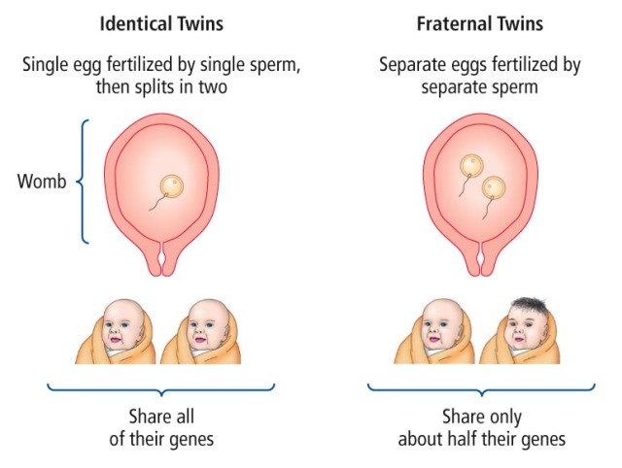

The Ovarian Cycle
1) ___________ is secreted by the ____________________________________and stimulates the growth of an ____________________________________around the oocyte
2) the __________________ starts to release more and more __________________
3) __________________ levels cause the pituitary to release ________ along with ________which triggers the follicle to rupture and ____________________________________________________
4) The follicle then turns into the ____________________________________and releases __________________ that will stop the release of more FSH and LH, and cause the uterine lining (__________________) to __________________
5a) if the ovum is ____________________________the ________________________________ ______________________, and the ____________________________________from the uterus and is expelled through __________________
5b) if the ovum is __________________the __________________ (fertilized ovum) will _____________ itself in the uterine wall and the corpus luteum will continue to produce progesterone until the placenta is fully formed

The Menstrual Cycle
- The ____________________________________is trigged as a result of the ovarian cycle and ____________________________________
- The menstrual cycle has ____________________________________:
  - The ____________________________________: period of __________________ due to the expulsion of the endometrium and the unfertilized ovum
  - The ____________________________________: the __________________ begins to the __________________, __________________ levels increase due to new ovarian follicle
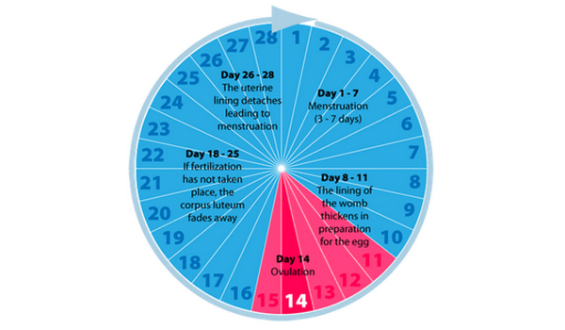
  - The ____________________________________: endometrium continues to thicken, __________________________levels increase from the corpus luteum
An ovum lives about
12-24 hours
A sperm lives about
24-72 hours

Assisted Reproductive Technologies (ARTs)

Infertility
- ________________________ is the __________________________________________ a child after 12 months of sexual relations _______________________________________ __________________
  - To be eligible for ART in many places, a couple is considered to be infertile if they have not been able to conceive a child after 2 years of trying
- ______________________________________consists of all the ___________________ ___________________used to help a woman become pregnant

Benefits of ARTs
- ______________________________________are able to have children
- ______________________________________are able to have children

Concerns of ARTs
- Risk of ______________________________________
- Very ___________________ for couple or government
- ___________________ increase the risk of ovarian cancer
- Many ______________________________________and procedures
- 3% increase in ______________________________________
- Frozen embryos need to eventually be ____________________________
- Risk of embryos being selected purely for ______________________________________ (ex. gender, eye colour)

Types of ARTs
Ovarian Stimulation
How does it work?  Uses medication to ___________________ ____________________________(female takes hormones in the form of needles or pills) which stimulate the __________________ _____ ________ _______.  ______________________________________  ___________________released each month | When is it used?  Used when __________________________ _______ ________________________ or for women who ___________________________ _______________

Artificial Insemination
How does it work?  ______________________________________ from a male, then washed and analyzed. It is then ______________________________________ ___________________on the day of ovulation  Usually combined with Ovarian stimulation | When is it used?  Used when the _________________________ _______________________________because female’s cervical mucus kills sperm (too acidic) or when the males’s ___________________ (number) or __________________________ ________________

In Vitro Fertilization
How does it work?  The ovum is fertilized in a ________________ (outside the woman’s body)  After 2-8 days of growth in the lab, _________ ______________________________________ to continue development until birth | When is it used?  Used when the ________________________ ___ ___________, ______________________________, or other methods have not worked
Steps

1) ______________________________________– the woman produces multiple mature ova which is collected
2) ___________________and washing of ___________________
3) _______________________________________________– ova and sperm placed together in a test tube where fertilization occurs
4) _________________________________________________________– after 2-7 days the most developed embryos are transferred to the uterus (usually 2-4 at a time). Un-transferred embryos can be frozen to be used later
Fertilization Through Micro Injection
How does it work?  Uses the same steps as In Vitro Fertilization BUT the _______________________________ ______________________________________ | When is it used?  Used when there is _____________________ ___________________or fertilization poses a problem or other methods have not worked.

