Notes: Eye Reflexes
A healthy person has a number of eye reflexes:
- _
- _
- _
- _
Pupillary Light Reflex
- The reflex that controls the of the pupil (its )
- This is a response to of light (brightness)
- Allows us to adapt to different light levels
  - _ light → pupil
  - _ light → pupil
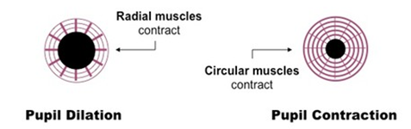

Vestibulo-ocular reflex
- Sometime called the “doll’s head reflex”
- Links eye movement with the
  - The system that controls and
- Trying to image on the retina during head movement by moving the eyes in the direction of head movement
  - This way the image stays in the centre of the field of vision

Corneal Reflex
- Also known as the
- Caused by the stimulation of the
  - Example: when something your eye or
  - Can also happen with really
- Trying to the eye from foreign bodies and bright light
Accommodation Reflex
- How the eye on near and far objects
  - Changes in , lens and pupil
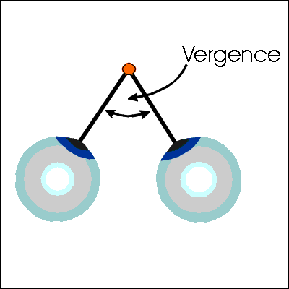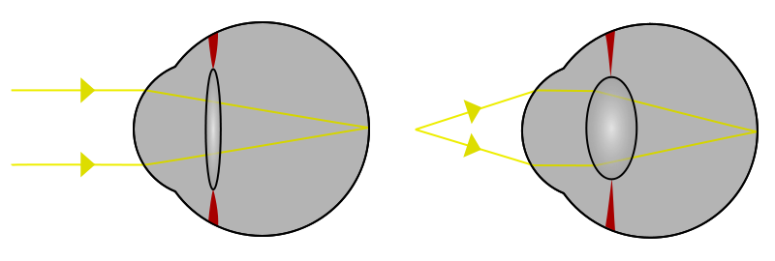
This you need to know for the test!

Reflexes
Reflex | Personal Example
Pupillary Reflex
Near /Far  - You look _____________ pupil is ______  - You look _____________ the pupil is ______  Light/ Dark  - In _____________ your pupils get _____________, so less light will get in  - In _____________ your pupils get _____________ to let in more light.  Love/Hate  - Your pupils get _____ when you look at someone you __________ (or have a crush on).  - They get _____when you look at someone you _______ | Near /Far  - You look at the board pupil is big.  - You look at you paper, pupil is small  Light/ Dark  Love/Hate
Adaptation
- In _____________your retina uses the _____________  - In _____________your retina uses the _____________  - It takes about ten seconds to switch from one to the  other | - You are playing outside in the snow and you come inside and it’s so dark it’s hard to see but after a few seconds it seems normal again.  - You are at a matinee movie and you come outside into the sun. It’s so bright it hurts your eyes. But then you get used to it.
After Images
Negative after images  - Look at a ____________that ______________________.  - When you look at a paper you see the ____________ colour.  Positive after images  - Look at a ____________  - Close your eyes and you can still see them. Your retina is _____________________ and keeps firing | - Look at red for a long time then look at a white paper. You see green
Peripheral Vision
Peripheral vision
- If you are looking __________________but can still see something ____________ you.

Movement vs colour
- Most of your retina is covered with _________so you can see ____________ first.
- Your ________are only in the ____________. You can see _________________before ____________

Reflexes with 2 eyes
Binocular vision  - your ___________sees a slightly different picture from your ___________.  - Your brain sees these two images and interprets them as ____  Blind spot  - Each eye has a ___________where the ___________________ leave the eyes.  - They’re in ___________ places in each eye. As long as you have two eyes _____________________________________________ | - It’s hard to thread a needle with just one eye.
Near point accommodation
Convergence  - When you look at something ___________your medial rectus muscles bend your eyeballs ___________  - When you look ___________the muscles relax and your eyeballs are ___________ | - You can hold your arm up and cover the moon with your thumb.  - But the brain knows one is close and the other is far because it feels the muscles move.

