Notes: Eye Anatomy
The eye: is the related to vision
- Picks up light rays by light sources or by objects
- This is how we see!
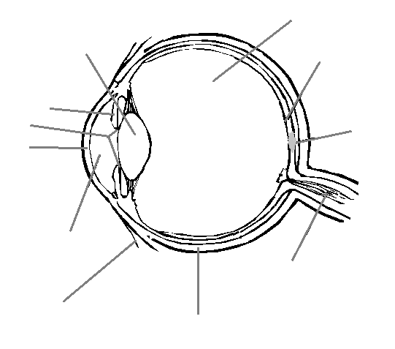

Sclera
- _ , & outer layer
- Gives the eye a shape
- _
- Provides a place to attach the muscles

Cornea
- Here the sclera becomes like a window
  - It bulges out slightly in front
- The anterior (front) chamber is filled with a liquid called
  - It’s clear and watery and the cornea

Choroid
- Dark and pigmented of the eye
  - Very thin
- Contains a lot of that nourish the eye
- Prevents light from inside the eye
- In some animals there is a bright strip called the
  - It’s found in nocturnal animals. It catches the light and shines it back through the retina.
- That’s why animals eyes glow in your headlights

Iris
- The of your eye
  - It’s derived from the
- It controls the entering the eye
- It has two sets of
  - One the inner ring of the iris
  - One the inner ring

Pupil
- The pupil is the
  - This is where
  - It appears because the inside of the eye
    - Like looking inside

Lens
- Is
- It is behind the pupil
- It is held by
- Controlled by
  - They make the lens fatter or thinner
    - This focuses the image on the retina

Retina
- Innermost layer
- Very , like wet tissue paper
- Contains
  - They respond to light (convert light to )
  - Transmit a nerve impulse to the brain
  - Two types of receptor cells:
    - and

Rods
- Sensitive to and
  - Important for
- Contain (pigment)
  - Rhodopsin is made from vitamin A (eat your carrots)
- 125,000,000 rods in each eye

Cones
- Sensitive in
- Detect ,
- Three kinds of cones: , ,
- Concentrated behind the pupil in an area called the .
  - This is where your vision is most .

Cones and Rods
  - We have many than cones (about 20x!)
  - The are relatively across the retina but the are really concentrated in the

Blind spot
- there is also a part of the retina that has
  - This is where the _______is attached to the
  - Because there are there, if light hits this part of the retina you

Eye muscles
Eye muscles and to move the eye and the lens.

Intrinsic Eye Muscles

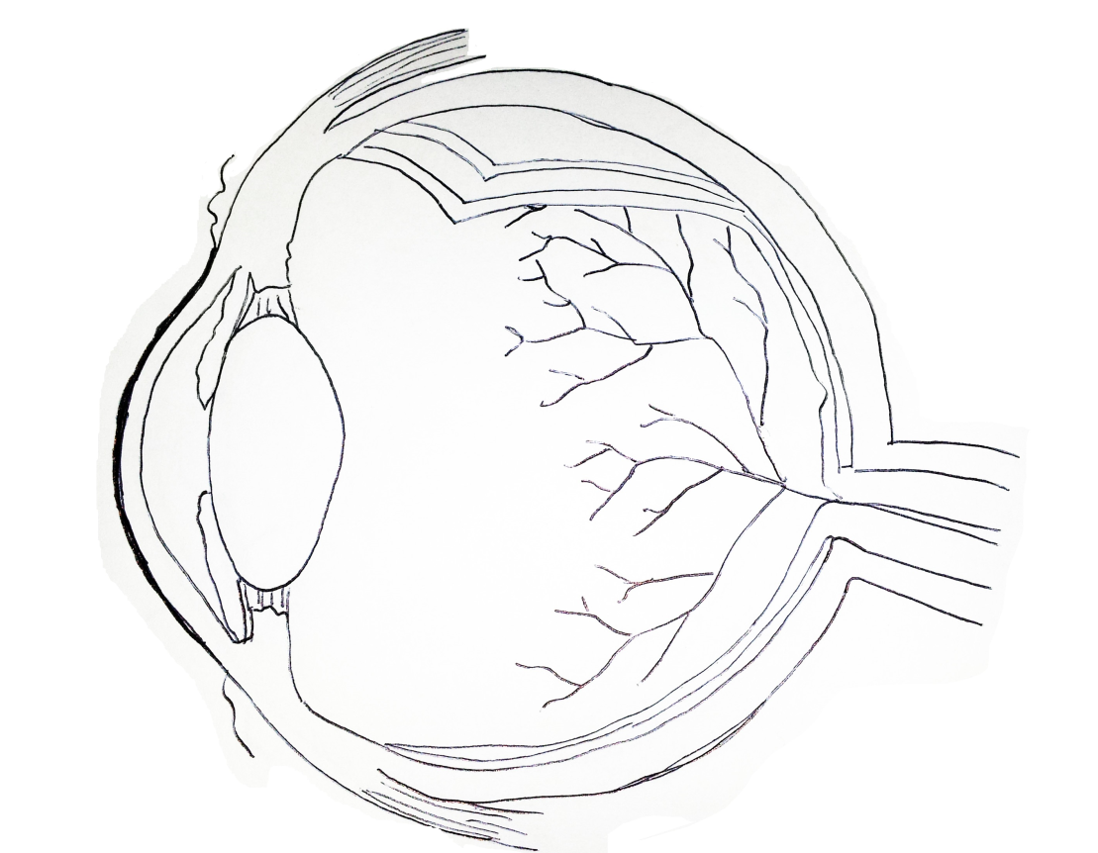

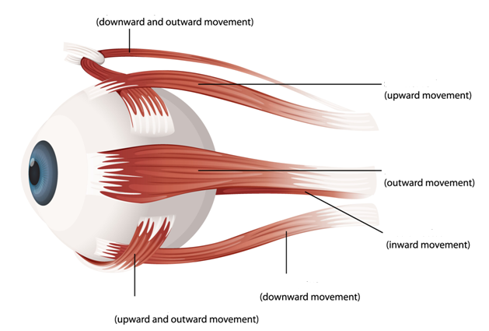
Extrinsic Eye Muscles

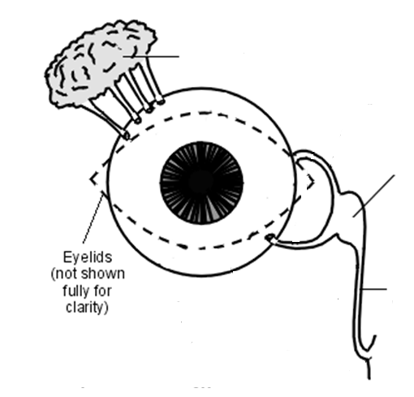
Protection of the Eye – Auxiliary Structures

Eyelids & Eyelashes
- Protect the eye from like dust & dirt
- Also protect the eye from
- Blinking also helps to keep your eye moist and comfortable
Eyebrows
- Also believed to help keep , and other debris from falling into the eye
- Also important in human (think facial expressions)
Lacrimal tear glands
- Produce tears that keep eyes
- Tears protect the eyes from and
  - Have properties
  - Also foreign bodies
- Transport and to surface of the eye (no blood vessels)
- Tears allow for light to be ___________________ properly so we can see!
Tear sac and tear ducts
- _ the extra tears and them into the nose

