Electricity Review Assignment
- In your own words, describe what static electricity is and what causes it.

- List the three main types of particles found in the atom, where they are found within the atom, and their respective charges.
(i)
(ii)
(iii)
- When you charge an object, what is happening to the protons and electrons?

- If an object is neutral, then it has:

- An object becomes negatively charged by …

- An object becomes positively charged by …

- Two spheres are placed next to one another. Sphere 1 has a positive charge, sphere 2 has a negative charge. What will happen?

- Two spheres are placed next to one another. Sphere 1 has a negative charge, sphere 2 also has a negative charge. What will happen?

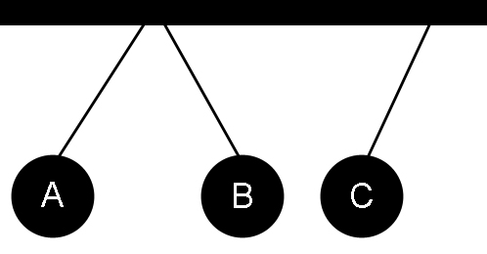
- Examine the image to the right. Spheres A, B, and C were each given charge. Spheres A and B were then suspended close to each other, resulting in repulsion. Sphere C was suspended further away from the other two. As sphere B moved away from sphere A, sphere C moved towards sphere B. What would happen if sphere A and C were brought close together?

- Three spheres are each given a static charge. Spheres 1 and 2 repel each other. Spheres 2 and 3 attract each other. What will happen to spheres 1 and 3?

- Four spheres are each given a static charge. Spheres 1 and 2 attract, spheres 2 and 3 repel, and spheres 1 and 4 attract.
  - Spheres 1 and 3 will:
  - Spheres 2 and 4 will:
  - Spheres 3 and 4 will:
- You are given a series of objects. You know that object A is negatively charged, and object B is neutral. You conduct a series of tests to see which objects attract and which objects repel each other. You discover the following:
Object C:  Attracts B | Object D:  Repels C | Object E:  Attracts D  Repels F | Object F:  Attracts A
What are the charges of objects C, D, E, and F?
Object C:
Object D:
Object E:
Object F:

- Sometimes when you put on clothes, they start to stick to you because of static. This is an example of charging by:
- If you bring a charged object close to running tap water, the tap water is sometimes attracted to it. This is an example of charging by:
- If you shuffle your feet across a carpet, and then shock someone by touching them, what two types of charging are involved?
- If you have a negatively charged object, and you charge a neutral object by conduction, what charge will the neutral object gain?
- If you have a positively charged object, and you charge a neutral object by induction, what charge will the neutral object gain?
- If you have two neutral materials, and you charge them using friction, what will happen to their charges?
- If a glass rod is rubbed against your skin, what charge will each object have afterwards?
Glass:
Skin:
- If rubber is rubbed with vinyl, what charge will each object have afterwards?
Rubber:
Vinyl:
- Where are electrons moving to and from when you rub a piece of amber and fur together?
- Where are electrons moving to and from when you rub a piece of wool and ebonite together?
- If plastic and vinyl are rubbed together, and then the plastic is brought close to a negatively charged object, what will happen?
- If nylon and silk are rubbed together, and then paper and acetate are rubbed together, what will happen when you bring silk and paper close to each other?
- If you want to give wool a positive charge, why would it be better to rub it with plastic rather than silk?
- In your own words, explain how an object can become positively charged. You must correctly use and describe the following terms: protons, electrons, valence shell. Be clear about which particles can be transferred and which cannot.
- An electrical appliance has a broken resistor with a resistance of 15 Ω. Which of the following resistors could be used to replace the broken one?
  - Potential difference = 2 V, Current intensity = 0.5 A
  - Potential difference = 30 V, Current intensity = 2 A
  - Potential difference = 10 V, Current intensity = 5 A
  - Potential difference = 5 V, Current intensity = 3 A
Answer: _______

- A toy ambulance has lights and sound that are on the same electrical circuit. The headlights turn on when you turn on the main power switch. The siren is controlled by a second switch. Draw a circuit diagram that represents this situation. You can use the symbol for a resistor to represent the siren.
- A circuit has a current intensity of 0.05 A and a 5 Ω resistor. What is the potential difference?

- A circuit has a potential difference of 25 V and a current intensity of 5 A. What is the resistance?
- A circuit has a potential difference of 30 V and a resistance of 25 Ω. What is the current intensity?
- There are 0.05 A of current running through an electrical circuit. The circuit has a resistance of 200 Ω. What is the potential difference of this circuit?
- There are 4 mA of current running through an electrical circuit. The circuit has a resistance of 500 Ω. What is the potential difference of this circuit?
- If a circuit has a potential difference of 3 V and a current intensity of 0.4 A, what is the resistance?
- If a circuit has a current intensity of 0.6 A and a potential difference of 20 V, what is the resistance?
- If a circuit has a resistance of 5000 Ω and a potential difference of 150 V, what is the current intensity?

- If a circuit has a potential difference of 200 V and a resistance of 100 Ω, what is the current intensity?
- An electrical appliance has a defective resistor with a resistance of 10 Ω. Based on the information in the table below, which resistor should you select to replace the defective one?
Resistor | Current Intensity (A) | Potential Difference (V)
1 | 0.8 | 4
2 | 5 | 30
3 | 1 | 12
4 | 3 | 30
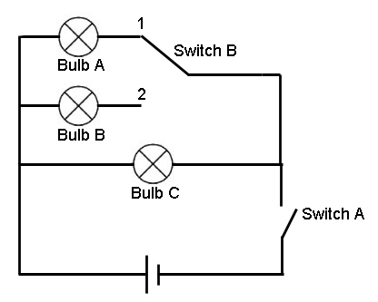
- In the diagram to the right, which light bulbs would be on if switch A was open and switch B was in position 1?
- In the diagram to the right, which light bulbs would be on if switch A was closed and switch B was in position 2?
- In the diagram to the right, which light bulbs would be on if switch A was closed and switch B was in position1?
- In the diagram above, if light bulb C is burnt out, would the other bulbs still work? Explain. ________________________________________________________________
- Draw a circuit diagram with a power source, a switch, and two light bulbs in series. Add a voltmeter measuring the potential difference across one of the bulbs.

- Draw a circuit diagram with a power source, a switch, and two light bulbs in parallel. Add an ammeter measuring current intensity through one of the bulbs.
- Tom is an avid Star Trek fan, and decides to build a model of the USS Enterprise NCC-1701 shown below.
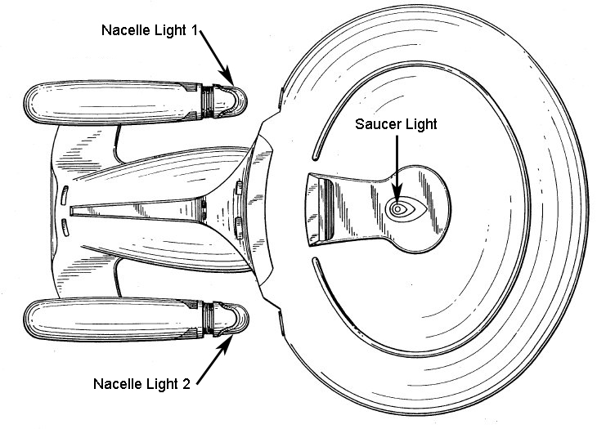
  - There are three lights on this model, all in the same circuit.
  - The saucer light comes on when you turn on the main power switch.
  - The two nacelle lights come on at the same time as each other, but independently of the saucer light (using a second switch), when you want to simulate warp flight.
Draw a circuit diagram that meets these requirements.

