Notes: Ecosystems

Ecosystems
- Definition:
  - a community of __________________________________________________________ with one another and with the ____________________ components in their habitat.
4 Levels of ecological organisation:
- ______________________________
- ______________________________
- ______________________________
- ______________________________

Trophic Relationships
- Definition:
  - ________________________________________among living organisms in an ecosystem
- 3 trophic levels:
  - ____________________
  - ____________________
  - ____________________

Producers (Autotrophs)
- Produce their own food through ____________________.
  - They need __________ for the process to occur.
- They ________________________________________into an ecosystem.
ex. Land: ________________________________________
Water: ________________________________________

Consumers (Heterotrophs)
- Definition:
  - obtain their energy by _________________________________________________ _________________________________________
- Two types:
  - Primary or first order consumers
  - Secondary or second order consumers
Primary Consumers:
- ________________________________________
- Must be ____________________
  - Includes omnivores
Secondary (tertiary, etc) consumers:
- ____________________ that ______________________________________________________ (herbivores/omnivores)
  - Note: Insectivores eat insects
- ________________________________________ (third order consumer)
  - Feeds on secondary consumers
- ________________________________________
  - Has no predator

Decomposers (Detritivores)
- feed on ____________________________________________________________
- ____________________________________________________________levels (everything dies)
- they are an essential component to completely ______________________________an organism
- helps keep soil and environment healthy
Ex:
______________________________________________________________________________

Food Pyramid
- Representing ____________________________________________________________, in which various forms of life are shown on different levels, with __________________________ _____________________________________________________________________________.

Food Chain
- A trophic relationship with a ______________________________________________________. ____________________ are part of each trophic level.

Food Web
- Trophic levels with ____________________________________________________________. Many food chains can be made from it.
- Notice the arrows go from the _____________________________________________. They show energy transfer.

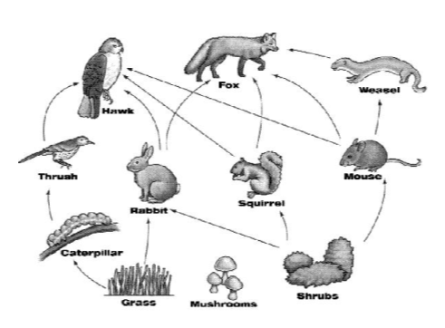
Practice

- Identify a:
producer
primary consumer
secondary consumer
tertiary consumer

2) What would happen to the # hawks if grass disappeared?

3) What would happen to # rabbits if grass disappeared?

4) What would happen if the hawks disappeared?

5) Would you expect to find more weasels or foxes?

6) How would you add the mushrooms into the web?

7) Make a food chain to the second order consumer.

8) Make a food chain to the third order consumer.

Chemical Recycling
- Decomposers make ________________________________________available by ____________________________________________________________

Material and Energy Flow
- Energy ____________________ in an ecosystem
- Only _________ of the energy gained from food can actually be used _____________________ _________________________________
  - The other 90% of the energy gained will ____________________through meeting the animal’s daily needs (ex: ________________________________________) and ____________________
- Energy is __________ recycled in a food web
  - This means ________________________________from the sun is required

Primary Productivity
- Definition:
  - amount of ________________________________________created (by producers).
  - Depends on ____________________________________________________________.

Biomass
- Definition:
  - the total mass of ________________________________________in an ecosystem (mass of all ________________________________________)

Disturbances
- an event that ________________________________________________________
- Two types:
1- ________________________________________
2- ________________________________________
Natural disturbances are:
  - Events triggered by the ________________________________________
    - Ex- storms, droughts, wildfires
Human disturbances are:
  - Disturbances triggered by __________________________________________________
    - ex. logging, oil spills, mining

Ecological Succession
- All the steps necessary for an ecosystem to be stable again ________________________ ________________________has occurred.

Past Exam Questions
- The table below gives a list of disturbances. Some are natural, and others are the result of human activity.
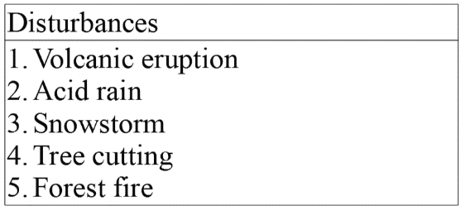
Which of these disturbances result from natural causes only?
A) 1, 2 and 3
B) 1 and 3
C) 1, 3, 4 and 5
D) 2 and 5

- Four characteristics of certain living things are listed below:
1 – They are autotrophs.
2 – They are heterotrophs.
3 – They transform organic matter into inorganic matter.
4 – They transform inorganic matter into organic matter.
Which of the above characteristics can be associated with producers?
A) 1 and 3
B) 1 and 4
C) 2 and 3
D) 2 and 4

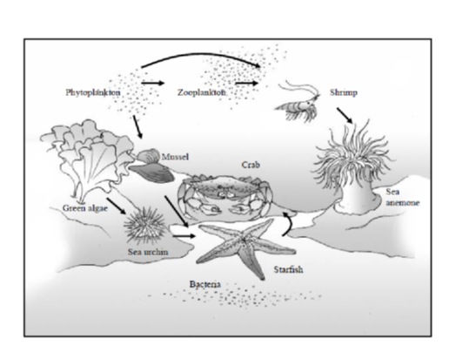
- Biologists have noticed a rapid decline in the sea anemone population of the estuary near Grand Island. At first, they thought this was caused by abiotic factors, but they discovered that the direct cause of this rapid decline is a new type of fungus affecting sea anemones only.
In the short term, what impact is this disturbance likely to have on the zooplankton population?

