**Review for Carbon cycle, Hydrosphere and Space and Energy Types Test**

**Cycles and Greenhouse effect**

1. Which of the following statements about the Greenhouse effect is true?

A) An increase in greenhouse gases in the atmosphere leads to an increase in the amount of heat that escapes into space.

B) A decrease in greenhouse gases in the atmosphere leads to an increase in the amount of heat that escapes into space.

C) An increase in greenhouse gases in the atmosphere leads to an increase in the amount of solar radiation that will enter the atmosphere.

D) A decrease in greenhouse gases in the atmosphere leads to an increase in the amount of solar radiation that will enter the atmosphere.

1. Which of the following does not contribute to the formation of greenhouse gases?

A) Decomposition of waste in landfills C) Melting of the permafrost

B) Burning of fossil fuels D) Photosynthesis in plants

1. In general, permafrost is ground that…

A) Is always frozen C) Only freezes during winter

B) Rarely freezes D) Is located mainly in high altitude

1. Which of the following is not a consequence of the warming of the permafrost?
2. Landslides
3. Unstable infrastructure (buildings and roads)
4. A decrease in the amount of vegetation
5. The release of greenhouse gases
6. Certain gases in the atmosphere absorb some of the heat from earth warmed by sun's rays, which increases the temperature of the Earth. Which of the **gases** listed below IS NOT related to this phenomenon known as the greenhouse effect?
7. Carbon dioxide B) Methane C) Oxygen D) Water Vapour

**Hydrosphere Questions**

1. Which of the following statements describes the impact of thermohaline circulation on climate?
2. It regulates the world’s climate
3. It decreases the world’s average temperature
4. It increases the world’s average temperature
5. It has no notable impact on the world’s climate.
6. Four consequences of global warming are listed below.

|  |  |
| --- | --- |
|  | Consequences |
| 1 | The permafrost has thawed. |
| 2 | The number of extreme weather events has increased |
| 3 | Sea levels have risen |
| 4 | Snow geese have begun making their nests farther north |

Which of these consequences helps increase the greenhouse effect?

A) Consequence 1 B) Consequence 2 C) Consequence 3 D) Consequence 4

1. A pharmaceutical company is planning to build a factory where indicated by the letter X on the map below. Residents of towns 1, 2, 3 and 4 indicated on the map are concerned about the quality of their water in the event of a toxic spill. Which one of the 4 towns has a reason to be concerned about the quality of its water?

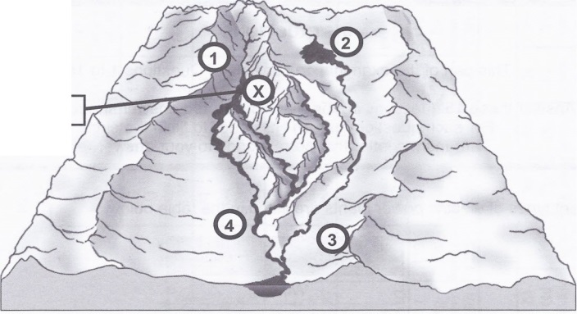

A) Town 1 B) Town 2 C) Town 3 D) Town 4

1. What is the role of thermohaline circulation?
2. It keeps the pH of oceans uniform.
3. It captures atmospheric CO2
4. It transports heat from the equator toward the poles.
5. It controls the tidal cycle
6. What do glaciers and pack ice have in common?
7. They float on the ocean
8. They are made up of water whose salinity level is below that of seawater
9. They are always located near the poles
10. When they melt, they do not affect the salinity of the oceans
11. Which of the following statements is true about pack ice?
12. The melting of pack ice affects the salinity of the ocean water.
13. The melting of pack ice does not affect the temperature of the ocean water.
14. The melting of pack ice affects sea levels.
15. The melting of pack ice does not affect oceans.
16. The take below lists three human activities that can have an impact on the quality of the water in a drainage basin.

Human activities

|  |  |
| --- | --- |
| 1 | Fertilizing farmland |
| 2 | Using jet skis and motor boats |
| 3 | Planting vegetation along the bank of a river or stream |

Choose 2 of the 3 human activities and explain their positive or negative impact on the rivers and streams of a drainage basin.

1. An inspector for a town of has noticed that the wastewater for the A2A carwash has been flowing into a nearby stream. The inspector informed the A2A carwash owners that they would be fined since they were polluting the town’s water source.

Use the map of the town’s watershed below to explain whether the inspector was correct in fining the carwash. Explain your answer.

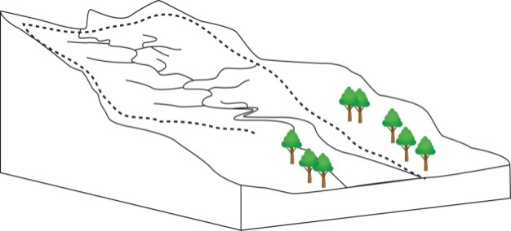

A2A Car Wash

Water Filtration Plant

1. Using the following diagram, complete the table below by writing YES or NO to indicate whether points Y and Z would be affected by a spill at point X and whether points X and Z would be affected by a spill at point Y.

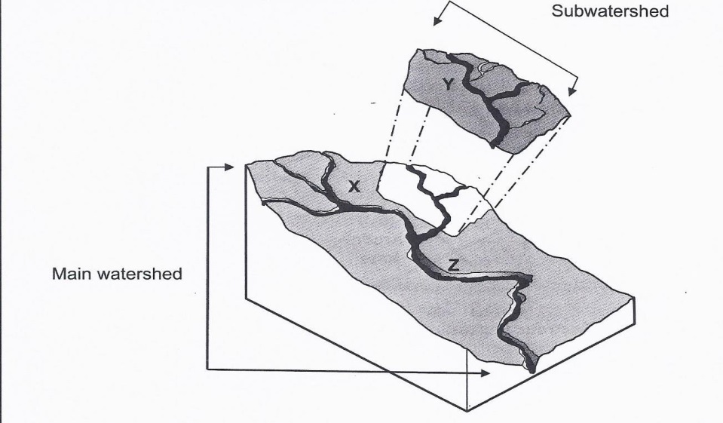

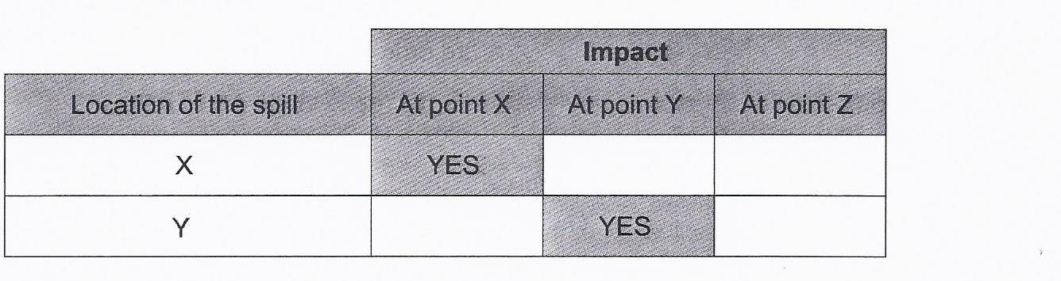

Explain your reasoning.

1. Global temperatures have been increasing at a steady rate. Ecologists have been hired to study the impact of increasing temperature s on a region in Northern Quebec. Which graph below correctly shows the consequence of a rise of temperature in the region? Explain your answer.

**Graph A Graph B**

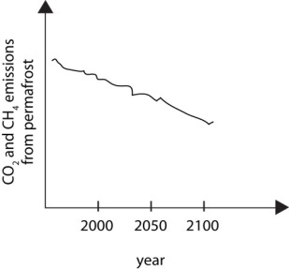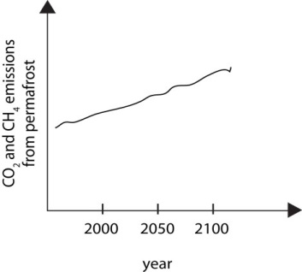

**Energy Types**

1. The following graph shows different sources of electricity in three major regions in Canada.

Graph 1 -Proportion of Electricity Produced From Different Sources in Three Major Regions in

Canada.



Given the information in this graph and your knowledge of energy resources, which conclusion is TRUE?

1. Electricity production has little impact on the environment in these three regions, since they all mainly use hydro power
2. Air pollution caused by electricity production is greater in Ontario than in Quebec, since Ontario has more thermal power plants.
3. Greenhouse gas emissions related to electricity production are greater in Ontario than in the Atlantic Provinces, since Ontario has more nuclear power plants.
4. Electricity production has a major impact on the environment in the three regions, since they use no renewable energy.
5. Different types of electric power plants are listed in the table below.

|  |
| --- |
| **Types of Power Plants** |
| Wind |
| Geothermal |
| Hydroelectric |
| Tidal |

Which statement is true about all these types of power plants?

1. They produce few air pollutants.
2. They can be set up anywhere in Canada.
3. They all use water as the primary source of energy.
4. They use non-renewable resources.
5. In Ungava Bay in northern Québec, the tidal range can reach more than 17 m. The diagram below shows the Earth along with a dotted circle representing the moon’s orbit around the planet.

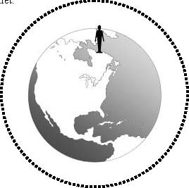

• Draw the symbol ☾ on the dotted circle to indicate the two (2) points in its orbit where the moon causes high tides in Ungava Bay. The position of this bay is denoted by the symbol: .

• Write the letter L on the Earth to indicate the two (2) points where the tides are low at the same time as the tide is high in Ungava Bay ().

1. Listed below are different facilities that use energy resources as well as negative consequences that may result from operating these facilities.

|  |  |  |
| --- | --- | --- |
|  | Facilities | Negative consequences |
| A) | Coal-fired power plant | Noise produced |
| B) | Nuclear power plant | Greenhouse gas emissions |
| C) | Wind turbines | Greenhouse gas emissions |
| D) | Water turbines | Can negatively affect the migration patterns of aquatic species |

Which choice correctly matches each facility with its consequence?