**Earth and Space Test Review 2**

**Multiple Choice**

1. Which of the following activities has the greatest impact on the flow of water in a catchment area?
2. Filling up a child’s swimming pool with 40 L of water.
3. Treating drinking water for a city in a municipal water treatment plant.
4. Rerouting rivers for the construction of a hydroelectric dam.
5. Repairing a bridge connecting Montreal’s South Shore to the Island of Montreal.
6. A cold air mass meets a warm air mass. What kind of weather occurs when these two air masses meet?

A) Light showers C) A hurricane

B) Thunderstorm D) A sunny day

1. The melting of glaciers and pack ice has environmental consequences. Which of the following statements is true?
2. The melting of glaciers reduces the concentration of sea salts, which increases the density of sea water.
3. The melting of pack ice influences thermohaline circulation
4. The melting of glaciers and pack ice has no impact on the quantity of available drinking water.
5. The melting of pack ice is the main cause of rising sea levels
6. Which statement regarding a mineral ore is TRUE?
7. All rocks in the lithosphere are ores.
8. A mineral ore is a rock not found in the Abitibi and North Shore regions.
9. A mineral ore is a rock rich in minerals that can be mined profitably.
10. A mineral ore contains only metal-bearing minerals
11. The following statements are related to permafrost.

Statement 1- Permafrost is frozen ground found only in certain regions near the poles

Statement 2- When the upper layer of the permafrost thaws, landslides can occur and some buildings can suffer cracking or be destroyed.

Which of the following is correct?

1. Statement 1 C) Statement 2
2. Statements 1 and 2 D) Neither statement
3. Which of the diagrams correctly represents the greenhouse effect?

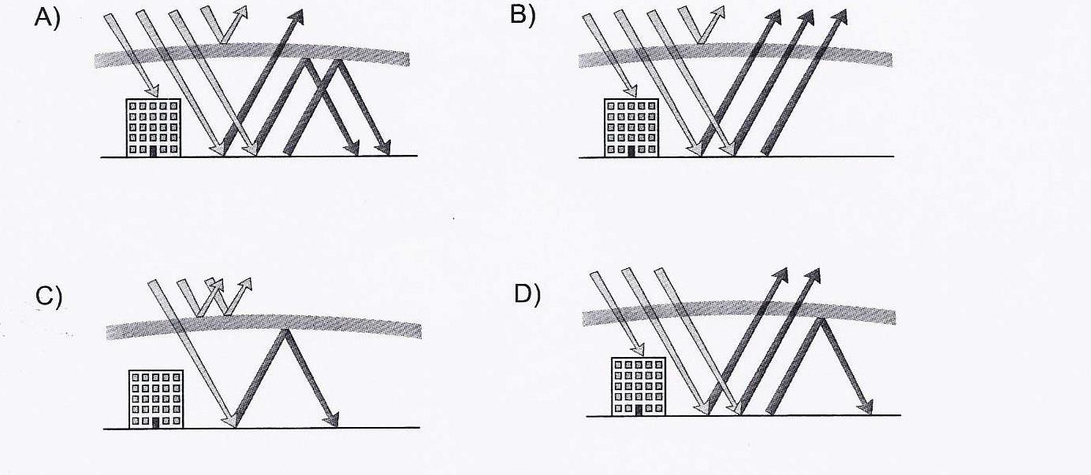

1. The following graph shows different sources of electricity in three major regions in Canada.

Graph 1 -Proportion of Electricity Produced From Different Sources in Three Major Regions in

Canada.



Given the information in this graph and your knowledge of energy resources, which conclusion is FALSE?

1. Ontario produces more greenhouse gases than Quebec since it uses more fossil fuels.
2. Ontario depends more on nuclear power than Quebec and the Atlantic provinces.
3. Quebec produces the least amount of greenhouse gases since it relies mostly on Hydroelectricity.
4. Quebec produces the most greenhouse gases since it relies mostly on Hydroelectricity.
5. What is the role of thermohaline circulation?
   1. It keeps the pH of oceans uniform.
   2. It captures atmospheric CO2
   3. It transports heat from the equator toward the poles.
   4. It controls the tidal cycle.
6. A pharmaceutical company is planning to build a factory where indicated by the letter X on the map below. Residents of towns 1, 2, 3 and 4 indicated on the map are concerned about the quality of their water in the event of a toxic spill. Which one of the 4 towns has a reason to be concerned about the quality of its water?

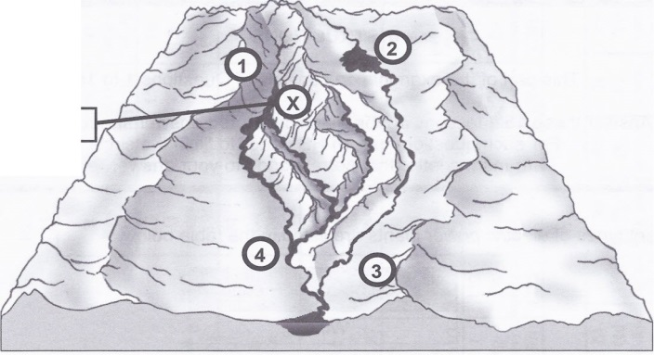

A) Town 1 B) Town 2 C) Town 3 D) Town 4

1. Four statements about glaciers or pack ice (ice floes) are provided below.

1- Glaciers and pack ice hold a large supply of salty water.

2- Melting glaciers and pack ice will increase the surface area that reflects sunlight.

3- Melting glaciers lead to rising sea levels.

4- Melting pack ice is one of the factors that slows down thermohaline circulation.

Which of these statements are true?

A) 1 and 2 B) 1 and 4 C) 2 and 3 D) 3 and 4

1. What effect will fewer plants and trees have on the environment?

A) There will a reduction in photosynthesis  
B) There will be an equilibrium of gases in the atmosphere  
C) There will be an increase in animal respiration  
D) There will be less greenhouse gases in the atmosphere

**Short Answer**

1. The inhabitants of a remote island would like to replace gasoline-powered generators with devices that use renewable energy. The table below indicates certain characteristics of the island.

|  |  |
| --- | --- |
| Population | 583 inhabitants |
| Area | 250 km2 |
| Climate | Summer: humid and sunny Winter: cold and sunny |
| Environment | Wildlife: seals, fish, aquatic birds Vegetation: diversified |
| Topography | Coasts: sandy beaches and small waves  Igneous rock and volcanic activity constantly monitored |
| Economic activities | Tourism, sailing, deep sea fishing, excursions |

Fill in the table below the inhabitants could use to produce renewable electrical energy and that would be appropriate for this island.

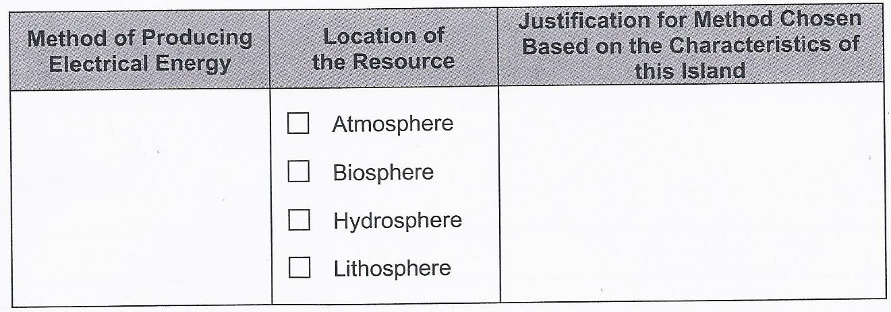

1. Some scientists claim that global warming has caused Arctic pack ice (ice floes) and continental glaciers to melt more quickly. Answer the following three questions.
2. Explain if melting glaciers affect sea levels.
3. Explain if melting pack ice (ice floes) affect sea levels.
4. Explain how melting Arctic pack ice (ice floes) affects thermohaline circulation.