Notes: Ear Anatomy

Outer Ear
Outer ear:
- Made up of the ____________________ and the ____________________________________
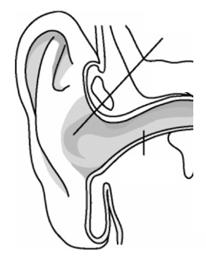
Pinna (also called the __________________)
- The ____________________________________of the ear
- Shaped like a __________________ to pick up sound and carry it into the auditory canal
Auditory canal
- 2.5 cm long canal that ____________________________________to the eardrum
- Lined with ______________________________and ____________________________________
  - The glands produce __________________

Importance of earwax (__________________):
- __________________ the skin of the human ear canal, assists in __________________ and lubrication, and also provides some protection from __________________, __________________, __________________ and __________________.
Why the hairs?
- The hairs act like a __________________ to help trap material and prevent it from entering the ear

Middle Ear
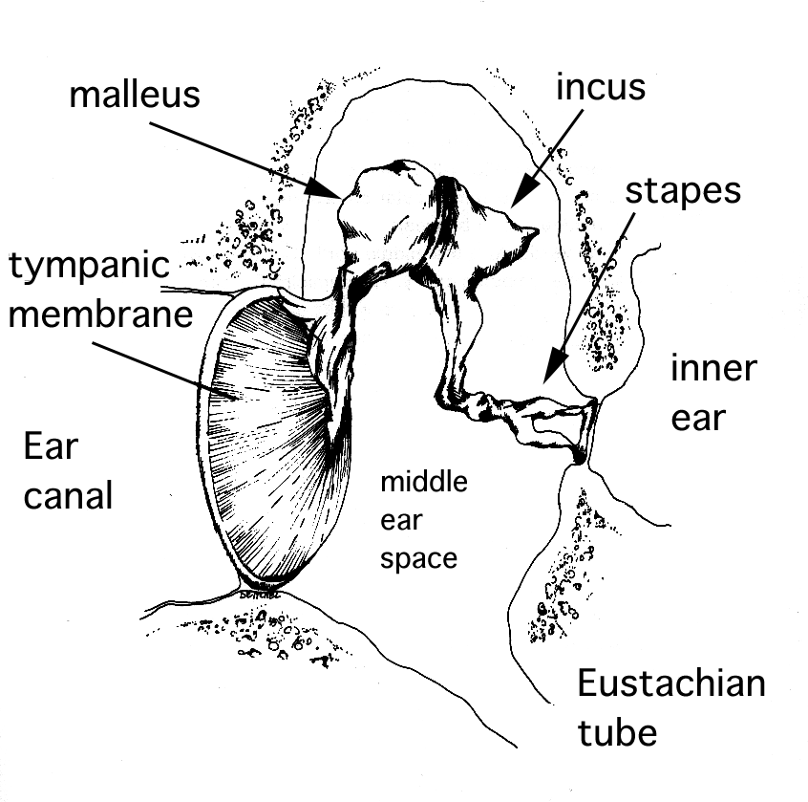
Tympanic membrane (ear drum)
- A thin, flexible and fibrous __________________ about 1cm in diameter
- __________________ when sound waves come in contact with it
  - Turning sound waves into ____________________________________

Ossicles
- ____________________________________located in the temporal bone
- Made up of 3 bones:
  - Hammer
  - Anvil
  - Stirrup
- The hammer (__________________)
  - Touches the __________________and moves as a response to the movements of the eardrum
  - It then hits the __________________
- The anvil (__________________)
  - The anvil __________________ vibrations from the hammer to the _________________
- The stirrup (__________________)
  - the stirrup __________________vibrations from the anvil to the __________________ (another membrane)
Eustachian tube:
- The canal that links the __________________to the __________________ (throat)
- Allows for ____________________________________on either side of the eardrum by swallowing
  - There is _____________on either side of the ear drum that can be at different pressures
  - The Eustachian tube is ____________________________________but can be opened to ____________________________________in order to equalize the pressure on both sides
  - The Eustachian tube also allows for __________________ to drain from the middle ear during allergies or an infection; this ____________________________________can also lead to ____________________________________
Why do you sometimes have trouble hearing when you have a cold?
- The build up of mucus can ____________________________________of air between the middle ear and throat and thus decrease the ability of the __________________or __________________ to conduct sound properly.

Inner Ear
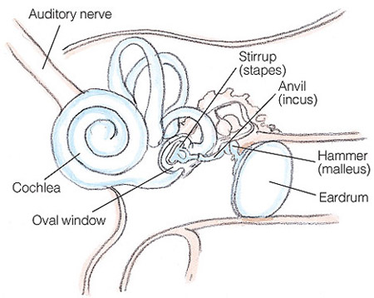
Semi-circular canals:
- 3 sets of __________________________________tubes
- Help in ___________________________________and _________________ when the body is in _________________
Vestibule:
- _________________structure that links the semi-circular canals to the cochlea
- Helps with balance when the body is in a _________________ position
- Linked to the __________________________________
Cochlea:
- Liquid-filled structure lined with hair-like __________________________________
- Connected to the __________________________________
- The auditory nerve then transmits nerve impulses to the ______________________of the brain
  - Remember from our notes on the brain?

Hearing Loss
Two main types of hearing loss:
- __________________________________
- __________________________________
Conduction deafness:
- Conduction deafness occurs when there is a problem __________________________________
- It is a _________________problem
Where does conduction deafness occur?
- Conduction deafness can occur anywhere along the route that sound travels. This can be in the _________________, the tympanic membrane (_________________) or in the ____________________________ (damage to ossicles).
- It could also occur due to a build up of _________________ or ___________ (in an ear infection)
Nerve deafness:
- Occurs when there is damage done to or abnormalities in the __________________________________, the __________________________________or the processing centres in the _________________
Presbycusis:
- __________________________________hearing loss that results from damage to the ___________________________________________________ in the cochlea
  - Ability to hear __________________________________is the first to go usually

Organs of Balance
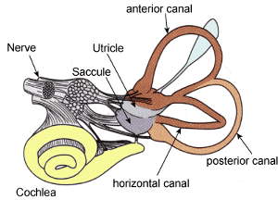
The organs of balance:
- The _________________________________ (3)
- _________________:
  - Made up of the _________________ and_________________
The organs of balance are again filled with fluid and lined with hair-like receptors that detect _________________

Vestibule
- The saccule and utricle are filled with a jelly-like fluid (__________________________________) that contains small particles called _________________.
  - Otoliths are small particles of __________________________________in the jellylike substance filled inside the saccule
- When the head moves, the particles move in response to _________________ (so if you move your head down, the particles would move down) and this triggers _______________________ which __________________________________to the brain, letting it know the _________________of the head.
The Semi-Circular Canals
- The semicircular canals help you to respond to __________________________________
  - like starting, stopping and turning
- The canals are set at right angles to one another and on __________________________________. The canals are filled with liquid and lined with __________________________________ that respond to the ___________________________________________________.
  - The brain will recognize which impulses are coming from which canal and therefore lets it know __________________________________your head is moving.

