Notes: Diffusion and Osmosis
Cellular Respiration Review

Photosynthesis vs Cellular Respiration
Photosynthesis

Cellular Respiration

Rubber Eggs!
Observations of first egg

What do you think happened to the egg?

Observations about eggs A and B
Egg A | Egg B

What happened to these eggs? Explain using a drawing, words, etc
Egg A | Egg B

Diffusion:
- ________________________________________________________ from an area of ___________________ concentration to an area of__________________ concentration
Think back to the egg we saw in class…the same thing will happen with a cell
- Substances will move ______________________________________from __________________________________ to __________________________________
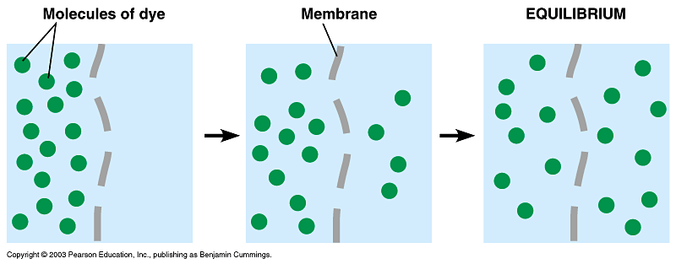
Osmosis
- When the substance undergoing diffusion is ___________________, we call the process ___________________
  - The water will move across the membrane to establish equilibrium
  - For both diffusion and osmosis ______________________________________the membrane continues until the ________________________________________________________________________
Types of Solutions
- Hypertonic solution:
  - ___________ ________ (substance) ___________________ the cell than inside the cell (hyper means “a lot”)
- Hypotonic solution:
  - ___________ ________ (substance) ___________ ____ the cell than outside the cell (hypo means “low”)
- Isotonic solution:
  - The concentration is the _____________ inside and outside of the cell (iso means same)
High sugar concentration  Low sugar | High sugar  Low sugar concentration

Closing Thoughts
Based on your newfound understanding of osmosis and diffusion, why can you not place a saltwater fish into a freshwater aquarium? Or a freshwater fish into a saltwater aquarium?
  - E.g. why can’t you put a goldfish in the ocean??

