Contraception and Menstrual Cycle Activity

Female Menstrual Cycle
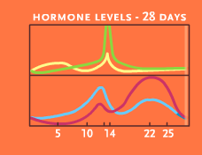
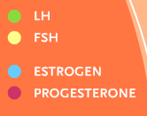

Menstrual Cycle with Pill
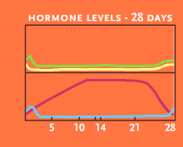
Legend

