Notes: Circulatory System

In order for blood to get to all the places it needs to in the body it needs to be ________________
- This pumping is done by the _________________!
The heart is located in the thoracic cavity ___________________________________
- In adults it is about the size of ____________________

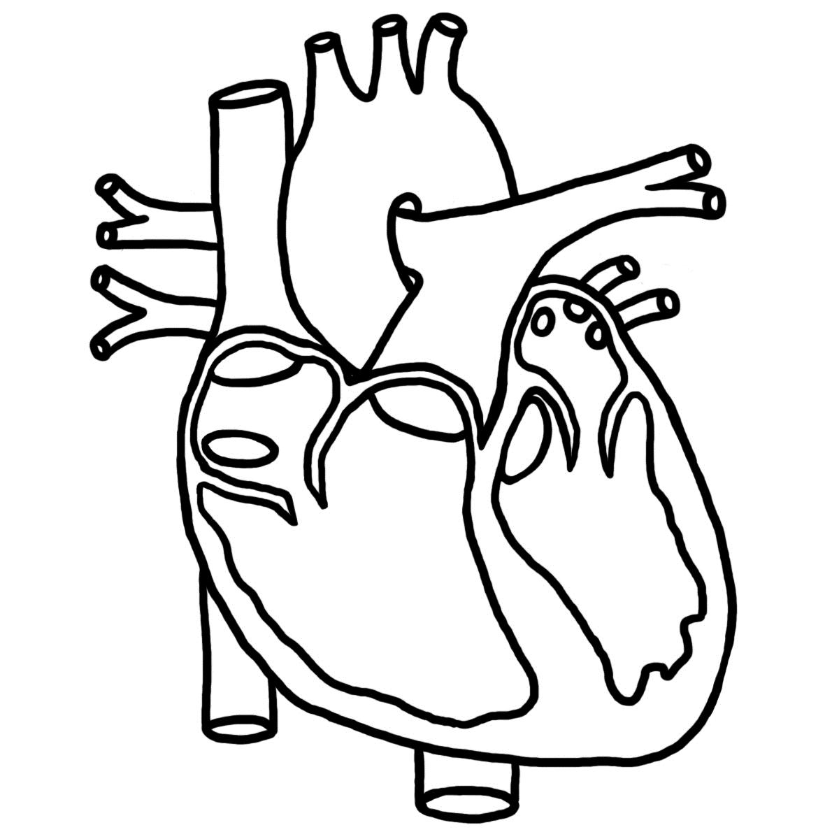
The heart is a hollow muscle with four cavities
- The ________________________________________
- The ________________________________________
- The ________________________________________
- The ________________________________________

The __________________________ is connected to the _______________________________through a _______________________
  - the tricuspid valve
The _______________________________ is connected to the _______________________________ through a _______________________
  - The bicuspid (or mitral) valve
The tricuspid and bicuspid valves are the ______________________________________________valves (because they connect the atria to the ventricles) and are designed so that blood can only move in ______________________________________________
  - From the _________________ into the ____________________
There is _______________________________ blood movement between the left and right side of the heart

Movement into and out of the Heart
Blood enters the heart through 2 sets of _________________
- The ____________________________ veins
  - Blood coming from the _________________ to the heart
- The _________________ and ___________________________________________________
  - Blood coming from the rest of the _________________to the heart
Blood exits the heart through 2 main sets of ________________
  - The ________________ arteries
    - Blood going to the ________________
  - The ________________
    - Blood going to the rest of the ________________
Remember: the heart is responsible for _________________________________ throughout the body
- For this to happen blood must be allowed to __________________ the heart before it can be _______________________________

Blood entering the heart
- For blood to ________________ the heart (through the ________________), the muscles must be at ________________ (relaxed, not contracting)
  - This is called the ________________ phase
Blood exiting the heart
- For blood to ________________ the chambers, the muscles must ________________
  - Both ________________________________at the same time, pumping blood into the ______________________
  - A few tenths of a second later, both ________________________________in order to push the blood into the ________________
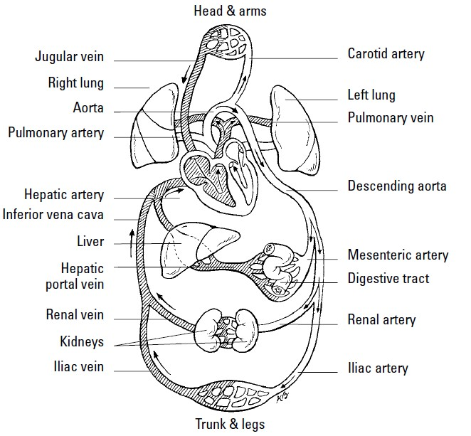
    - This is called the ___________________phase

Types of Circulation
Pulmonary: the path followed by ______________________________________________________ away from the ____________________________________________and then back to the heart as __________________________________________________________________
- ____________________________________________diffuses out of the blood and ____________________________________________and ______________________ diffuses ____________________________________________ (gas ______________________)
- Begins at the ____________________________________________, ends with the ____________________________________________

Systemic: the circulation of blood to all parts of the ______________, except to the lungs.
- Transports ____________________________________________away from the heart to the rest of the ________________, and returns ___________________________________________ (CO₂ rich) __________________________________
- __________________________________ O₂ out of blood, CO₂ into blood
- Begins in the __________________________________, ends with ____________________________________________

