Notes: Cells

Cells
The cell is the
We are made of about 10,000 billion cells.
At the beginning , but as they they become .
There are about 200 types of cells that

Structures inside the cell:
Cell Membrane:
- __________________________________ which _________________the cell, and ____________________________________________________________________.
Cytoplasm:
- __________________________________membrane which allows substances to circulate in the cell
Nucleus:
- ___________________________________________________ (growth and reproduction) and contains _________________
Nuclear Membrane:
- __________________________________and __________________________________ between nucleus and the rest of the cell
Vacuole
- __________________________________and __________________________________ inside the cell (and _________________ in plants)
Mitochondria
- Where __________________________________happens → ______________________

Endoplasmic Reticulum
- Folded network of canals that helps _________________ (thanks to ribosomes) ___________________________________________________
Chloroplasts
- Where __________________________________ happens (only in _________________)

Animal Cell

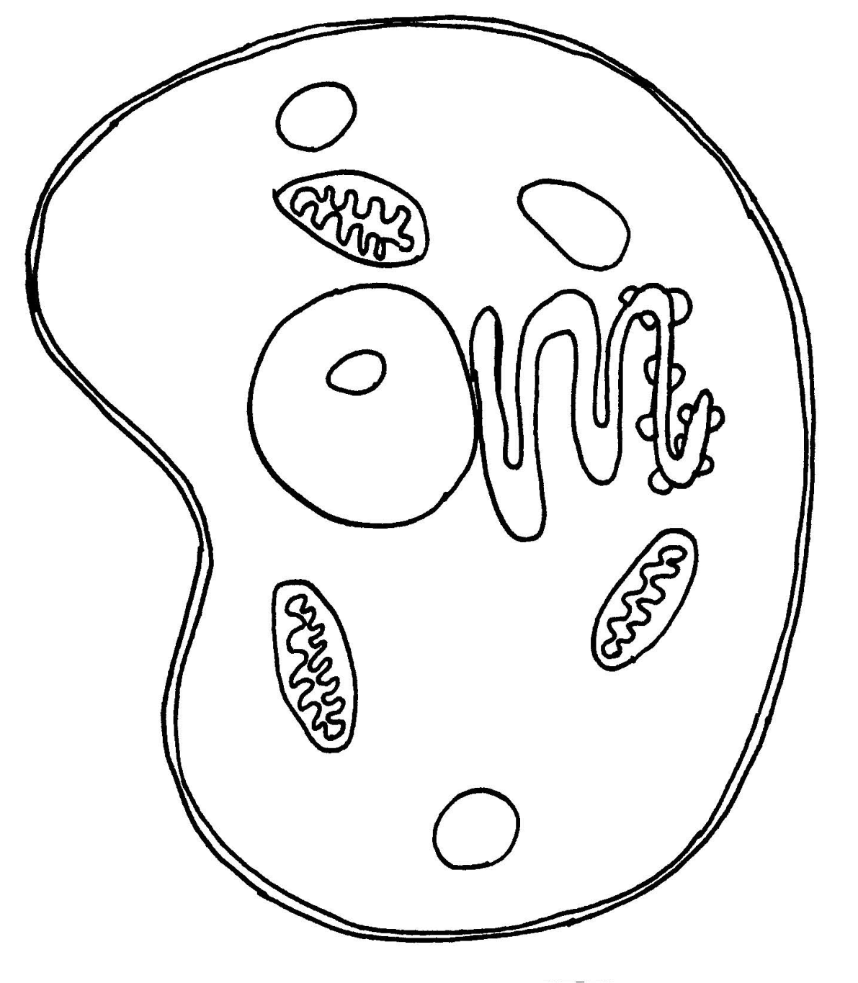

Plant Cell

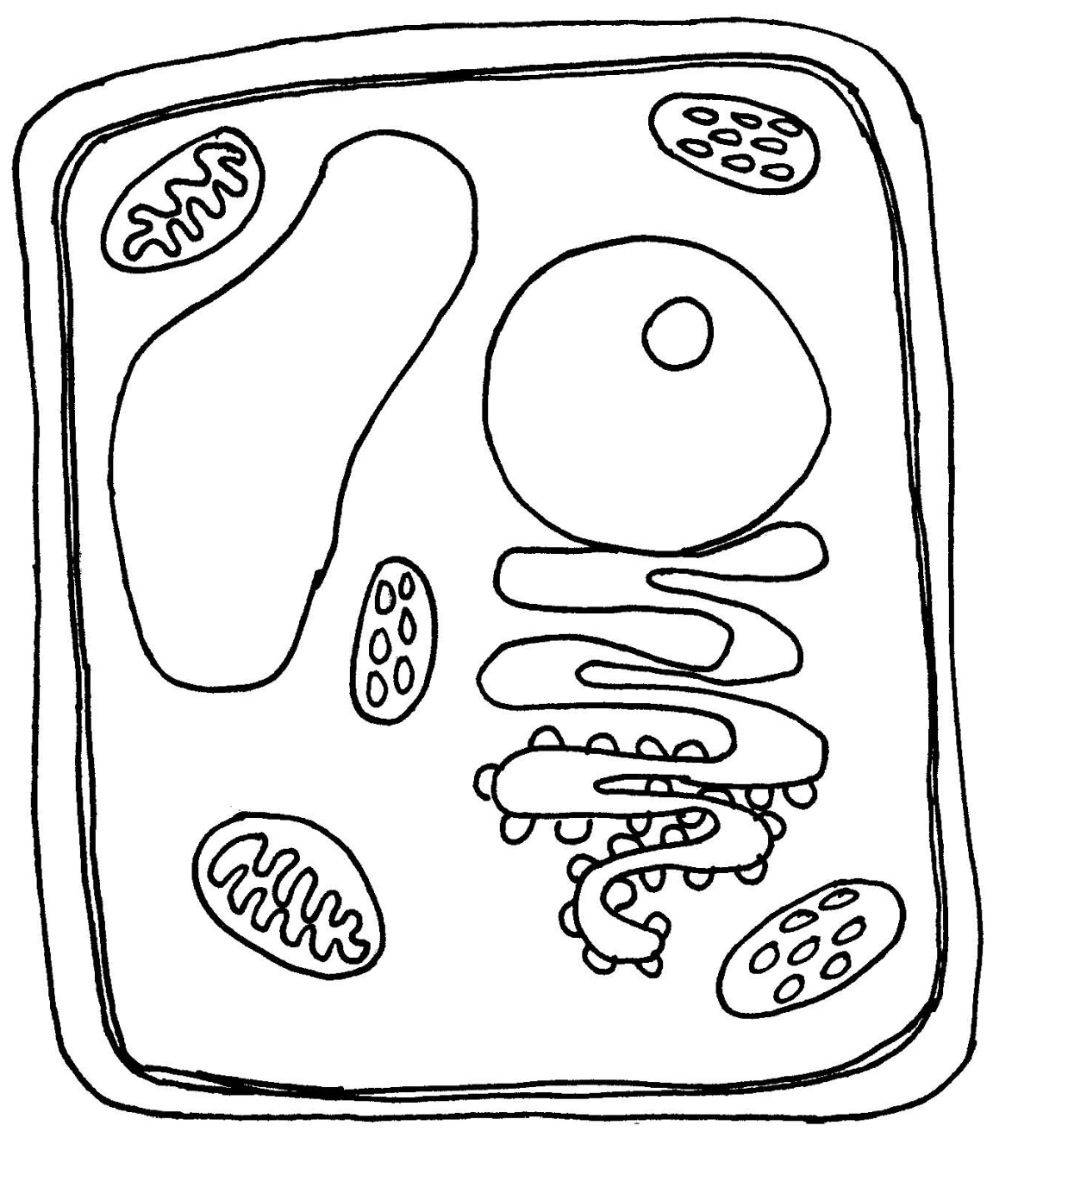

Cellular Reproduction
- Our focus this year is primarily on animal cells
- In particular, we are interested in the different types of cells and how these are produced
  - We’re going to start the year by discussing cellular reproduction
- The structures most essential for cellular reproduction are:
  - __________________________________
  - __________________________________
  - __________________________________
  - __________________________________

Conditions Essential for Life
- The conditions essential for the emergence of life on earth are the conditions that made it possible for the _________________________________________________________ and their ___________________________________________________
- These conditions are:
  - __________________________________________________________________
  - __________________________________________________________________
  - __________________________________________________________________
  - __________________________________________________________________

 | Essential Chemicals | Energy Source | Liquid Water | Time
Description
Source(s)
Other

Cellular Reproduction
The whole process of cellular reproduction is focused on the passing on of genetic material

DNA
- DNA stands for ___________________________________________________
- DNA is the __________________________________of most organisms:
  - It contains the “____________” that will ________________________________ ____________________________________________________________________________________________________________________________________
    - Reading the code tells the cells and its structures ___________________
- A DNA molecule is a ________________________________________ (a twisted ladder)
A complete molecule of DNA is called a _________________________.
- Each “bar” in the ladder is called a ____________________ and is made of 2 base pairs.
- There are 4 bases:
  - _________________________________________________________________
- They are always paired: __________________________________
- The _________________in which these base pairs are arranged _________________ ___________________________________________________ (the “code”)
Chromosomes:
  - Structures containing an ____________________________________________ (a ___________________________________________________). In animal and plant cells, the chromosomes are located in the _________________.
  - Chromosomes form when DNA packs itself up tightly by _________________ itself again and again until it is shaped like an X.

Chromosomes contain:
- Genes:
  - These are ___________________________________________________that _________________________________________________________________.
    - ex: eye color, skin color, etc.
  - We all have __________________________________but minor _____________________ make us all unique.
    - There are different variations of genes possible and these can be ___________________________________________________.

Cell Division and Multiplication
- As we already mentioned, the genetic information contained in the nucleus is _________________
  - Meaning it is passed on __________________________________; __________________________________
  - This happens during __________________________________
- Why would cells need to reproduce?
  - __________________________________________________________________
  - __________________________________________________________________
  - __________________________________________________________________
- To reproduce a _________________________________________, humans require __________________________________
  - And this requires the product of sex cells (_________________) through _________________
- But we do sometimes need to reproduce individual _________________for _________________ or _________________ through _________________ reproduction
  - And this is done through _________________

Mitosis vs Meiosis
- There are 2 types of cellular reproduction:
  - Mitosis: when a cell divides to produce __________________________________________________________________
    - Used for ___________________________________________________
  - Meiosis: when a cell divides to produce ________________________________ ___________________ that are each _________________from the original cell. These daughter cells only contain ___________________________________ _________________________________
    - Used to create __________________________________

Mitosis
- Ensures _________________ (an increase in the number of cells that make up an organism).
  - When our bodies grow so does the __________________________________, so we have more cells when we are adults than when we were babies
  - __________________________________: number of mitoses carried out by cells (more intense during childhood and adolescence than any other stage of life)
    - __________________________________________________________
- Ensures __________________________________ (ex. injuries, cuts, fractures, etc) or tissues that have become __________________________________
  - Certain cells wear down more easily than others and need replacing more often
    - E.g. skin cells are replaced every 2 weeks and white blood cells every 120 days)
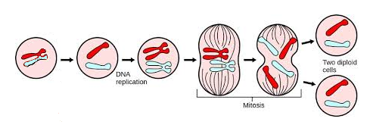

Steps of Mitosis
- DNA _________________
- DNA _________________
- DNA _________________ into _________________
- Chromosome __________________________________
  - Half go to one end, the other half to the other
- New nuclear __________________________________around the two new cells
Go from ___________________________cell to _______________________________cells

Diploid vs Haploid
- Diploid:
  - A cell that contains _____________________________________ (one from each parent) → _________
- Haploid:
  - A cell that ______________________________________________________ (half of what is needed to make a full individual) → ________

Meiosis
- _________________ is a form of cell division that produces ___________________ ___________________that are __________________________________________ ______________ because they each contain __________________________________
  - The result is 4 daughter cells, each contain _____________________________ and all different genetic material.
- Each daughter cell ends up with ____________________________________________. These are called __________________________________.
- This is used to create sex cells
  - Sex Cells: __________________________________ (eggs), are also called _________________
- In order to produce cells that contain only half the DNA, there are ________________ __________________ that take place.
- The _________________ one is ________________________________________ (where DNA doubles itself first)
- The _________________division happens right after the first division, ___________________________________________________

Steps of Meiosis
- DNA _____________________
- DNA _____________________
- DNA ____________________ into _____________________
- ______________________ chromosomes _________________and swap sections of DNA
- Cell _________________ into two diploid cells with homologous pairs
- Each of these cells then __________________________________
- Nuclear _________________ forms
Go from _________________cell to _________________cells
These are the _________________ (sperm or ova)

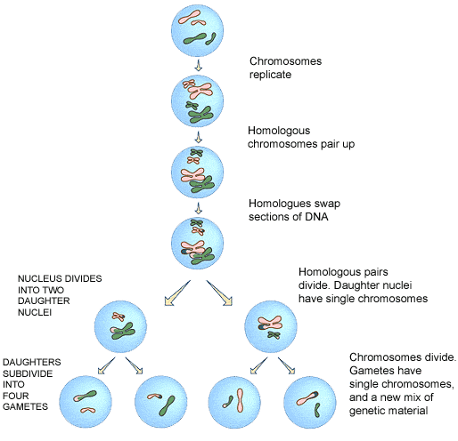

Meiosis and Fertilization
- Meiosis __________________________________________________________ ___________________________.
- During _______________________ millions of spermatozoa (n) encounter the ovum (n).
  - Only ______________________will be able to penetrate _________________ and combine the male genetic info (n) with that of the female (n) to produce a _________________.
  - From there, _________________ results in the development of an _________________ (the first steps to a baby)

Cellular Organization
- Remember: _________________give a total of _______________________________ of which ½ come from the mother and ½ from the father.
  - 22 of the 23 pairs are similar in both sexes
  - The _________________is made up of the ______________________________
- A chart showing the pairs of chromosomes in descending order of size is called a __________________________________

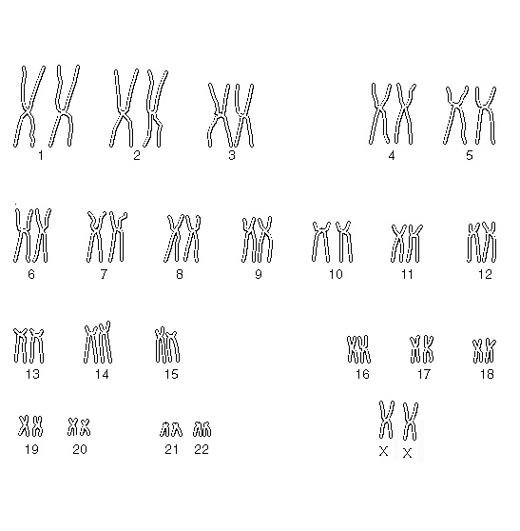
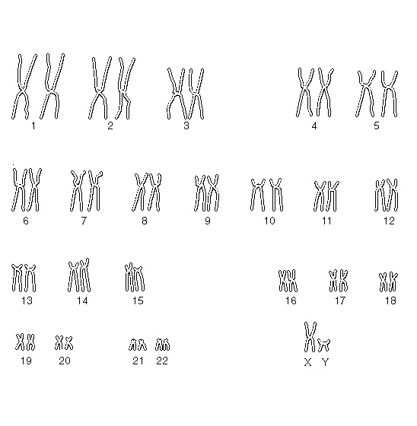
Genetic Diversity
- Genetic diversity:
  - is the __________________________________among the individuals of the __________________________________.
  - __________________________________of a species
    - Ex: not all susceptible to the same diseases, etc

Factors that contribute to genetic diversity
  - Genetic recombination: ______________________________________________________________________________________________________during the beginning of meiosis
  - Genetic mutation: where ________________________________________ __________________________________ (A,C,T,G).
    - This can be caused by UV rays, X rays or cigarette smoke.
  - Population mixing: where _______________________________________ ______________________________________________

What comes next?
- ________________________________________can perform all the ________________________________________to survive.
- ________________________________________being more complex require cells to ____________________________________________________________to perform these same functions.
- These cells are grouped into:
        - ________________________________________
        - ________________________________________
        - ________________________________________
        - ________________________________________

