Notes: Nervous System I - Brain

Nervous system: The system that __________________, ___________________, ________________ and __________________ information that comes from various parts of the body and the external world
The nervous system is composed of two parts:
- ______________________________________________________
- ______________________________________________________

The Central Nervous System (CNS)
The central nervous system is the part of the nervous system that is made up of the ________________ and the ________________________.

The Brain
The brain: __________________________________________________________________________________________________________________________________________________________________________
The brain can be divided into 3 main parts:
- __________________________________________
- __________________________________________
- __________________________________________

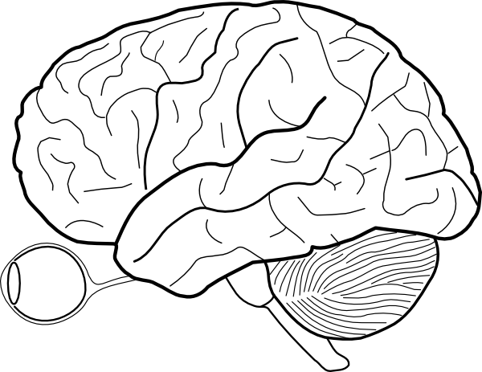

The cerebrum: the cerebrum is the ________________________________for all voluntary movement, interpretation of senses, emotions and intelligence. In other words it is responsible for: _______________________, ____________________________, ______________________________, and ___________________________.
The cerebrum is divided into the right and left _________________________.
The left hemisphere | The right hemisphere
Controls the ___________________ side of the body | Controls the ___________________ side of the body

The cerebrum is made up of two types of matter:
- ______________________________: the outer layer
  - Also sometimes called the cerebral cortex
  - Directs higher brain functions like , , and .
  - Grey matter makes up about of the brain and uses up about

- ______________________________: the inner layer
  - Acts as a relay between the different brain regions
    - In other words, it coordinates
  - White matter makes up about of the brain
The cerebellum: the part of the brain that coordinates and (by contracting the appropriate muscles).
The brain stem: the part of the brain that is responsible for regulating _______________________, _____________________________, ___________________________________________________.
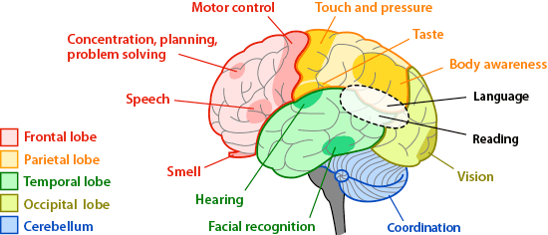

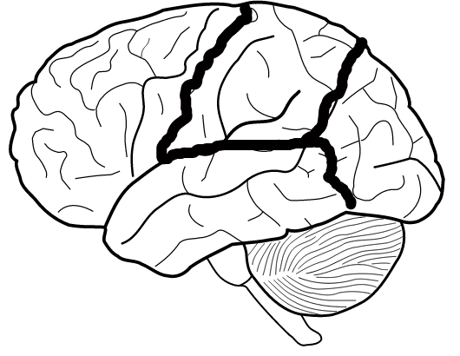

Frontal lobe: , , ____, ______________________ , ____, ________________________
Parietal Lobe: ,
Occipital Lobe:
Temporal Lobe: , ,

