Notes: Blood Types

Blood Types
Determined by blood ____________________________
  - The antigens are ____________________ markers or bumps on the surface of the ________________________________________
  - There are three main antigens (proteins)
    - _______
    - _______
    - _____________________________ (Rhesus factor) which determines positive/negative
If we combine these different antigens, there are _____ different blood types possible in humans:

- _____________
- _____________
- _____________
- _____________
- _____________
- _____________
- _____________
- _____________

What does this mean?
If you are blood type A:
- You have the ________________________(protein)
If you are blood type B:
- You have the ________________________ (protein)
If you are blood type AB:
- You have both the ________________________and the ________________________
If you are blood type O:
- You don’t have either antigen (________________________)
Then if you have a “______” it means you also have the ______________________________
- Ex: if you are __________you have the _______ antigen and the _______ antigen
If you have a “_____” it means you ____________________the _______________ antigen
- Ex: if you are _________you only have the_______antigen

Antigens and Antibodies
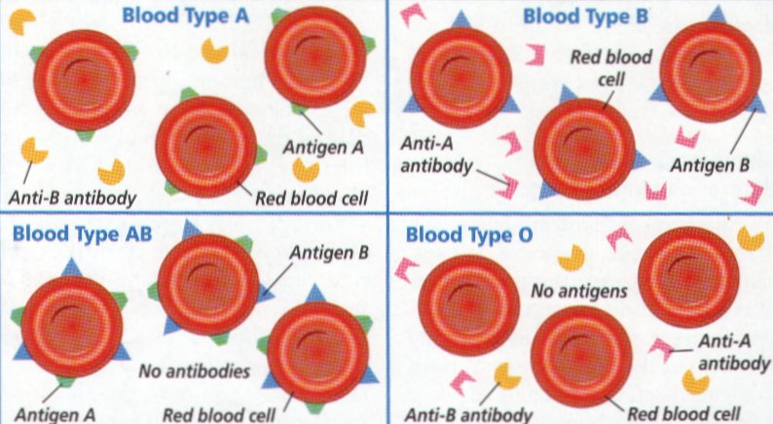
What are antibodies?
They’re ______________ used by the __________________ system to ______________and ______________ unwanted things in the blood
- They’re like the blood’s ________________________! They attack anything that’s not supposed to be there
For every blood type there are ______________ for the other types.
- For example, if you are _______
  - You have the ___________________and the _____________________
  - You don’t want _______ blood so you have ______________antibodies

I CANNOT RECEIVE WHAT ________________________

Determining Blood Type
  - Place 2 drops of _____________________on each spot of the spot plate.
  - Add 2 drops ______________to spot A, 2 drops of ______________to spot B and 2 drops of ______________to spot Rh.
  - When _______________________happens, the RBC has the _____________ _______________.
- If it clumps it’s because the _____________________found the ______________ they are there to protect against
  - Record your results.
Test Results
ABO Blood Reactions
 | A | B | AB | O
Anti-A
Anti-B

Blood Transfusions
The _____________________________________________into a person
- Recipient -> _________________________ (gets) blood
- Donor -> _________________________ (gives) blood
The recipient ___________________________________blood with ______________ that are __________________________________________________in his/her own blood.
Blood will _____________________ (coagulate/clump) if it is mixed with blood having foreign ______________
Universal Donor
- Is blood type ______
  - Can give to every blood type since it has ________________________________
Universal Recipient
- Is blood type _______
  - Can receive every blood types since it has _______________________________

Blood Compatibility Chart
 |  | Donor Blood Type
 |  | O- | O+ | A- | A+ | B- | B+ | AB- | AB+
Recipient Blood Type | AB+
 | AB-
 | B+
 | B-
 | A+
 | A-
 | O+
 | O-

