Notes: Blood and its Components

What is blood?
Blood is a _____________________________________________________________
- It connects many different organs and tissues in the body and ______________________various substances from one to the other
It has a ________________________component (________________________) in which ________________________ are suspended (blood cells, platelets, etc)
- These formed elements make blood more ________________________ (thick)
- It is a __________________!

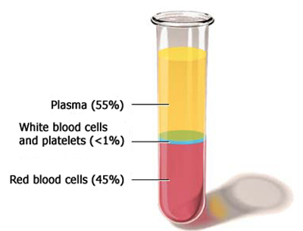
Constituents of Blood
________________________ is the ____________________________________
Formed elements:
- ________________________
- ________________________
- ________________________

Plasma
This is the ________________________ component of blood
Has a slightly ________________________ colour
Makes up about _________of total blood volume
Composed of:
- ______water
- ______ dissolved substances:
  - Nutrients, hormones, antibodies, proteins
Function:
- ________________________________________________________to cells (ex: oxygen, nutrients) and transport ________________________to excretory organs (ex: carbon dioxide)

Red Blood Cells
Also called ________________________
Part of the formed elements in the blood
- They are the most ________________________!
Their shape is a ________________________ disk (a disk with indents on both sides)
They don’t have a ________________________
Contain ________________________
- The protein that binds to ________________________ and _____________________________
Function:
- To ________________________________________________and ________________________

White Blood Cells
Also called ________________________
The ________________________________________________formed elements in the blood
Characteristics:
- Actually ________________________as opposed to white
- Don’t have a regular shape; can take on _______________________________________
- Have a ________________________
Function:
- Provide ________________________
  - _________________ against foreign bodies and ________________ by creating ______________________

Platelets
Also called ________________________
Characteristics:
- Cell ________________________ (little bits of cell)
- No ________________________
- ________________________ of the formed elements
Function:
- Help in ________________________ (blood clotting)
  - This is important for repairing _____________ which helps prevent you from bleeding out!

