**Atmosphere and Lithosphere Worksheet**

1. What is the difference between a rock and a mineral?
2. A teacher takes an enormous rock from her garden and shatters it into small pieces. She gives each of her students a piece, and they must analyze its hardness, colour and streak. Will all the students obtain different results? Explain your answer.
3. Read the statements below and classify them as igneous, sedimentary or metamorphic rocks.
4. Transformed rock due to heat and pressure
5. Rock with accumulated debris
6. Occurs in or outside a volcano
7. Name each layer of soil and give a characteristics of each.

[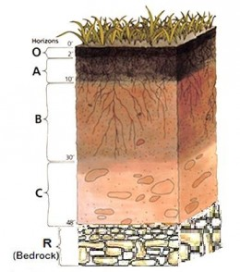](http://www.google.ca/url?sa=i&rct=j&q=soil+horizons&source=images&cd=&cad=rja&docid=qiDCmi9nH0tZlM&tbnid=mlGA_1VCezM13M:&ved=0CAUQjRw&url=http://cuttler.hubpages.com/hub/Soil-pH&ei=WnR8UbnPDZKL0QGH_4FY&bvm=bv.45645796,d.dmg&psig=AFQjCNE1v6gcd6EG8zG8GhjNJXDNIha_pw&ust=1367197009333640)

1. Explain how soil is produced.
2. Some regions of Québec are known for being very fertile, while others are much less fertile even though they are exposed to the same climate. What are the three conditions for soil fertility?
3. Which statement regarding a mineral ore is TRUE?
4. All rocks in the lithosphere are ores.
5. A mineral ore is a rock not found in the Abitibi and North Shore regions.
6. A mineral ore is a rock rich in minerals that can be mined profitably.
7. A mineral ore contains only metal-bearing minerals
8. The following map indicates the location of an anticyclone (A) and a depression (D) on July 30.



a- Using the information on the map shown above, describe the weather conditions on the Îles-de-la-Madeleine and in Kuujjuaq on July 30.

b- Name the place (Îles-de-la-Madeleine or Kuujjuaq) with the higher atmospheric pressure on July 30.

1. Looking at the weather map below. Give two differences with regards to weather conditions where the letter ‘L’ is compared to the letter ‘H’.

[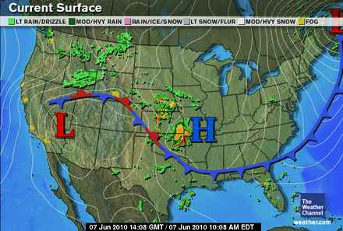](http://www.google.ca/url?sa=i&rct=j&q=&esrc=s&source=images&cd=&cad=rja&uact=8&ved=0ahUKEwin0cro4_vQAhUr0YMKHezAAQgQjRwIBw&url=http://climate.ncsu.edu/edu/k12/.fronts&psig=AFQjCNEEqoZcVPteiQDfHDEQrROOijmyPA&ust=1482083058124917)

1. An air mass that originated in the Caribbean now lies over Québec, while a fast-moving air mass from the far north is heading down toward the southern part of the province. Given that the air mass from the far north is moving faster than the air mass that came up from the Caribbean: Explain what happens when these two air masses meet.
2. A mineral exploration company was planning a trip to the Far North to check whether the rocks in the area contain fossil fuels. However, the organizer first wanted to be sure that the weather would be conducive to his undertaking the expedition. The meteorological conditions in the Far North region for the two days prior to the intended departure are recorded in the table below.

|  |  |  |
| --- | --- | --- |
| **Date** | September 10 | September 11 |
| **Hour** | 07: 00 | 07: 00 |
| **Temperature** | 7°C | 1°C |
| **Pressure** | 102.1 kPa | 103.6 kPa |
| **Relative humidity** | 55% | 37% |
| **Rainfall in the previous 12 hours** | 8 mm | 1 mm |
| **Wind velocity** | 22 km/h | 8 km/h |
| **Wind direction** | West | South-west |
| **Nebulosity** | Cumulonimbus clouds | Clear sky |

Based on the information above, what was the likely weather forecast for September 12?

1. Fill in the blank

|  |  |
| --- | --- |
| a) The Earth receives ____________ energy which is distributed by atmospheric circulation.  b)What type of wind is illustrated on Figure 1 by the thick black arrows?  c)Name two types of prevailing winds. | Figure 1: Circulation Cells and Prevailing Winds |

1. Louise is listening to the weather forecast with her friend Lucy.

TV host: “A warm front is heading toward our region and will remain over the area for the whole week . . .”

Lucy, all excited, interrupts the forecast to say to Louise: “Great! Nice weather at last! Do you want to go camping this week?”

Louise: “Wait. Let’s listen to the rest of the forecast first.”

Lucy does not understand why Louise does not share her enthusiasm about the weather forecast. Is Lucy right to think that the weather will be nice in the coming days? Explain your answer.

1. Louise and Lucy try once again to organize a camping trip. Louise has bought a barometer to predict the weather, but she doesn’t know how to read it. She has been watching the barometer since early this morning: the needle is slowly rising, and its current reading is 101.3 kPa.

Considering the barometer reading, would you recommend the camping trip? Explain your answer.

1. A highly trained cyclist leaves Montréal for Québec. At the same time, another cyclist, of equal ability, makes the trip in the opposite direction. If a high-pressure system is hanging over Montréal, and a low-pressure system, over Québec, which cyclist will be the first to arrive at destination? Explain your answer.
2. Out of concern for the environment, Sophie has chosen to leave her car at home two days a week and walk to the office instead of driving. Before leaving home, she listens to the radio. According to the weather report, a high-pressure area has appeared over the city where she lives.

a) What is the name of the weather system affecting the city?

b) Explain if Sophie should take an umbrella to work?