Additional Information
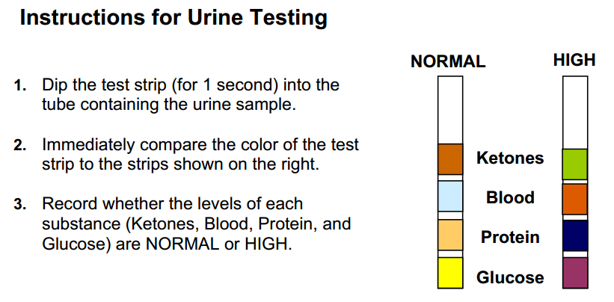
Interpreting Urine Test Results
Ketones
Ketones are present in the urine when a person does not eat enough carbohydrates (for
example, in cases of starvation or high-protein diets), or when a person eats enough
carbohydrates but his body can’t use them properly (for example, if he has diabetes).
Ketones are produced when the body metabolizes fat (instead of carbs) to get the energy
it needs to keep functioning.
Protein
Protein is not normally present in the urine. Healthy kidneys take wastes out of the
blood but leave protein in the blood. Damaged kidneys may fail to separate blood protein
from the wastes and protein may leak into the urine. A small amount of protein in urine
can be an early sign of kidney disease. As kidney function worsens, the amount of
proteins in the urine increases. Other conditions may also result in protein in the urine.
Blood (Hemoglobin)
Normally, red blood cells and hemoglobin are not present in urine. Healthy kidneys do
not allow blood cells to move from the blood into the urine. Even small increases in the
amount of red blood cells or hemoglobin in urine may indicate disease. Numerous
diseases of the kidney and urinary tract, as well as trauma, medications, smoking, or
strenuous exercise, can cause red blood cells or hemoglobin to be present in the urine.
Glucose
Glucose is normally not present in urine. When glucose is present it may result from a
high concentration of glucose in the blood (due to diabetes) or a kidney problem.
Therefore, when glucose is present in the urine, further testing is recommended to
identify the specific cause.
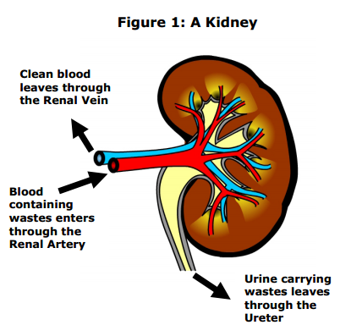
A. Kidneys Regulate the Composition of Blood
Your kidneys play a vital role in maintaininghomeostasis. They excrete (remove) urea and other wastes, regulate the amount of water in the blood, and adjust the concentration of various substances in the blood. The
substances removed from the blood form urine. The cleaned blood then travels to the heart and
is pumped to the rest of the body.
As blood travels through the kidney, some blood components need to be:
• Kept in the blood because they are essential. Red blood cells, white blood cells, protein, glucose and amino acids should be kept in the blood. These components should not be present in urine.
• Removed from the blood and excreted in the urine because they are toxic (poisonous). Urea is a toxic substance that should be removed from the blood.
• Balanced so they are present in the correct concentration in the blood. A certain amount of water and salt is needed by the body and will remain in the blood. If excess water and excess salt are present in the blood, they should be excreted in the urine.
B. Kidneys Filter Blood
Each kidney contains over 1 million microscopic blood-cleaning units called nephrons. A nephron, shown in the diagram below, is a tiny tube with a cup-shaped structure on the end. The cup-shaped part of the nephron surrounds a tight ball of capillaries called a glomerulus.
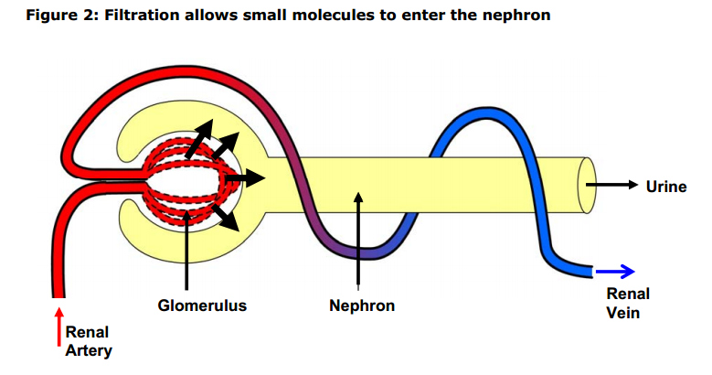
Blood enters the kidney through renal arteries. The renal arteries branch to supply blood to the
tiny balls of capillaries called glomeruli. The walls of the glomerulus capillaries are porous.
They act like filters to allow small molecules to move under pressure from the blood into a cuplike part of the nephron. The movement of materials out of the glomerulus capillaries and into the nephron is known as filtration. The fluid that collects in the nephron is called the filtrate.
C. Kidneys Reabsorb Needed Substances
Obviously you can’t afford to lose large amounts of water, salt, glucose, and amino acids in your
urine! So a second process, called reabsorption, moves essential materials from the nephron
back into the blood. Reabsorption occurs when transport proteins molecules in the walls of the
nephron return essential substances such as glucose, amino acids, water, and salt to the
capillaries that surround the nephron.
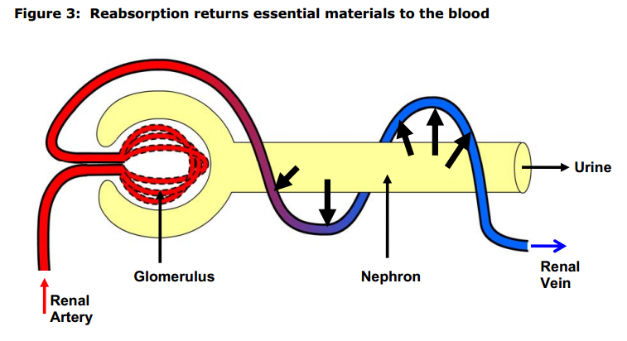
Complete Reabsorption.
Some essential molecules, such as glucose and amino acids, are kept by being completely
reabsorbed. These molecules should be completely returned to the blood and should not end
up in the urine produced by the kidney. Specific transport proteins in the nephron use energy to
move these molecules from the nephron into the capillaries that surround the nephron.
Selective Reabsorption
Other molecules, such as water and salt, are balanced by being selectively reabsorbed to
maintain the proper salt and water balance in the body. Their reabsorption is regulated so that
they are returned to the blood if needed but are excreted in the urine if present in excess
amounts. Specific transport proteins in the nephron use energy to move these molecules from
the nephron into the capillaries that surround the nephron.

