Notes: Hydrosphere

The _______________________________________ on the Earth:
- Includes _______________________and _______________________ forms
  - _______________________
  - _______________________
  - _____________ (Cryosphere; freshwater)
- Gases technically belong to the _______________________

Freshwater
- Water with ______________________________________________
- Water found in ______________, _______________________, _______________________, _______________________, etc.
  - _______________________and _______________________ are also made of freshwater!
- The ________________________________of water that land animals (and plants) and freshwater organisms can drink

Saltwater
- Water with _____________________________________________________________ and minerals in it (more than 3%)
- The type of water found in __________, _______________________ and _______________________ (where saltwater and freshwater meet)
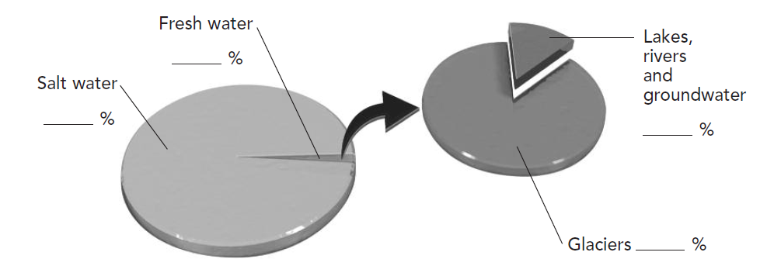

Hydrosphere
The hydrosphere can be split into 3 key categories
- _____________________________________________________________________
- _______________________ sources
- _______________________
- _______________________ sources
- _______________________
- “Frozen water”
- _______________________ sources

Inland Waters
Inland waters are ______________________________________________, which includes:
- _______________________
- _______________________
- _______________________

Catchment Areas/Watersheds
- Watersheds/catchment areas are areas where ________________________________ ______________________________________________________________________
Remember:
- Water flows _______________________! From areas of _______________________ ______________________________________________

Factors affecting flow in a watershed:
- _______________________
  - Shape, slope and terrain of the area
- _______________________
  - Type, depth and structure of surrounding rock
- _______________________
  - Amount of precipitation, temperature, winds, etc.
- _______________________
  - Density and diversity of plant life
- _______________________
  - Agricultural, Industrial and urban

Oceans
- Covers approx. _________ of Earth’s surface
  - 5 oceans (3 of which surround Canada)
  - ____________________________________________________________________________________________________________________________________
- Divided by _______________________
- Waters moved by _______________; _________________________________________
- Key parameters concerning oceans: __________________________________________

Ocean Temperature
3 key factors affect it
  - _______________________
    - Water temperatures relatively consistent for first 200m, then ___________ drastically in the _______________________
    - Deeper you go = _______________ sunlight = gets ________________
  - _______________________
    - Warmer in ____________________; colder in ____________________
  - _______________________
    - Warmer at _______________________, colder at __________________

Salinity
- The measure of __________________________________________________________
- Average salinity of oceans between _______________________

- 2 key factors affect it
  - ______________________________________________
    - _______________________ saline due to dilution
  - ______________________________________________
    - _______________________ saline due to evaporation

Melting of Pack Ice/Iceberg Example
Pour 0.3L of water into a beaker and then dissolve 6g of salt into the water. Lastly, add 3 ice cubes into the water.

Evaporation of Ocean Water Example
Pour 0.3L of water into a beaker and then dissolve 6g of salt into the water. Add heat!

Ocean Currents
- The _______________________ of seawater in particular directions
- Two types
  - Surface: _________________________________, causes ______________________________________________ (200m)
    - Result of the ______________________________________________
  - Subsurface: _______________________________due to _______________________ and _______________________ differences (800m+)
    - _______________________ water :
      - _______________________ water
      - water with ______________________________________________

Ocean Circulation
- ______________________________________________of all ocean currents moving water across the globe
- ______________________________________________is the combination of ______________________________________________ currents
  - _______________________ hot and cold water ______________________________________________
    - Responsible for ________________________________________ __________________________between equator and the poles
- How it works:
  - In _______________________________, ______________________surface water ______________ to the bottom of the ocean floor and travels along the ocean floor
  - When it gets to _________________________________(such as the _______________) the warmer ______________________water is heated and ____________ back up to the surface. Then the warm water travels along the surface

Summary – Thermohaline Circulation
- Water which is ______________________________will_______________because it is _______________.
- Water which is ______________________________will _______________because it is ______________________________.
- When water ________________________ the ocean will become ______________________________. When it _______________ the water becomes ______________________________.
- _______________ comes from the ________________________________________.

Cryosphere
- All the ______________________________________________on Earth
  - _______________________ (ice floes)
    - Ice ______________________________________________near the poles
    - Hugely affected (melting) by ____________________________________
  - _______________________
    - Masses of ________________________________________ (compressed snow)
  - _______________________
    - ______________________________________________that break off from glaciers and fall into the _______________________

Icebergs, Ice Floes and Glaciers
- Ice floes ________________affect _____________________, but icebergs _____.
  - Both affect the _____________________ content of the water.
- Glaciers also affect ____________________________and _____________________

Environmental Impacts
- Melting = _______________________salinity = change in ______________________________________________
  - Could affect ______________________________________________
- Melting = _______________________ ocean water levels = _______________________ of small islands and coastal area

The Hydrosphere and Energy
- Energy derived from ______________________________________________
- ______________________________________________energy converted into _______________________ energy (energy _______________________)
- All hydroelectric energy sources are _______________________
Two main sources
  - ______________________________________________
  - ______________________________________________ (still experimental-not in wide use…yet!)
Also:
- _______________________ (rare – not in wide use)

Hydroelectric Dams
- Majority of Quebec’s electrical energy comes from _______________________
- Forces the movement of water (kinetic energy) to turn _______________________, with the purpose of transforming it into ______________________________________________
Pros: Very _______________________; relies on a renewable resource
Cons: ______________________________________________when developing reservoirs and bypassing rivers

Ocean Turbines
- Like a wind turbine, but _______________________
- Underwater ______________________________________________ (kinetic energy) turn _______________________, with the purpose of transforming kinetic energy into ______________________________________________
Pros: _______________________produced, renewable resource, potential is huge for developing electricity
Cons: ________________________________________________________________________, still experimental, marine impact still being studied

Tidal Dam
- Similar in concept to hydro dam, yet runs on the ________________________________ of ocean water
- Tides are caused by the gravitational force between the Earth and the Moon
  - Water facing moon = ______________________________________________= _____________________________
  - Water on other side of Earth ______________________________________________= _______________________
  - Water ______________________________________________= low tide
  - Difference in height between high and low tide = _______________________
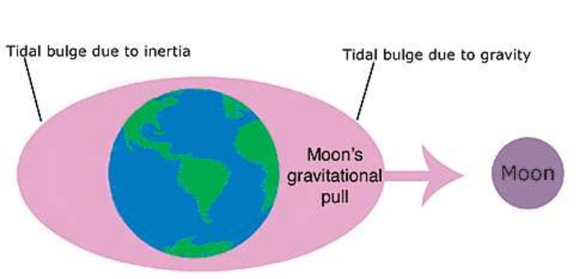

- High tide causes ______________________________________________.
- When low tide begins, gate opened, channeling water ______________________________________________, transforming kinetic energy of moving water into ______________________________________________.
Pros: _______________________ produced, uses renewable resource
Cons: Only works in ______________________________________________ (need a substantial tidal range), can be a trap for marine life

