Notes: Biogeochemical Cycles

Biosphere
- Sphere of _____________________________________________________
  - All the regions of the __________________________________________in which living organisms are __________________________________________.
- _______________________ with all the other spheres
  - Lithosphere: ______________________________________________ for land based organisms
  - Hydrosphere: ______________________________________________for water based organisms
  - Atmosphere: Necessary gases for all living organisms (_______________________)

Biogeochemical Cycles
- All living organisms require certain key _____________________ _________________________ to survive
- These chemicals are found in all of the spheres, and _____________________________ ________________________________________.
  - Without this _______________________, spheres would “_______________________” of these essential compounds/elements

Water Cycle
- Cycle where water goes from being on the _______________________of the Earth, to being in the _______________________, and finally going back to the _______________________ of the Earth
  - This cycle connects the _______________________ and the _______________________
- This cycle is possible thanks to ______________________________________________

Steps of the Water Cycles
- Evaporation and Evapotranspiration
  - Evaporation: Water in lakes, rivers and oceans _______________________and turn into _______________________ _______________________ (gas). Water vapour goes into _______________________
  - Evapotranspiration: Living things _______________________ and _______________________water vapour. Water vapour goes into _______________________
- Condensation – Cloud Formation
  - Water vapour in atmosphere _______________________ and _______________________ to form clouds
  - Clouds are made up of __________________________________ ____________of water

- Precipitation – Rain, snow, hail
  - Mini droplets get _______________________until they are ______________________________to remain in the atmosphere
  - Water ______________________________________________to Earth as _______________________ (either rain, snow or hail)

- Runoff and infiltration (absorption)
  - Runoff: Excess water _______________________ to a key body of water (ex: lake)
  - Infiltration: Precipitation seeps into the _______________________ and into ______________________________________________

Carbon Cycle
- The cycling of _______________________ (in different forms) in the different spheres
- Carbon mostly cycles throughout the spheres in the form of _______________________
  - Cycles through the spheres in its _______________________
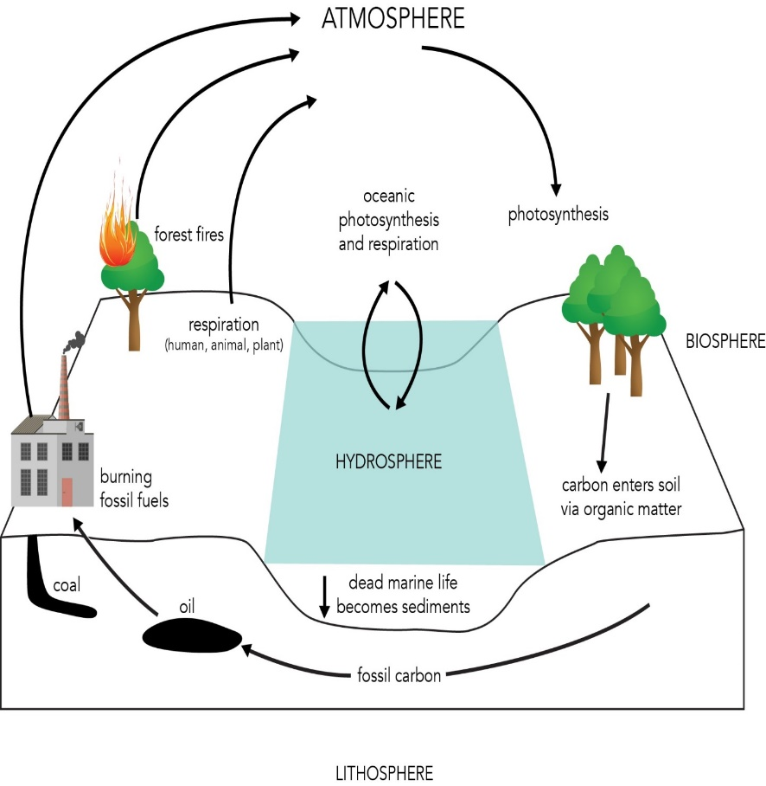
Things that put C into atmosphere:
    - _______________________
    - _______________________
    - ____________________________________________________________
    - _______________________
Things which take C out of atmosphere:
    - ______________________________________________
    - Formation of _______________ (sea creatures)
    - Formation of ____________________________ (takes millions of years)
    - Formation of _________________________________________ (water)

Stages that take CO₂ out of the atmosphere
- Photosynthesis: Plants take ______________________________from atmosphere with ___________________ to produce ____________________.
- Diffusion: Atmospheric CO₂ ___________________ into bodies of water. It is transformed into ______________________________________which is then ingested by aquatic organisms to form ______________________________________

Stages that put CO₂ into of the atmosphere (biotic)
- Respiration: living organisms ______________________________________as a by-product of ______________________________________
- Decomposition: living organisms are ______________________________________by decomposers, which produce ______________________________________ (CH₄) as by-products

Stages that put CO₂ into of the atmosphere (abiotic)
- Volcanic eruptions: Carbonic rock melting into magma produces _____________ which is then _________________________________________________________
- Forest fires: C in the form of cellulose undergoes ___________________, producing _______
- Burning of fossil fuels: C in the form of oil, natural gas and coal undergo ___________________, producing _______

Stages that put CO₂ into the lithosphere
- Decomposition: Sometimes living organisms are covered before they are decomposed by scavengers. The organism then ______________________________________
- Creation of fossil fuels: Under the right conditions, the organism is covered in ___________________, and slowly (through millions of years) transforms into ______________________________________
- Creation of carbonic rock: Aquatic organisms covered in sediment transform their exoskeleton and shells into ______________________________________.

Nitrogen Cycle
- The cycling of _______________________ (in different forms) in the different spheres
- Nitrogen is needed by living organisms for the manufacture of ____________________ _________________
  - ______________________________________is made up of _________ but we _________________________________it in this form!
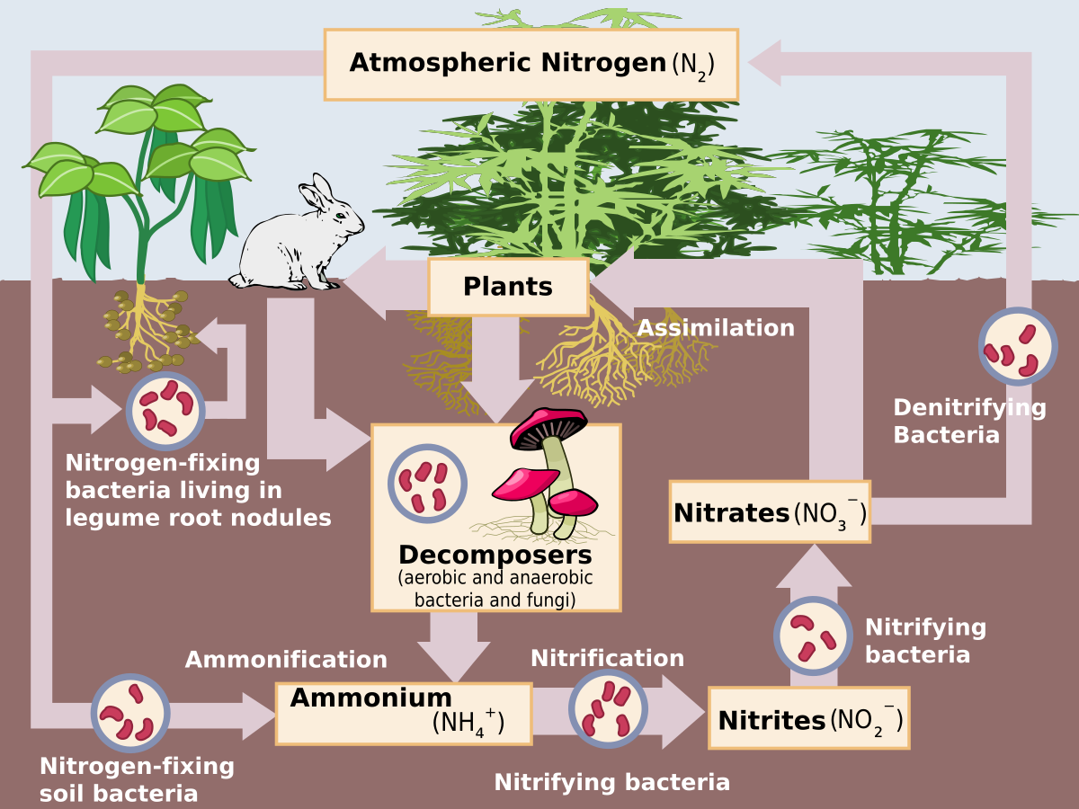

- 1) Nitrogen fixation
  - _______________________ absorb the _______ from the air and _______________________into a biological form that most other living organisms can actually use
  - They convert the __________________________(_______________________)
- 2) Assimilation
  - _______________ can now absorb the _______________________and use it to make other organic molecules
  - When _______________________then eat the plants they can then also take up the ______________________________________________________________
- 3) Nitrification
  - _______________________then convert the ammonia into nitrites and nitrates
- 4) Denitrification
  - ______________________________________then convert the nitrites/nitrates back into N₂ gas
- Note:
  - When things ______________________________________________they often also release _______________________in a process called _________________ __________________

Nitrogen Cycle Summary
- N₂ fixation
  - Bacteria convert ______________________________________________
- Nitrification
  - Bacteria convert ____________________________________________________
- Denitrification
  - Bacteria convert ______________________________________________

