Notes: Magnetic Fields

Magnetic Fields
- Magnetic field:
  - The __________________________________ (or ________________________) in which _____________________________________________will be affected
- Visualizing magnetic field lines
  - If we were to place a series of ___________________________ (__________________________________) around another large magnet we would see how all the arrows start to ___________________________________ _______________

Note: the arrows ______________ point towards the ___________!

Recall Domains
- Ferromagnetic substances and magnetic domains
  - Ferromagnetic:
    - Something that contains _________________, _________________ or _________________
    - __________________________________________________________
  - Ferromagnetic substances consist of _________________________________ __________________ (called ‘_________________’) that act like many __________________________________ within the material.
    - So iron filings will become _________________ and then act like tiny compasses and __________________________________to show the ___________________________________________!

Drawing Field Lines
- Look at the pattern, then draw a few lines (6 – 12) to show the basic shape
- Complete the drawing by giving each line a direction
- The direction can be determined by placing a compass in the magnetic field.

Magnetic Field Direction
What do we notice about the magnetic field direction?
_________________________________________________________________________________

Earth’s Magnetic Field
- The Earth’s core is filled with ______________________________________________________
  - These liquids are constantly in ___________________________ (due to the ______________________________________________________)
  - This motion creates a ______________________________________________________ that can be felt all over the Earth

- What way does a compass point?
  - ______________________________________________________
- The North pole of a magnet is attracted to…
  - ______________________________________________________
  - SO:
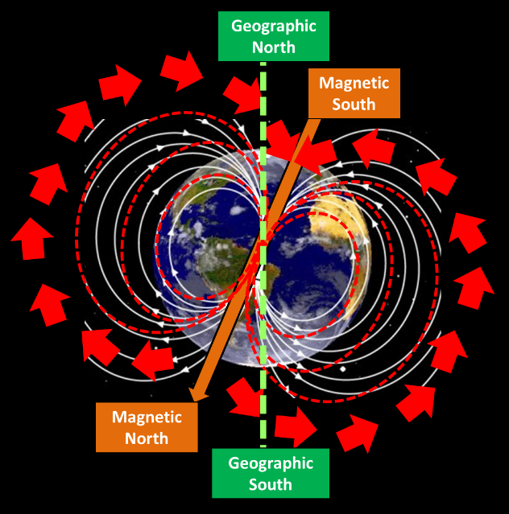
    - This means that our _______________________________________________ is actually a ______________________________________________________

